ShopSmart – E-commerce Customer Engagement & Order Tracking System

**Phase 1: Problem Understanding & Industry Analysis**

**Problem Statement**

The online retail company receives thousands of customer orders daily via its website and mobile app. However, the existing processes are fragmented and lead to multiple issues. Customer support teams face difficulties in providing real-time updates on order status, shipping, and returns. Marketing campaigns are generic and not personalized, reducing customer engagement and loyalty. Warehouse managers struggle with visibility into order fulfillment and returns. Additionally, management lacks consolidated dashboards to track customer experience, sales performance, and product trends. These gaps result in lower customer satisfaction, inefficiencies, and lost revenue opportunities.

**Requirement Gathering**

• Centralize customer and order data within Salesforce

• Real-time order tracking with automated status updates (Placed → Shipped → Delivered → Returned)

• Personalized marketing campaigns using customer purchase history and preferences

• Dashboards for sales trends, customer loyalty, and product return analysis

• Automated customer notifications (order confirmation, shipment tracking, return updates)

• Role-based access for Sales, Support, Warehouse, and Management

• Seamless integration with website/app and logistics APIs

**Stakeholder Analysis**

|  |  |  |
| --- | --- | --- |
| Stakeholder | Role | Key Needs |
| Sales Manager | Oversees sales and marketing campaigns | Personalized campaigns, customer insights, real-time revenue trends |
| Warehouse Manager | Manages stock & order fulfillment | Order tracking, inventory alerts, smooth return workflows |
| Customer Support | Handles customer queries & complaints | Quick access to customer order history, proactive notifications |
| Business Owner / CEO | Decision maker | Dashboards on customer engagement, sales performance, and returns |
| IT / Salesforce Admin | Configures Salesforce | Maintain scalable, secure, and integrated system |

**Business Process Mapping**

**Current State (As-Is Process)**

|  |  |  |  |
| --- | --- | --- | --- |
| Step | Owner | Process Description | Pain Points |
| 1 | Customer / Website | Customers place orders on the website or app, which are manually logged into disparate systems. | Manual entry delays, errors, no single source of truth. |
| 2 | Warehouse | Warehouse staff update stock only once per day in spreadsheets. | Frequent stockouts, overselling, lack of real-time sync. |
| 3 | Customer Support | Customers contact support for order/return status updates. | High workload, delayed responses, low customer satisfaction. |
| 4 | Marketing | Generic campaigns sent to all customers. | Low engagement, poor targeting, missed upsell opportunities. |
| 5 | Management | Sales & returns data consolidated monthly. | Delayed insights, lack of KPIs, no real-time decision-making. |

**Business Process Mapping – Future State (To-Be Process)**

|  |  |  |  |
| --- | --- | --- | --- |
| Step | Owner | Automated Solution in Salesforce | Benefit |
| 1 | Customer / Website | Orders captured directly into Salesforce via API or LWC form. | Eliminates manual entry, improves accuracy. |
| 2 | Flow + Trigger | Real-time inventory update with low-stock alerts. | Prevents overselling, ensures timely restocking. |
| 3 | Flow + Email / SMS Alert | Automated notifications for order placement, shipment, and returns. | Enhanced customer experience, fewer support calls. |
| 4 | Marketing Cloud / Journey Builder | Personalized campaigns based on purchase history. | Higher engagement, improved loyalty, increased sales. |
| 5 | Dashboards | Live dashboards for sales, returns, and engagement KPIs. | Faster decisions, better forecasting. |

**Industry-Specific Use Case Analysis**

1. Order Lifecycle Automation: Orders automatically progress through stages (Placed → Shipped → Delivered → Returned) with notifications at each step.  
  
2. Inventory Synchronization: Real-time stock level updates ensure accurate availability and reduce overselling risks.  
  
3. Customer Engagement: Personalized marketing journeys, loyalty rewards, and proactive notifications drive repeat purchases.  
  
4. Return & Refund Management: Automated workflows streamline returns and refunds while keeping customers informed.  
  
5. Performance Insights: Live dashboards show KPIs for sales, customer retention, product returns, and marketing effectiveness.  
  
6. Scalability & Growth: Salesforce infrastructure ensures seamless handling of higher order volumes as the business expands.

**Phase 2: Org Setup & Configuration**

**Salesforce Edition**

* Edition Used: Developer Edition is used.
* Reason: Provides full customization capabilities (Objects, Flows, Triggers, Dashboards) free of cost and ideal for building this project.

**Company Profile Setup**

* Update Company Name: ShopSmart Pvt. Ltd.
* Configure Default Time Zone: (GMT+5:30) IST (For India)
* Currency: INR (For India) or Multi-Currency for different countries.

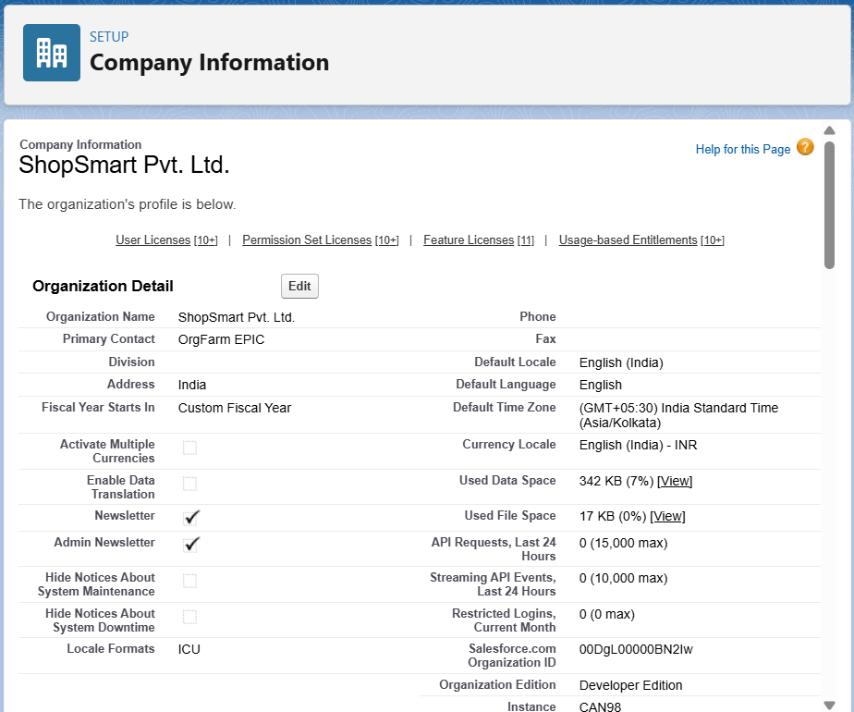

**Business Hours & Holidays**

* Business Hours: Mon–Sat, 9:00 AM – 6:00 PM IST
* Holidays: Republic Day (26-Jan), Independence Day (15-Aug).
* Reason: Ensures any escalations, SLAs, and workflows follow working hours and avoid holidays.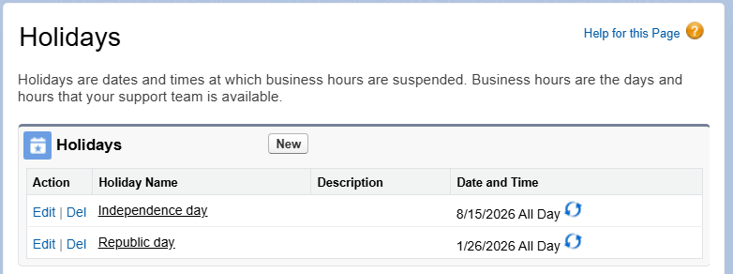

**Fiscal Year Settings**

* Fiscal Year: Standard Calendar Year (Jan–Dec) is used unless custom accounting alignment is needed.
* Reason: Simplifies reporting alignment unless business requires April–March fiscal year.

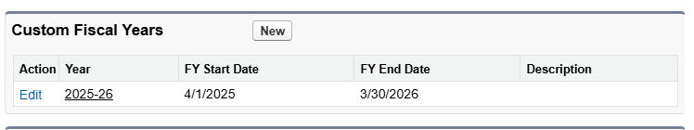

**User Setup & Licenses**

This shows the user, role, responsibility, and assigned Salesforce license.

|  |  |  |
| --- | --- | --- |
| **User** | **Role** | **License** |
| **CEO** | **CEO** | **Salesforce** |
| **Sales Manager** | **Sales Manager** | **Salesforce** |
| **Warehouse Manager** | **Warehouse Manager** | **Salesforce** |
| **Customer Support** | **Support** | **Salesforce** |

**Profiles**

Custom Profiles Created:

* CEO Profile: Full access to all objects.
* Sales Manager Profile: Full access to Leads, Opportunities, Orders; limited access to

Inventory.

* Warehouse Manager Profile: Read/Write on Inventory, Read/Write on Orders.
* Support Profile: Read-only on Orders, full access to Cases.

Reason: Profiles enforce object- and field-level security for different job roles.

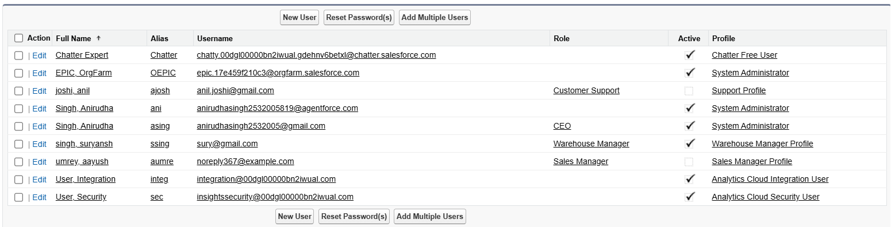

**Role Hierarchy**

|  |  |  |  |
| --- | --- | --- | --- |
| **Role** | **Reports To** | **Responsibilities** | **Data Visibility** |
| **CEO** | **Top Level** | **Business owner, strategic decisions** | **Sees all records (Orders, Inventory, Products, Cases)** |
| **Sales Manager** | **CEO** | **Manages sales team, approves orders, monitors performance** | **Sees own + subordinates’ orders** |
| **Warehouse Manager** | **CEO** | **Manages inventory, updates stock, fulfills orders** | **Sees all orders (via sharing rule), edits inventory** |
| **Support** | **CEO** | **Handles customer queries, updates order status** | **Read-only access to Orders, full access to Cases** |

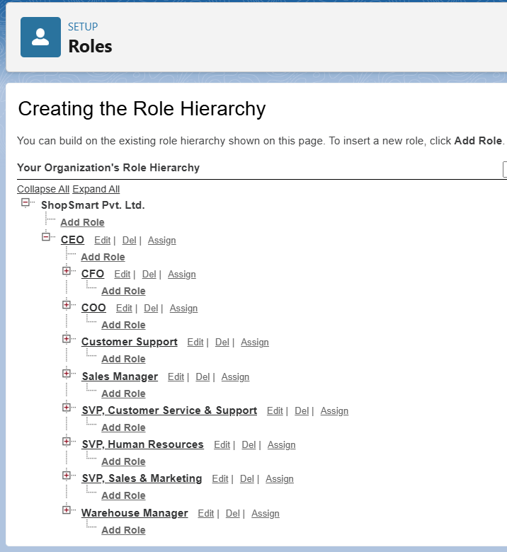

**Permission Sets**

* Reports Access: Grants CEO and Sales Manager access to create and customize reports/dashboards.
* Inventory Access: Grants Warehouse Manager edit access to Inventory custom object.
* Order Management: Allows Support to update Order status fields.







**Organization-Wide Defaults (OWD)**

* Accounts: Private
* Contacts: Controlled by Parent
* Orders: Private
* Cases: Private
* Products: Public Read Only
* Inventory: Private (shared with Warehouse Manager via Sharing Rule).

Reason: Ensures sensitive records are secure, shared only via hierarchy or rules.

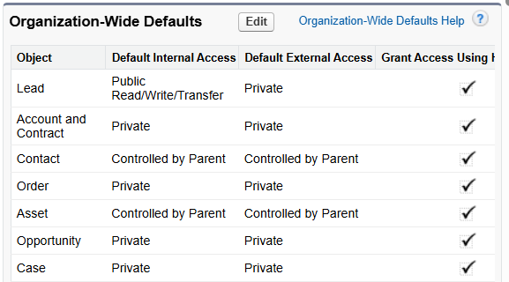



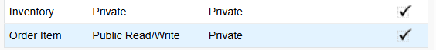

**Sharing Rules**

* Orders with Status = 'Ready to Ship' → Shared with Warehouse Manager role (Read/Write).
* Customer Accounts (Type = Customer) → Shared with Support role (Read Only).

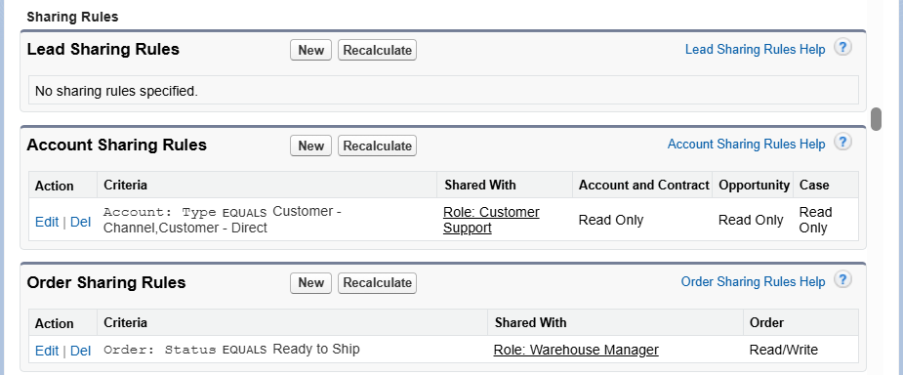

**Login & Security Policies**

* Password Policy: Minimum length 8, lockout after 5 attempts.
* Session Timeout: 30 minutes.
* Enable Two-Factor Authentication (2FA) for CEO users.
* Restrict access using Login IP Ranges if required.

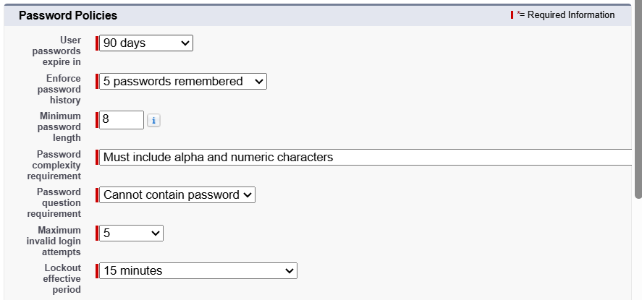



**Audit Trail & Field History**

* Enabled Field History Tracking on Orders (Status, Total Amount) and Cases (Status).
* Enabled Setup Audit Trail for configuration changes.

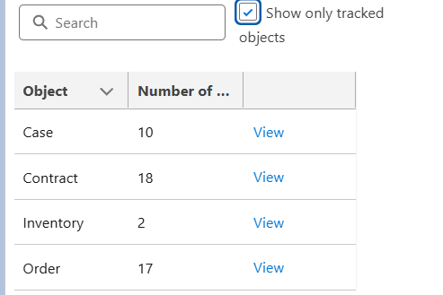

**Developer Org Setup & Deployment**

Since Developer Edition is used, additional sandboxes are not available.  
For deployment strategy:  
- Use a second Developer Org for testing OR  
- Use Salesforce DX (SFDX) with scratch orgs.

Deployment options:  
Change Sets: UI-based, simple for small changes.  
Salesforce DX / CLI: Source-driven, recommended for version control and CI/CD pipelines.

**Phase 3: Data Modeling & Relationships**

**Standard & Custom Objects**

Standard Objects used in ShopSmart CRM include: Accounts, Contacts, Products, Orders, and Cases.  
Custom Objects created include:  
- Order Item (Order_Item__c): Junction object to link Orders and Products.  
- Inventory (Inventory__c): Tracks stock levels for each product.

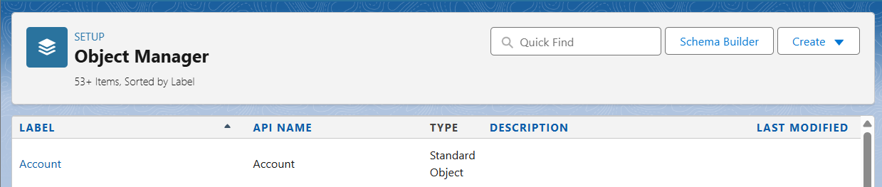









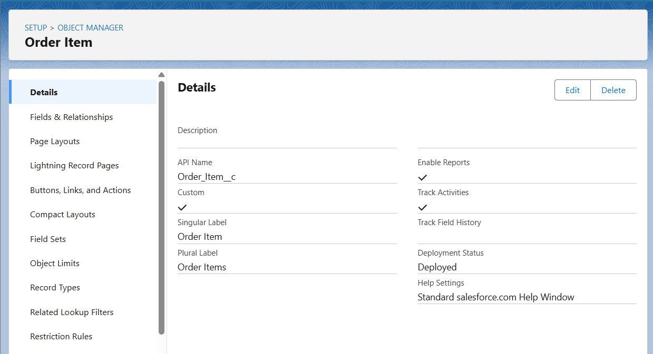

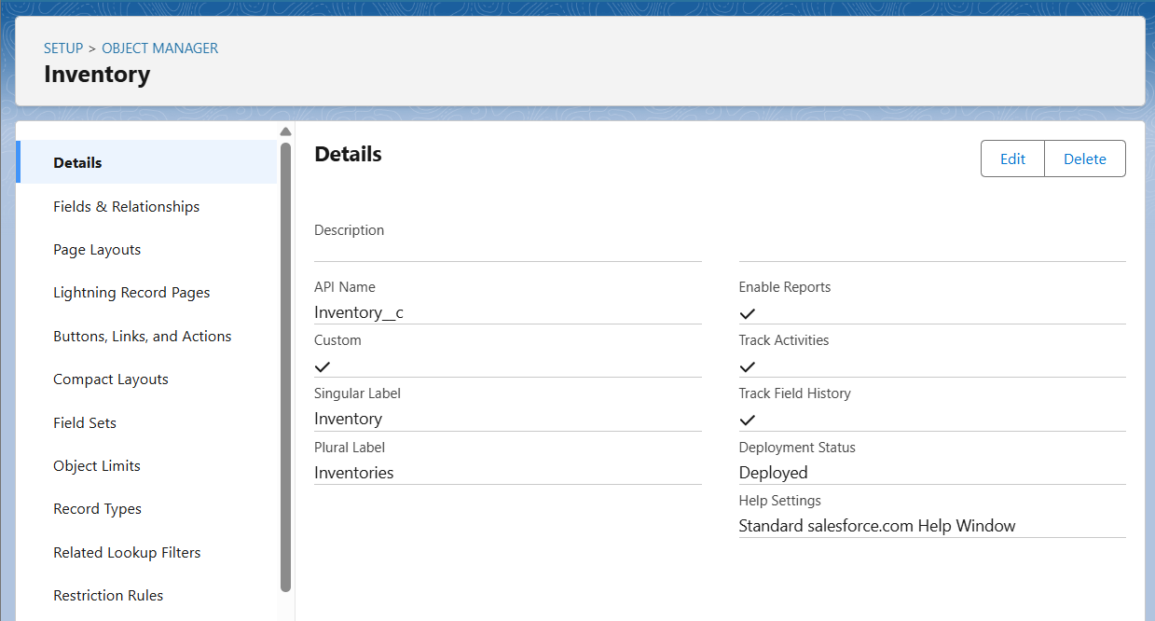

**Fields**

Key custom fields were added to extend business functionality:  
  
Accounts:  
- Customer Tier (Picklist: Regular, Premium, VIP)  
- Preferred Payment Method (Picklist)

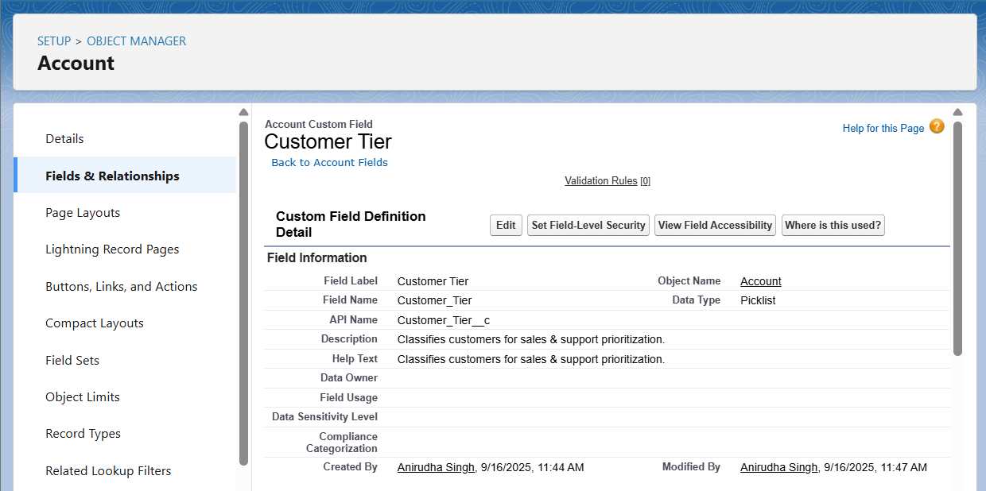

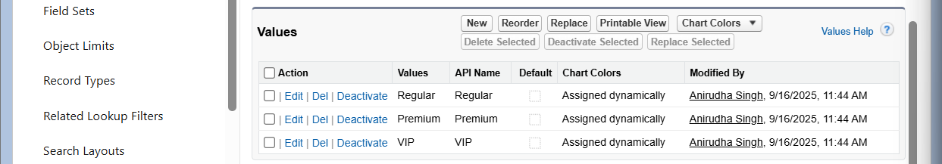

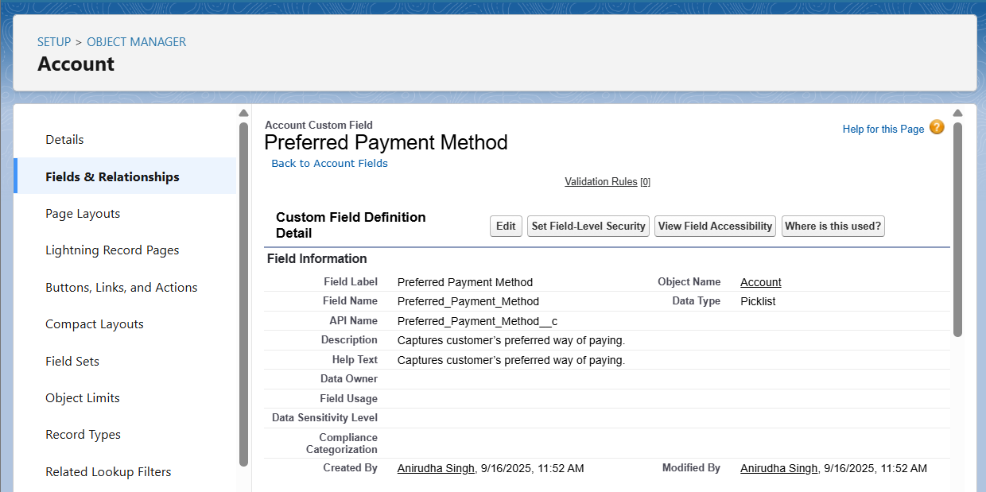  
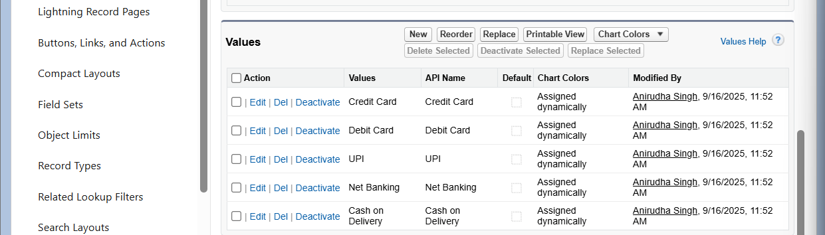  
Orders (Standard Object):  
- Payment Status (Picklist)  
- Delivery Method (Picklist)  
- PO Number (Text)

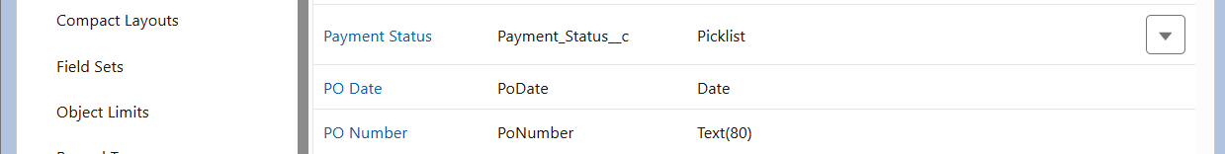

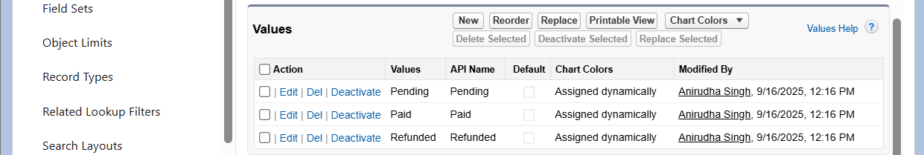



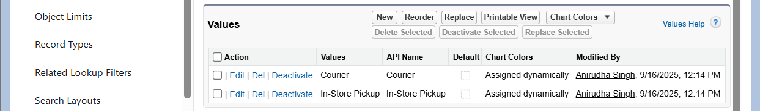  
  
Order Item (Order_Item__c):  
- Quantity (Number)  
- Unit Price (Currency)  
- Subtotal (Formula: Quantity × Unit Price)  
- Discount (%) (Percent)  
- Net Amount (Formula: Subtotal – Discount)

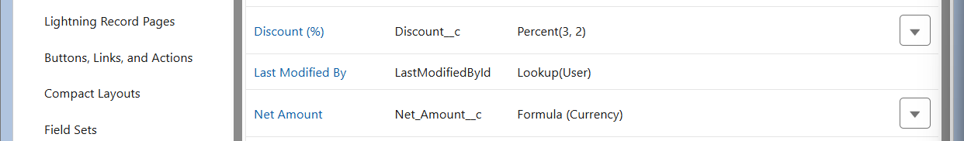

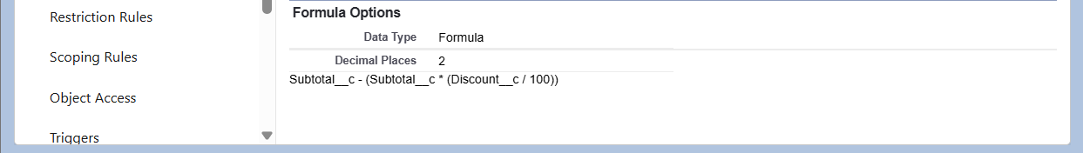

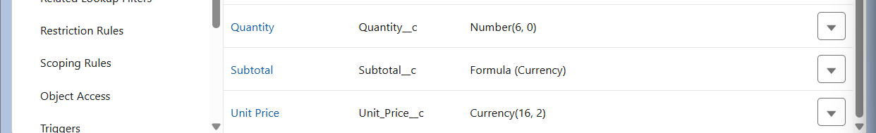  
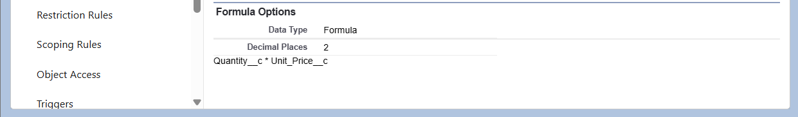  
Inventory (Inventory__c):  
- Product (Lookup → Product2)  
- Quantity On Hand (Number)  
- Reorder Level (Number)  
- Status (Picklist: Available, Reserved, Out of Stock)  
Validation Rule: Quantity On Hand cannot be negative.  
Field History Tracking: Enabled for Quantity On Hand and Status.

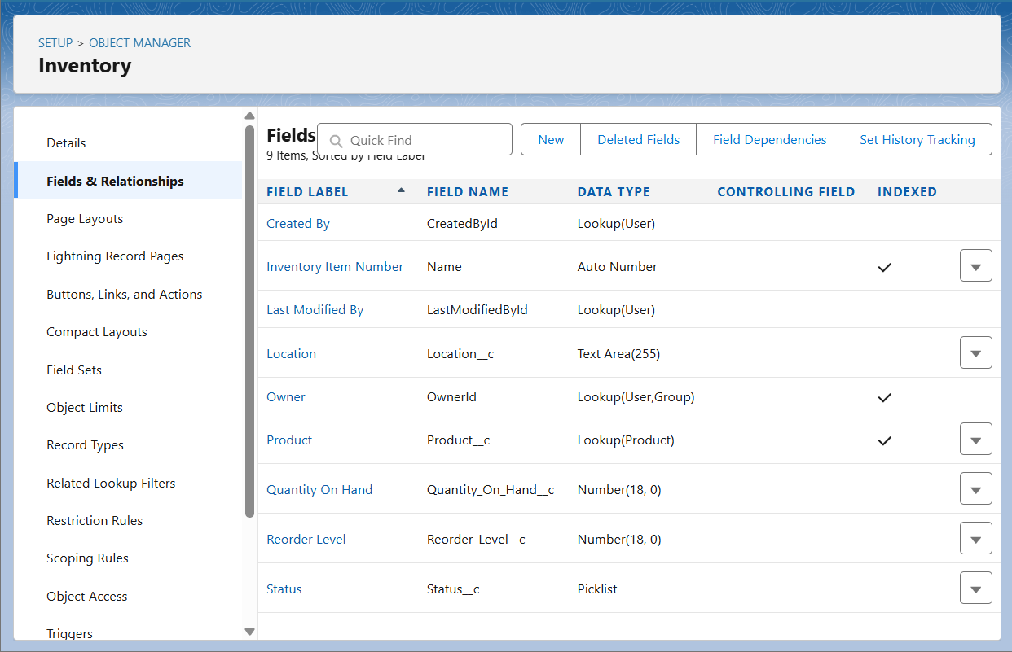  
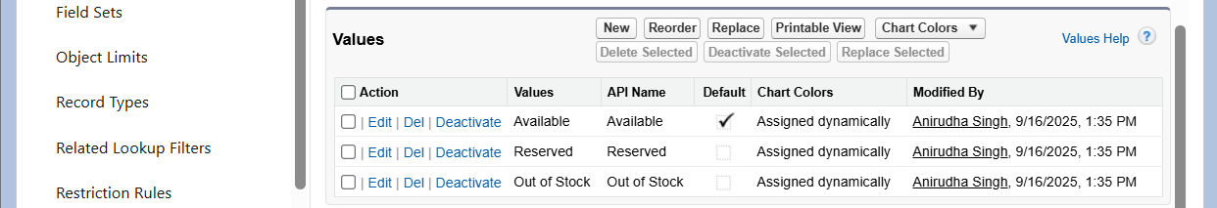

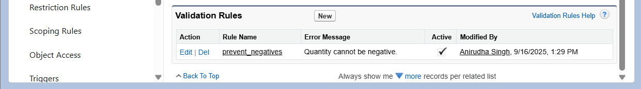  
Cases:  
- Issue Category (Picklist: Delivery, Payment, Product Quality, Other)  
- Resolution Time (Hrs) (Formula: ClosedDate – CreatedDate)



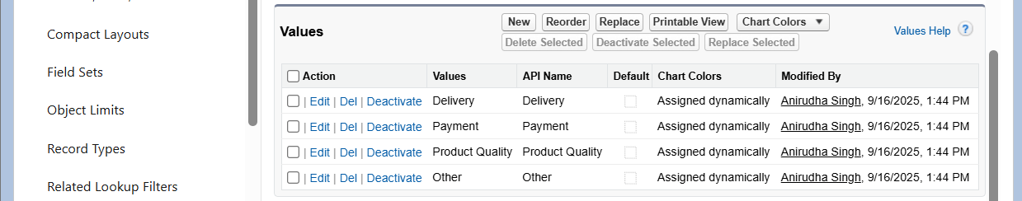



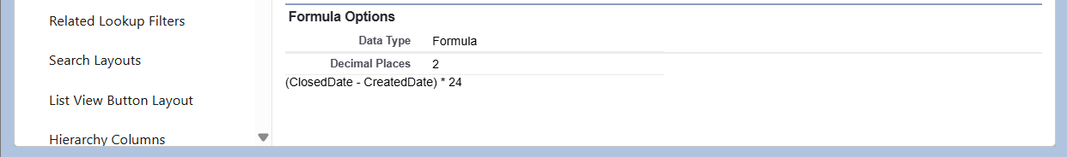

**Record Types**

Accounts:  
- Customer (default for Sales Manager, Support)  
- Partner/Vendor (used for reseller/partner accounts)

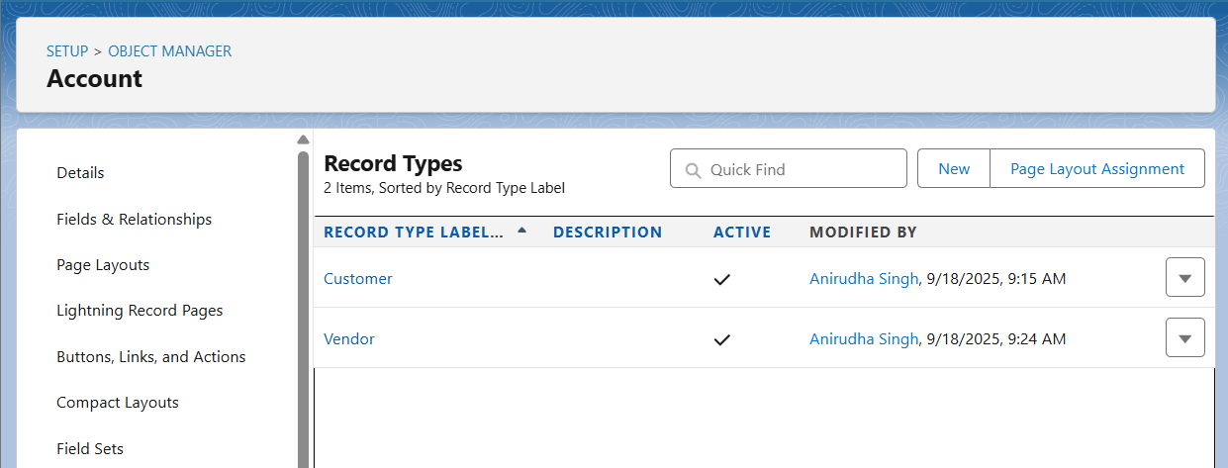  
Orders:  
- B2B Order: Includes PO Number and fields for business contracts.  
- B2C Order: Includes Payment Method and Delivery Slot (if added).

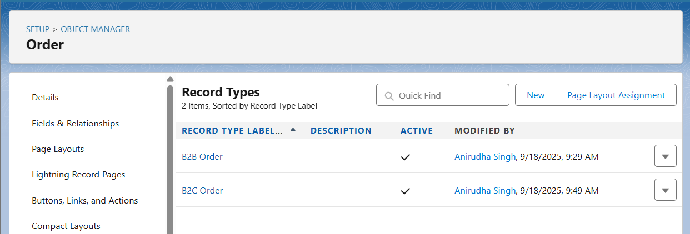  
Cases:  
- Complaint  
- Return  
- General Inquiry  
(Each linked to a Support Process to control Status values.)

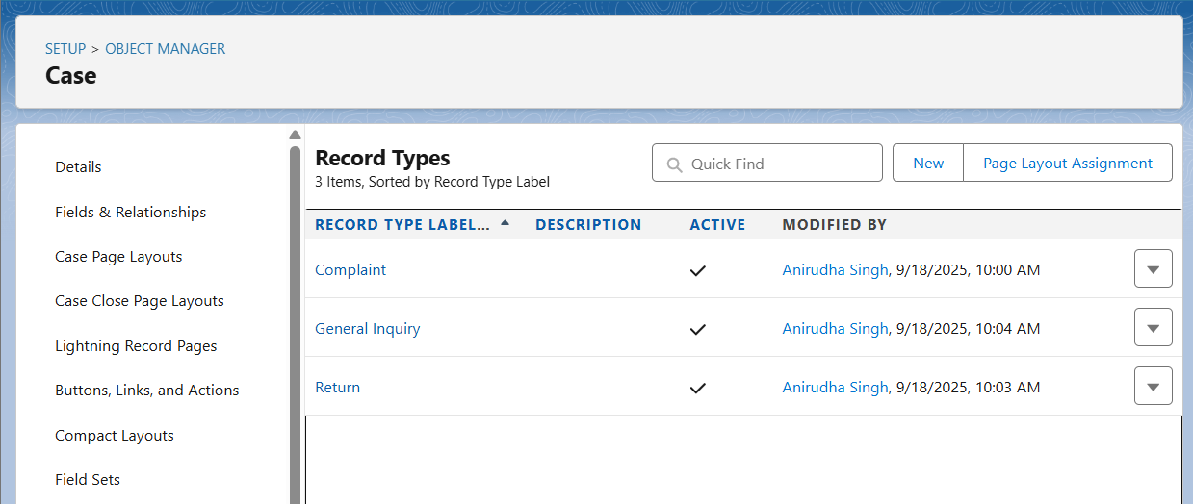

**Page Layouts**

Accounts:  
- CEO Layout: Full financial details (Annual Revenue).  
- Sales Manager Layout: Customer-facing fields, hides financial codes.  
- Support Layout: Simplified view, focused on Cases.

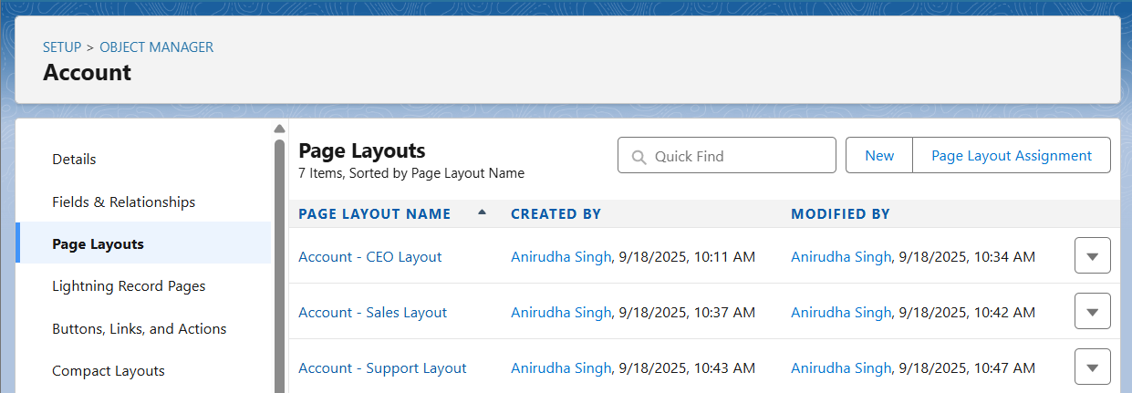  
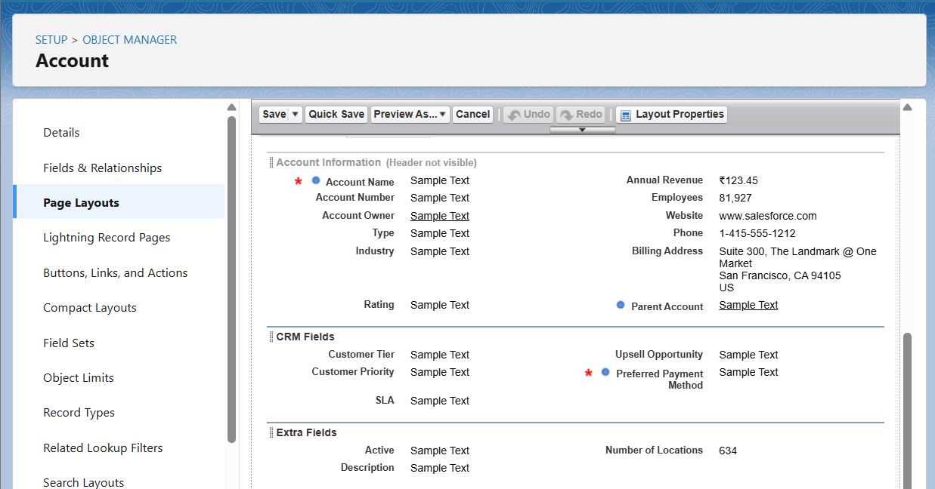

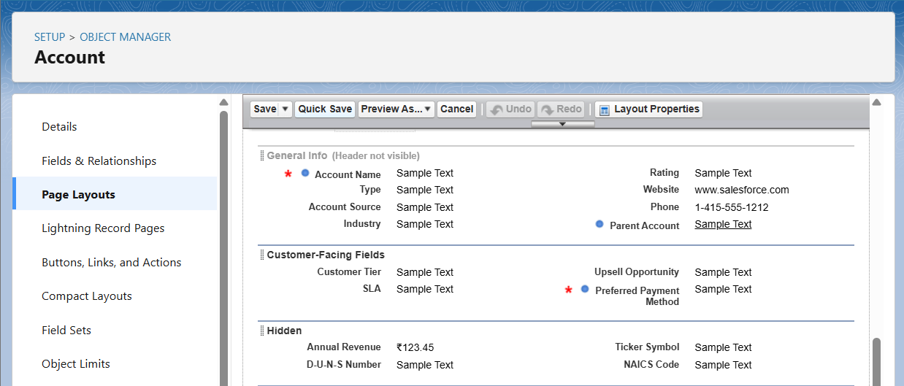

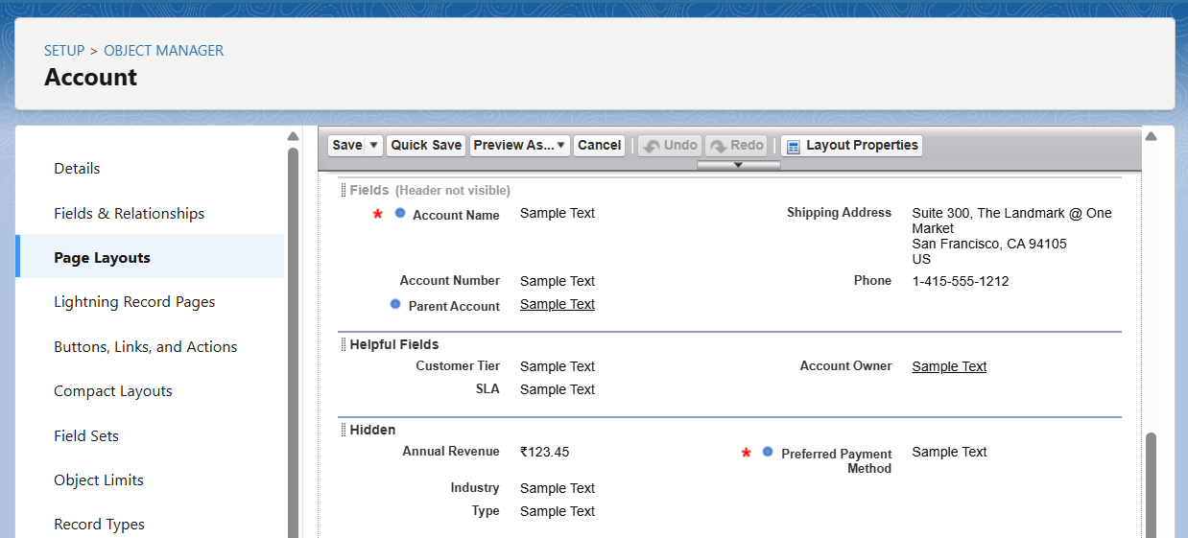  
Orders:  
- CEO Layout: All key fields (Order Amount, Payment Status, Dates).  
- Sales Manager Layout: Order details with B2B/B2C variations.  
- Warehouse Layout: Focused on shipping info and Order Items.  
- Support Layout: Order details tied to customer issues.

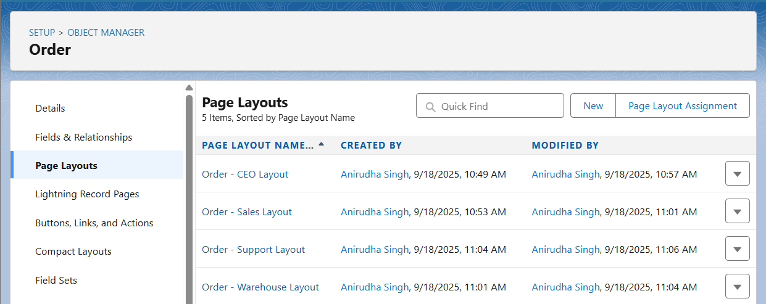  
Order Item:  
- Single layout showing Product, Quantity, Pricing details.

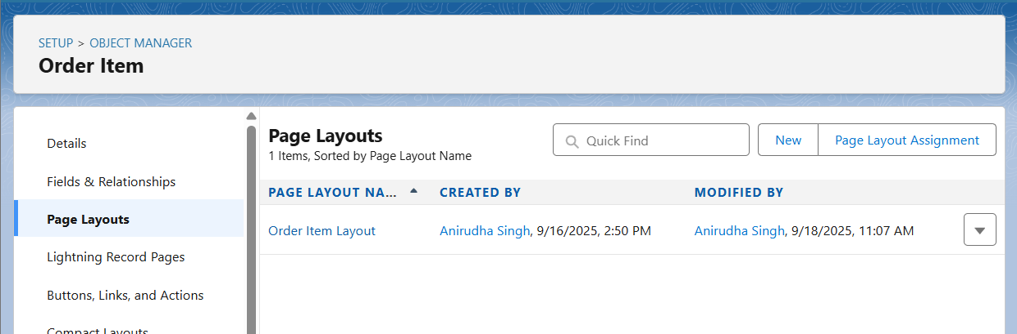  
Inventory:  
- CEO Layout: Stock status overview.  
- Warehouse Layout: Editable Quantity, Reorder Level, Status.

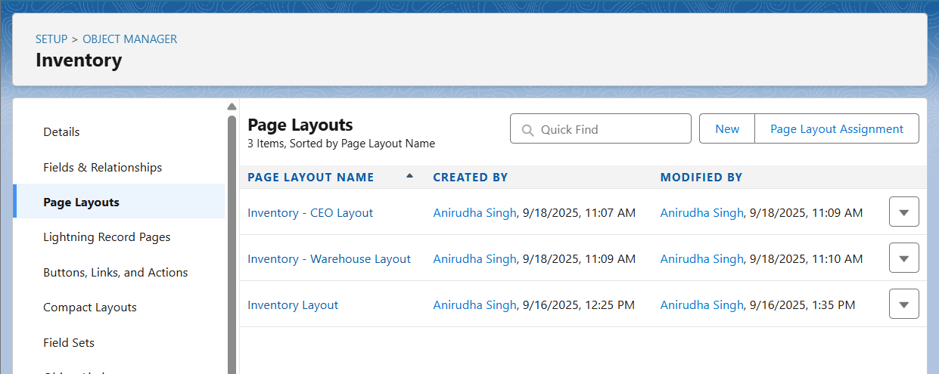  
Cases:  
- CEO Layout: Overview of customer issues.  
- Support Layout: Full detail including Issue Category, Resolution.

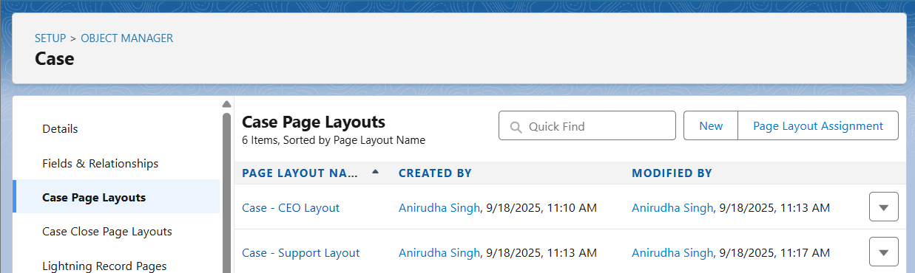

**Compact Layouts**

Configured compact layouts for mobile/highlights panel:  
  
Orders: Order Number, Status, Payment Status, Order Amount, Effective Date, End Date.  
Inventory: Product, Quantity On Hand, Reorder Level, Status.  
Cases: Case Number, Subject, Status, Priority, Issue Category, Account, Contact.  
Accounts: Account Name, Type, Phone, Industry, Customer Tier, Preferred Payment Method.

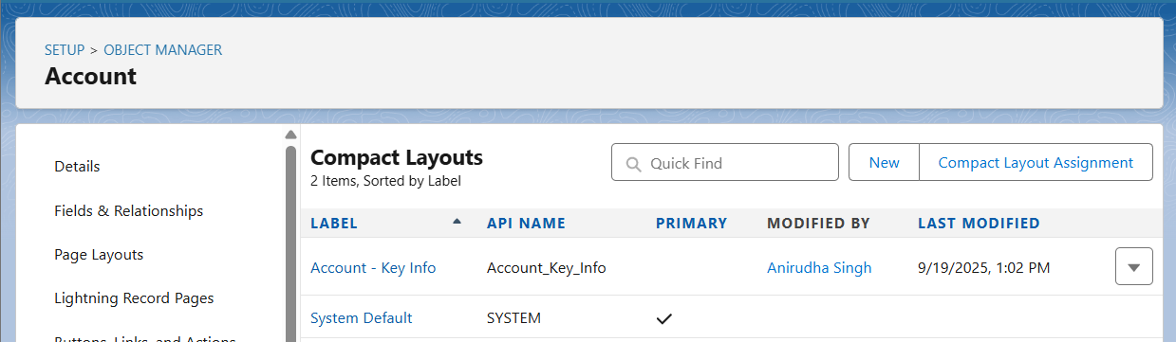

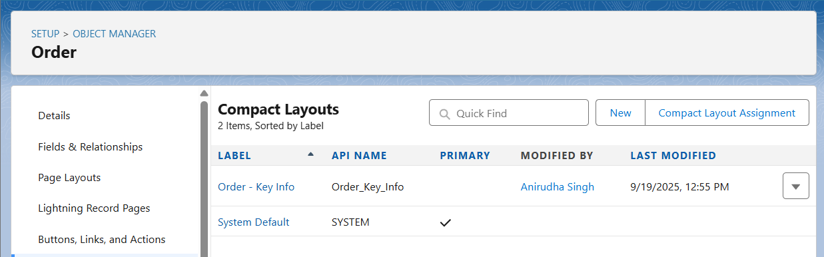

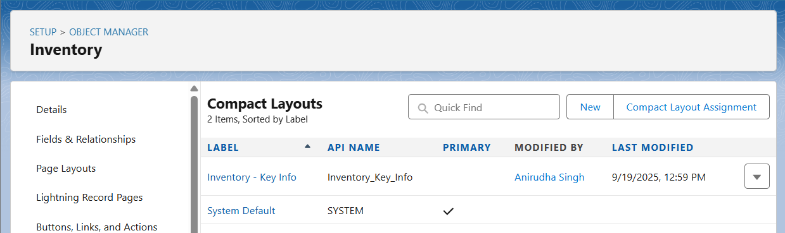

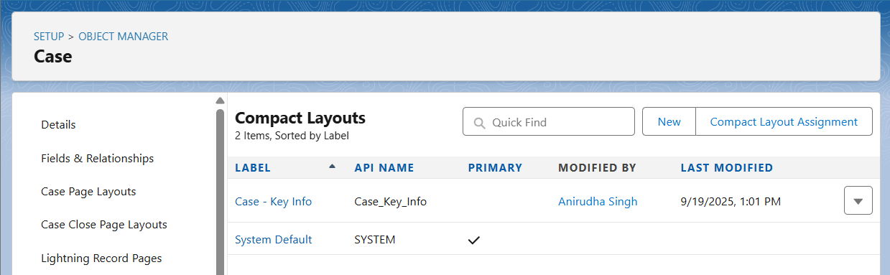

**Schema Builder**

Objects included: Account, Contact, Order, Order Item, Product2, Inventory, Case.  
  
Verified relationships:  
- Account → Order  
- Order → Order Item  
- Order Item → Product2  
- Product2 → Inventory  
- Account → Case  
- Contact → Case  
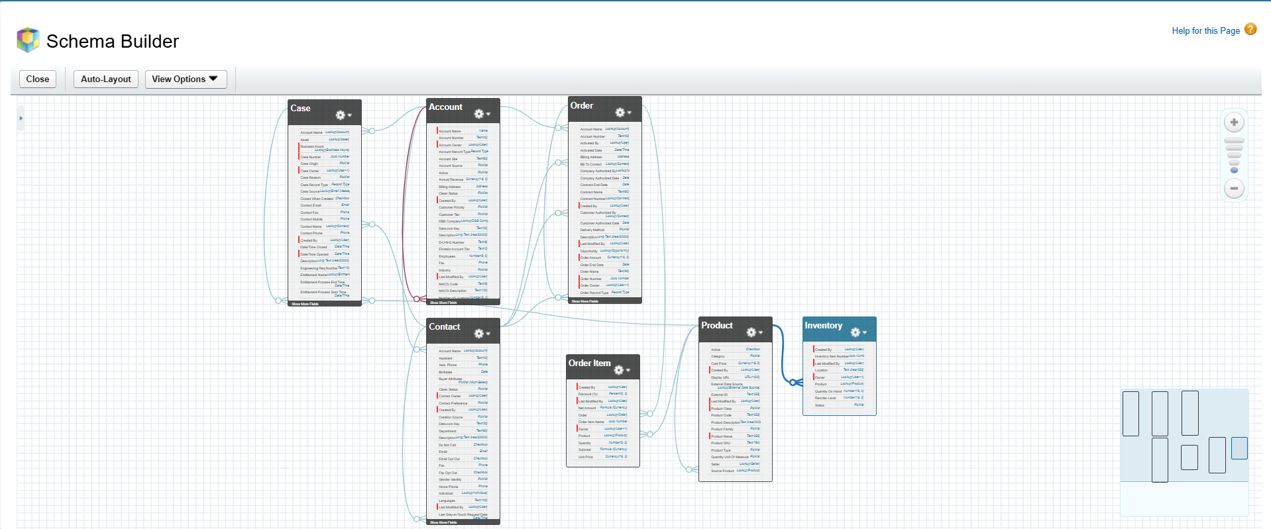

**Lookup vs Master-Detail vs Hierarchical Relationships**

- Lookup Relationships: Used for linking objects without tight dependency (e.g., Inventory → Product2).  
- Master-Detail Relationships: Not implemented, since deletion or roll-up dependencies not required in this model.  
- Hierarchical Relationships: Only available on User object, not used in this project.

**Junction Objects**

Order Item (Order_Item__c) is used as a junction object to manage many-to-many relationships:  
- One Order can contain many Products.  
- One Product can belong to many Orders.  
This is achieved by creating a junction between Order and Product2.

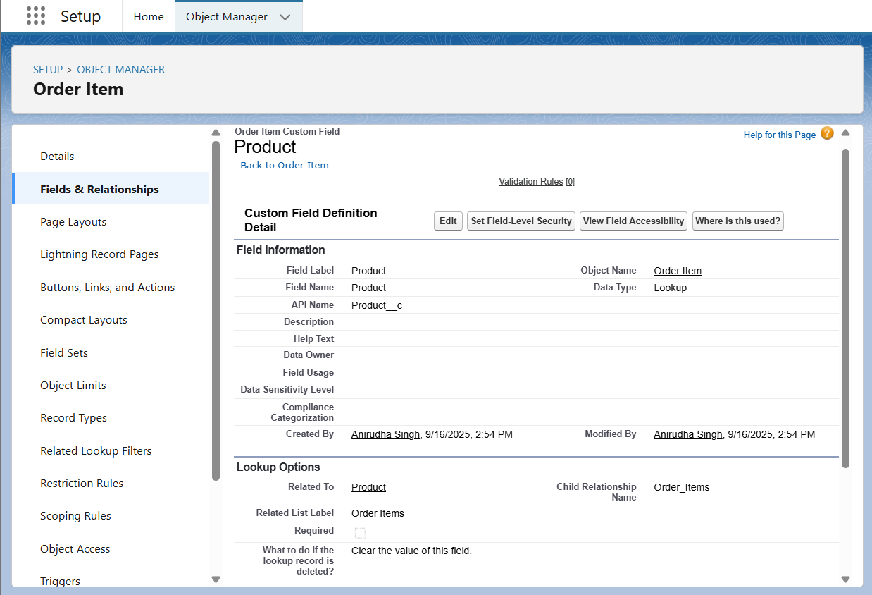

**External Objects**

External Objects are not implemented in Developer Edition but documented for future integration.  
Example: ShopSmart may connect its Salesforce org with a Warehouse ERP system.  
- Tool: Salesforce Connect using OData adapter.  
- External Object Example: Warehouse_Stock__x.  
- Relationship: Warehouse_Stock__x could relate to Product2 to show real-time stock levels.  
This would extend visibility of inventory without duplicating data in Salesforce.

**Phase 4: Process Automation (Admin)**

**Salesforce Edition**

Edition Used: Developer Edition is used.

Reason: Developer Edition supports full automation features (Validation Rules, Workflow, Process Builder, Flows, Approval Processes) without additional licensing. Ideal for ShopSmart project.

**Validation Rules**

Purpose: Ensure data integrity and enforce business rules.

|  |  |  |  |
| --- | --- | --- | --- |
| **Object** | **Rule Name** | **Formula** | **Error Message** |
| **Opportunity** | VR_CloseDate_Not_Past | CloseDate < TODAY() | Close Date cannot be in the past. |
| **Opportunity** | VR_Discount_Cap | AND(NOT($Permission.Approve_High_Discount), Discount__c > 30) | Discount cannot exceed 30% without manager approval. |
| **Order** | VR_Require_Shipping_Address | AND(ISPICKVAL(Delivery_Type__c,"Ship"), ISBLANK(Shipping_Address__c)) | Shipping address is required for non-pickup orders. |
| **Product** | VR_SKU_Format | NOT(REGEX(SKU__c,"[A-Z]{3}-[0-9]{4}")) | SKU must be in format AAA-1234. |

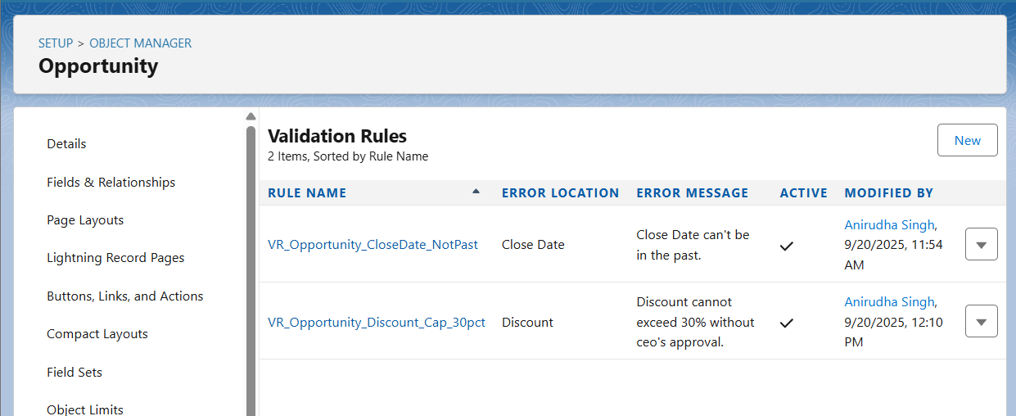

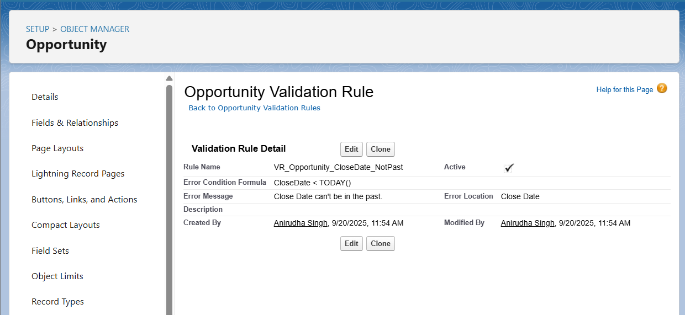

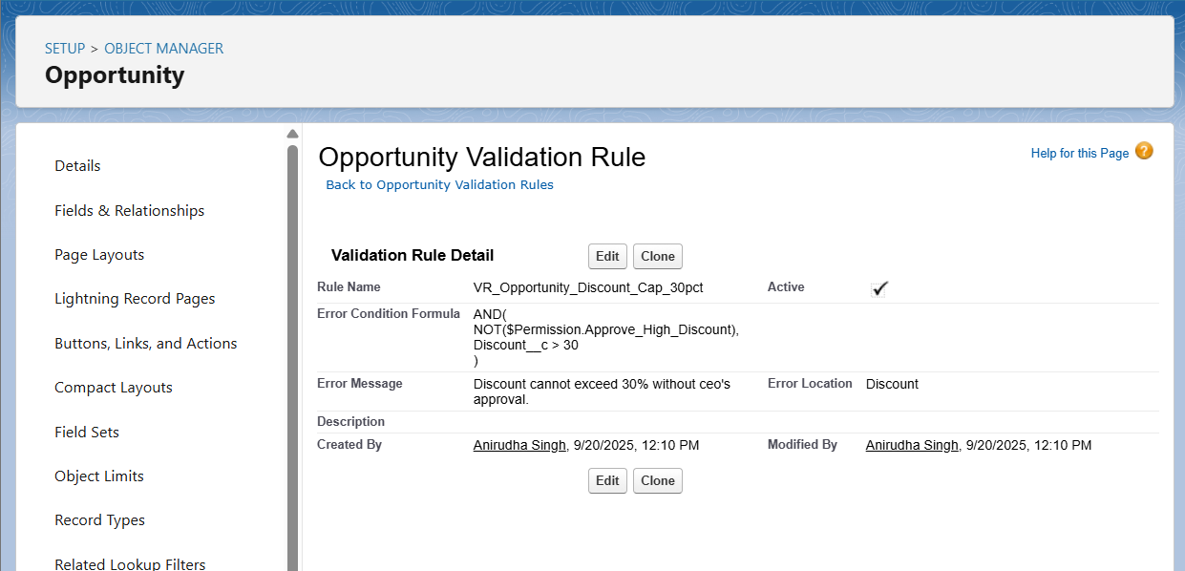

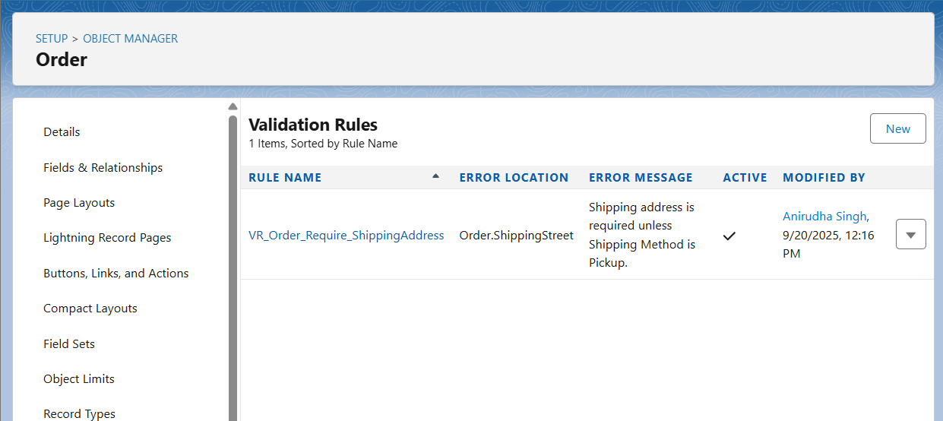

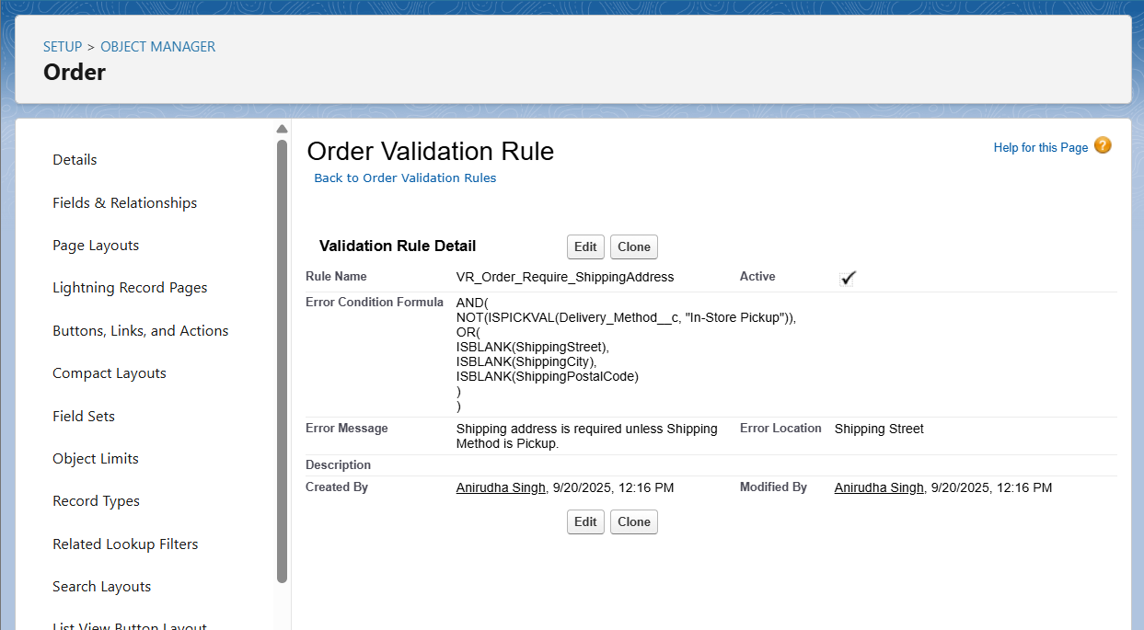

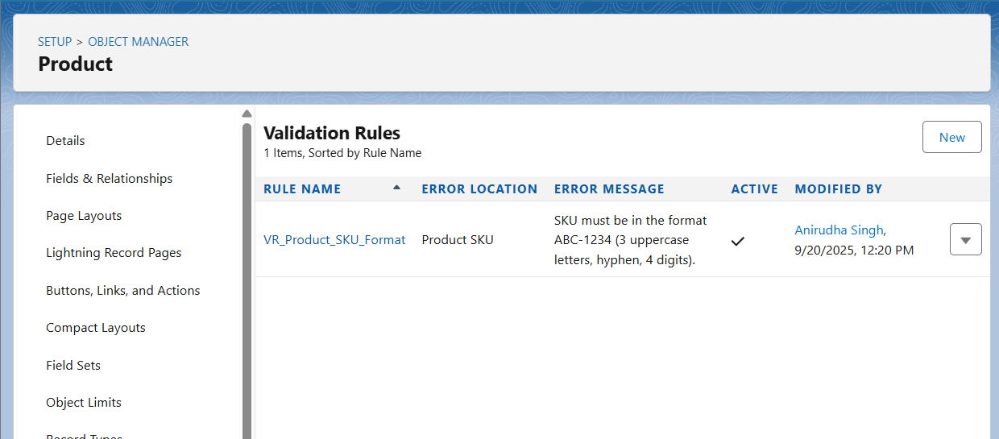

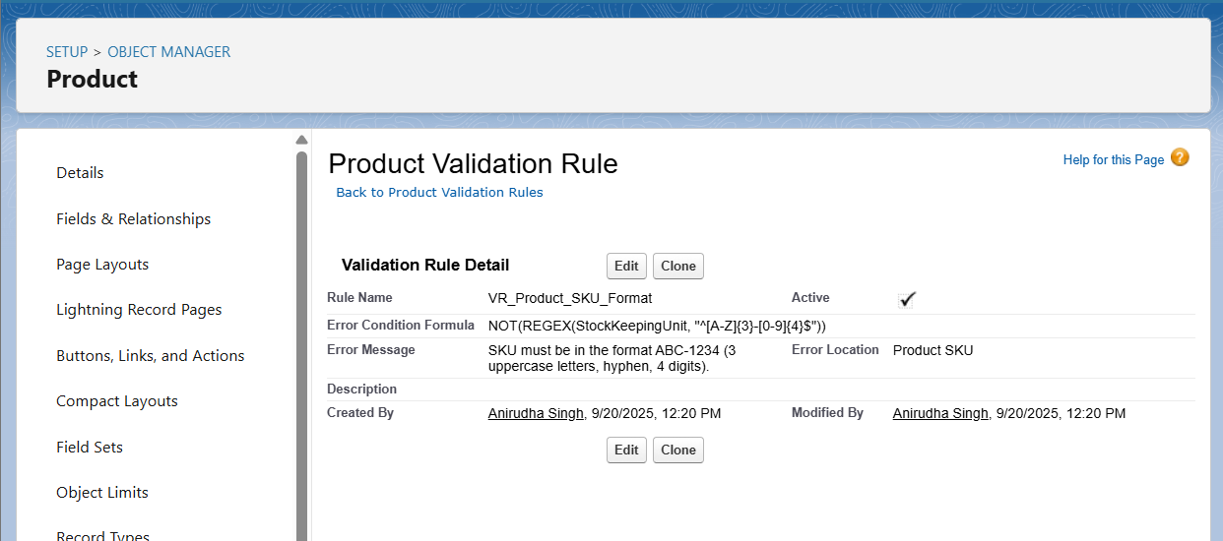

**Workflow Rules**

Purpose: Automate simple actions (Task creation, Email alerts, Field updates).

Example: High-Value Opportunity Task

- Object: Opportunity  
- Criteria: Amount > 100000  
- Immediate Actions:  
 • Create Task → Assigned to Opportunity Owner, Subject: Follow-up High-Value Opportunity, Due Date = Today + 1, Status = Not Started  
 • Email Alert → Template: HighValueOpportunityAlert, Recipient: Opportunity Owner

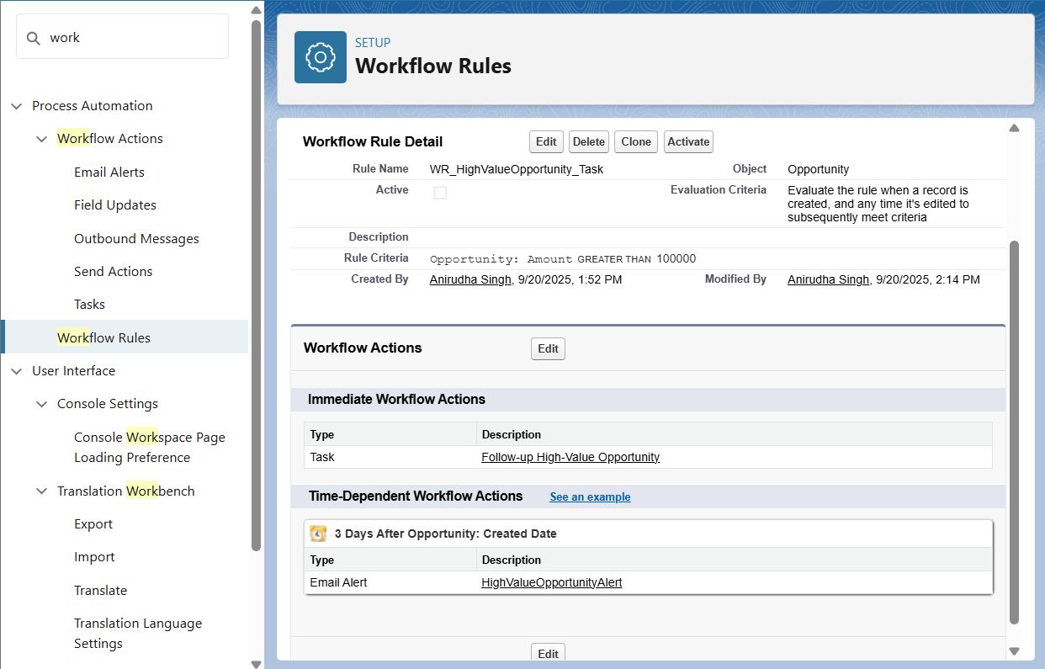

**Process Builder**

Purpose: Automate multi-step processes with more flexibility than Workflow Rules.

Example: High-Value Opportunity Process  
- Object: Opportunity  
- Trigger: Created or Edited  
- Criteria: Amount > 100000  
- Immediate Actions:  
 • Create Task (same as workflow)  
 • Send Email Alert (HighValueOpportunityAlert)

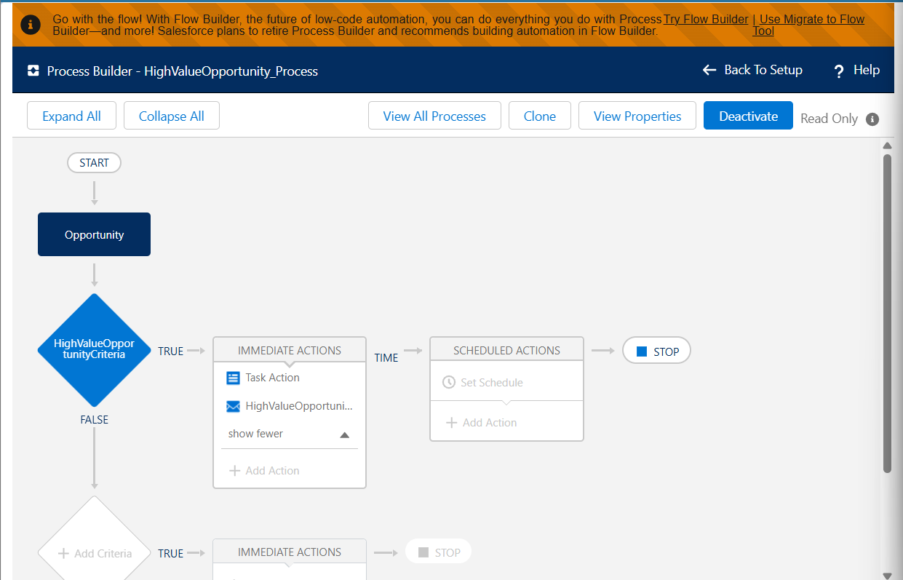

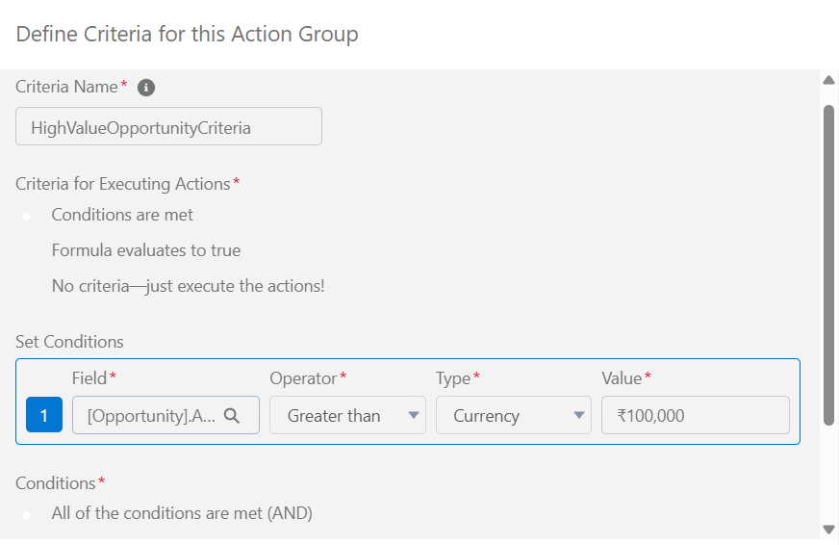

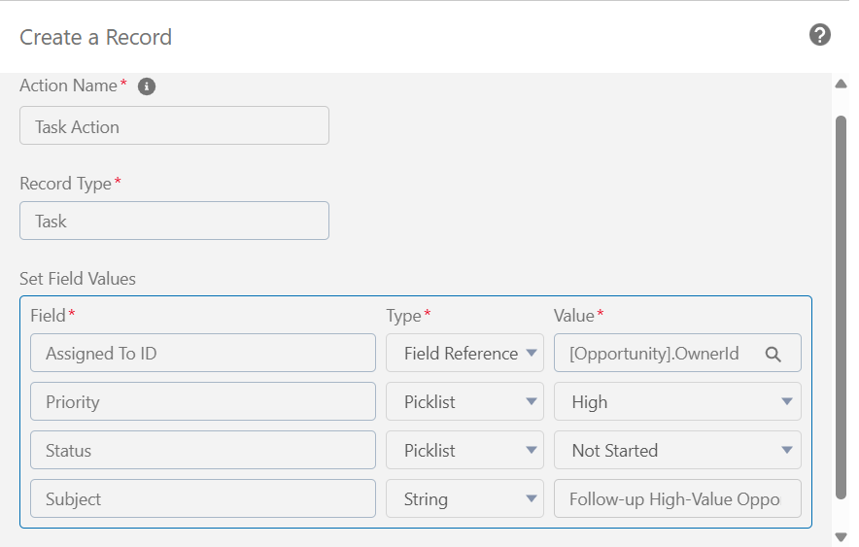

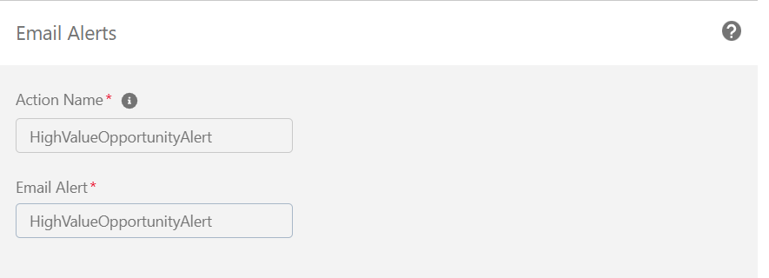

**Approval Processes**

Purpose: Automate record approvals for compliance or business rules.

Example: High Discount Approval  
- Object: Opportunity  
- Entry Criteria: Discount__c > 30  
- Approver: Opportunity Owner’s Manager  
- Initial Actions: Lock record, notify approver  
- Approval Actions: Unlock record, optional Field Update → Discount_Approved__c = TRUE  
- Rejection Actions: Unlock record, notify owner, optional Field Update → Discount__c = 30

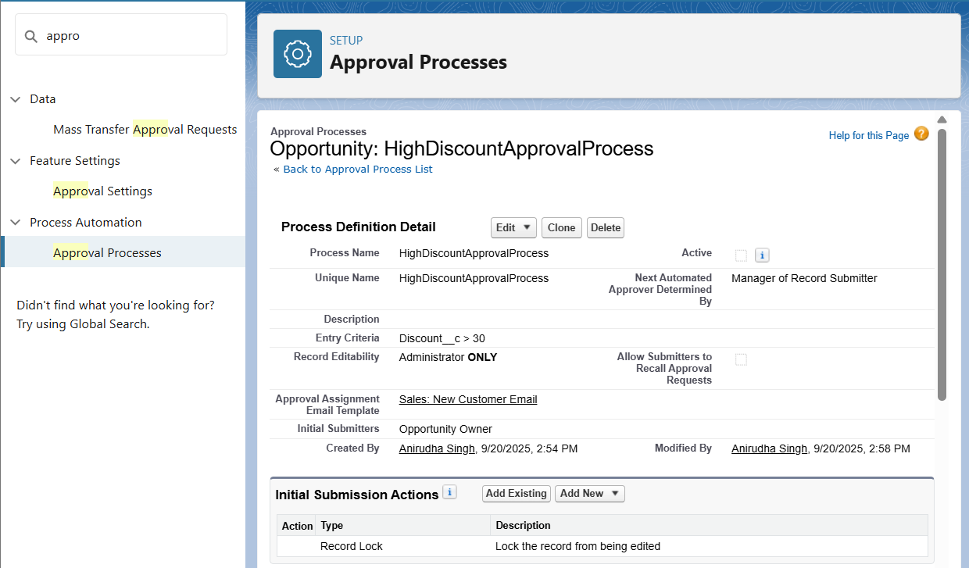

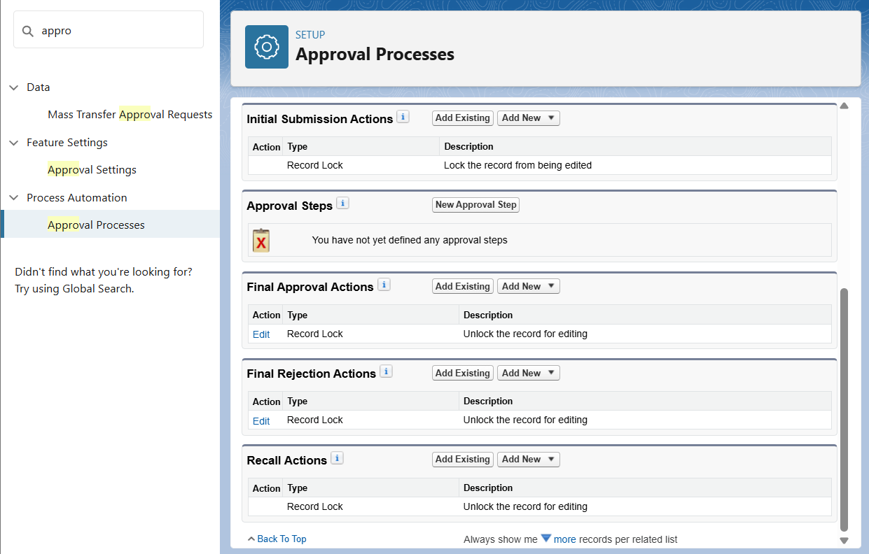

**Flow Builder**

Purpose: Advanced automation to create, update, and interact with records.

Example: Record-Triggered Flow – High-Value Opportunity  
- Trigger: Record Created or Updated  
- Condition: Amount > 100000  
- After Save Actions:  
 • Create Task → Subject: Follow-up High-Value Opportunity, Due Date = $Flow.CurrentDate + 1, Status = Not Started  
 • Send Email Alert → Template: HighValueOpportunityAlert

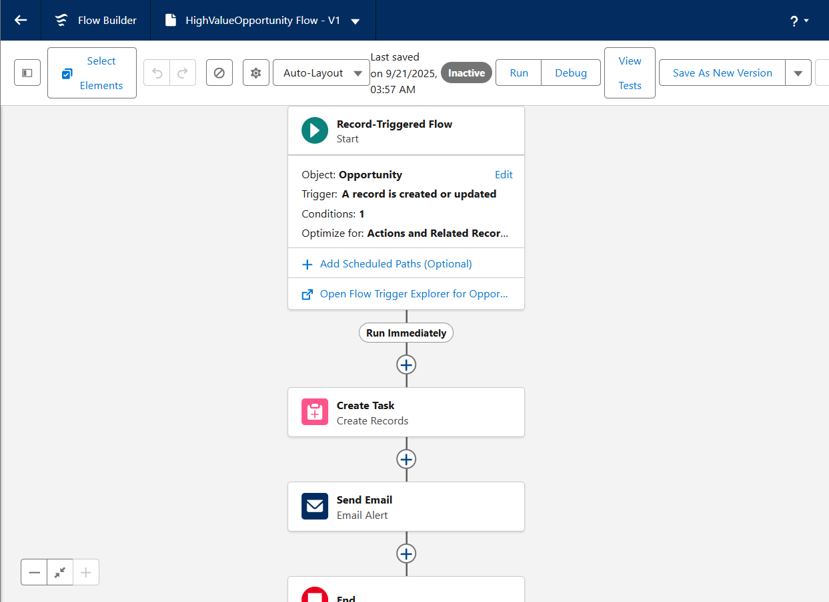

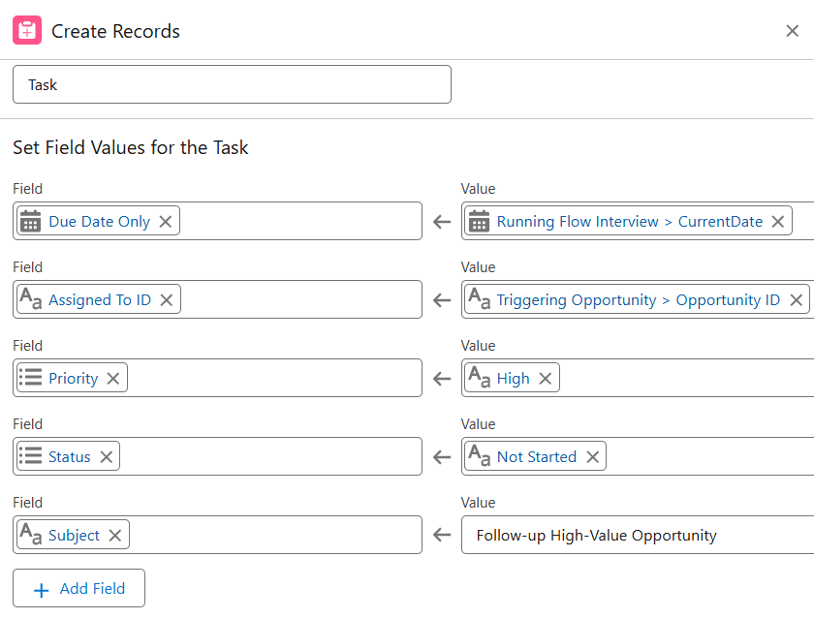

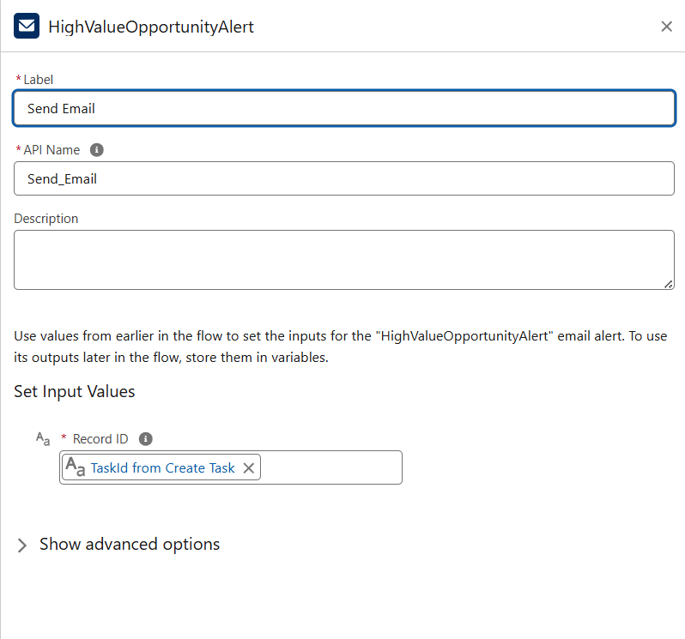

**Email Alerts**

Purpose: Notify users automatically via email.  
- Template: HighValueOpportunityAlert  
- Recipients: Opportunity Owner (mandatory), optional: Sales Manager or Role  
- Usage: Attached to Workflow Rule, Process Builder, or Flow

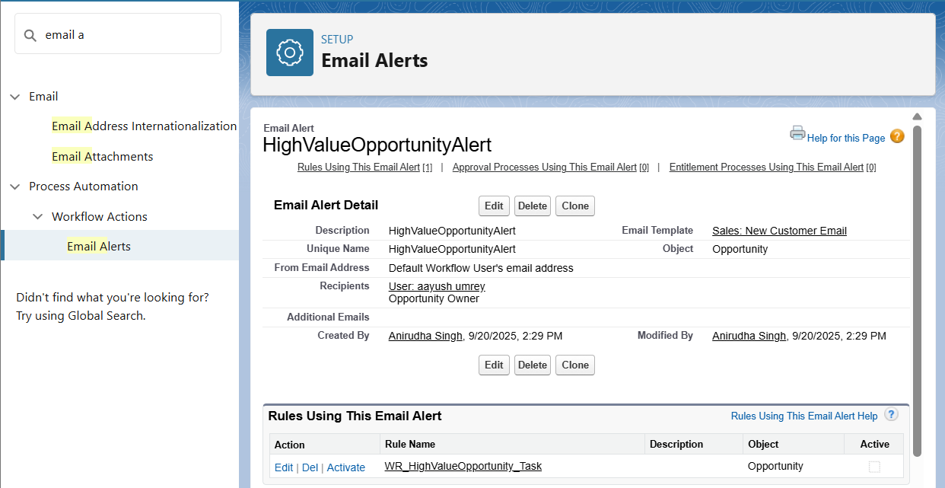

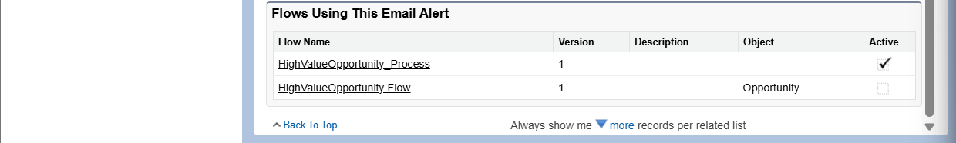

**Field Updates**

Purpose: Automatically update field values.  
- Examples:  
 • Opportunity → High_Value__c = TRUE when Amount > 100000  
 • Order → Status automatically set to Processing when submitted

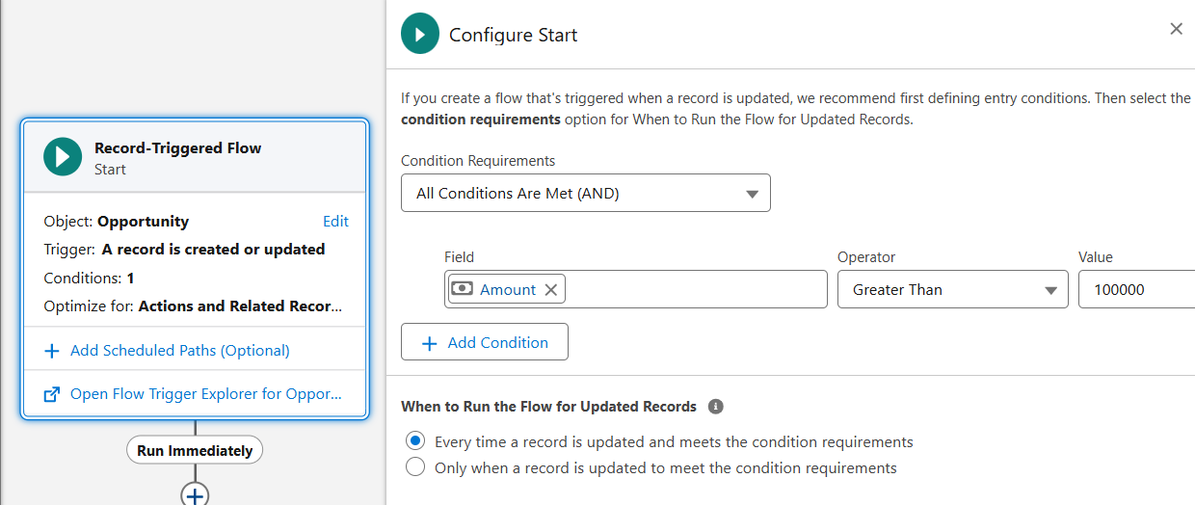

**Tasks**

Purpose: Automatically assign follow-up tasks.  
- Covered in Workflow, Process Builder, and Flow Builder examples.

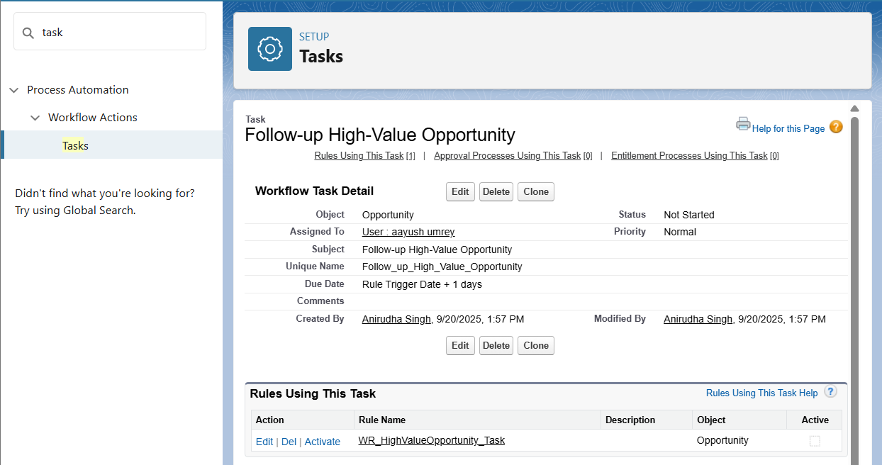

**Custom Notifications**

Purpose: Notify users in-app and via mobile for important events.  
- Example: Notify Sales Manager when a high-value order is submitted.  
- Steps:  
 • Setup → Custom Notifications → New → Name: High_Value_Order_Notification  
 • Add to Flow/Process → Action: Send Custom Notification → Recipient: Role/User → Message: “High-value order submitted: {!Order.Name}”

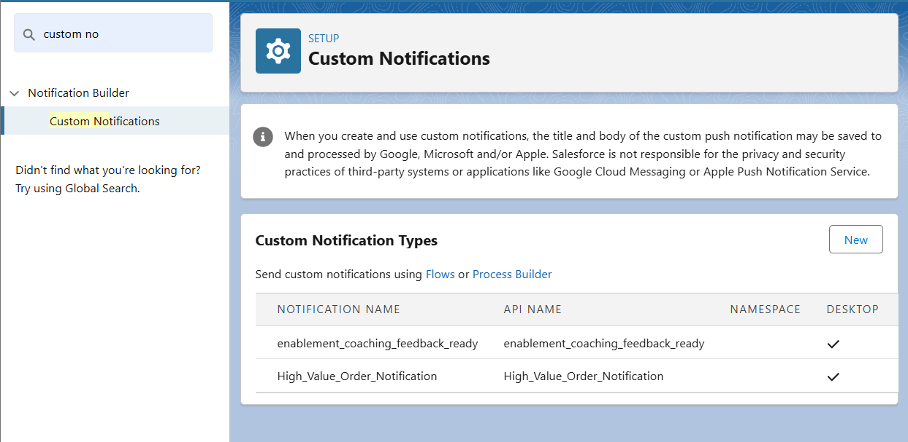  
Optional enhancements like multi-step approval or advanced recipient roles can be added later.

**Phase 5: Apex Programming (Developer)**

* **Classes & Objects**
* We created the `OrderHelper` class to calculate loyalty points using CMDT rules. This class included exception handling to avoid errors when CMDT records are missing.

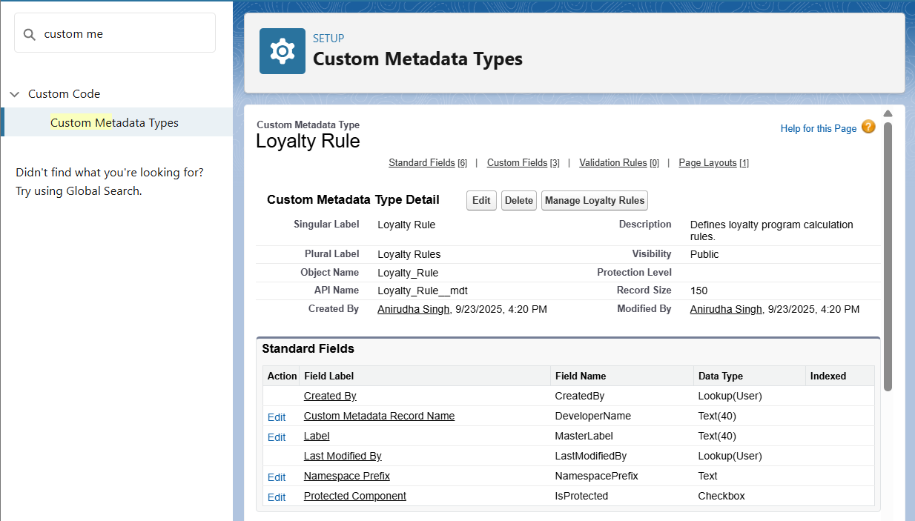

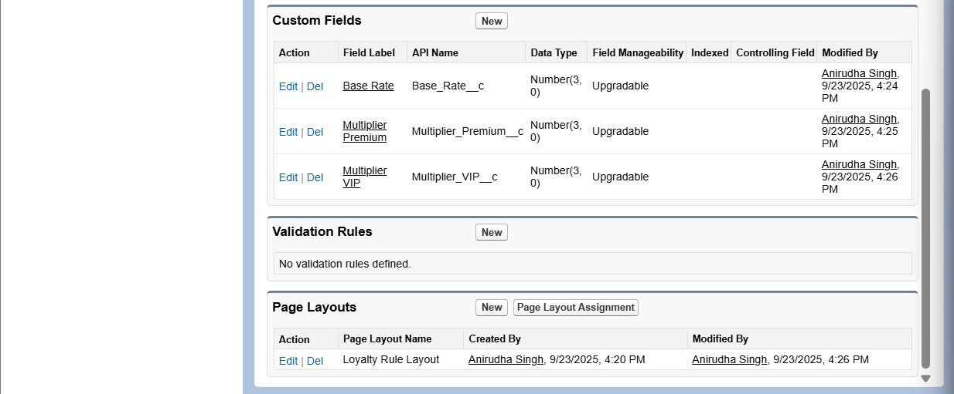

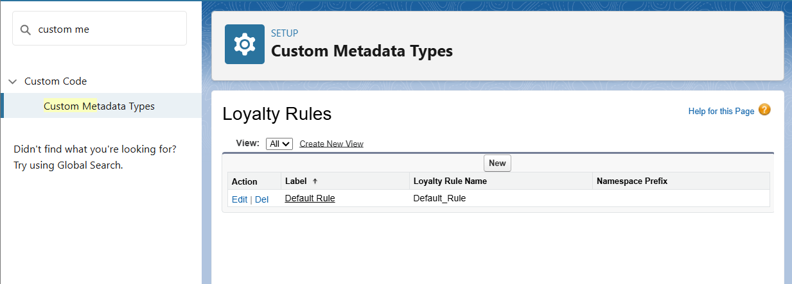

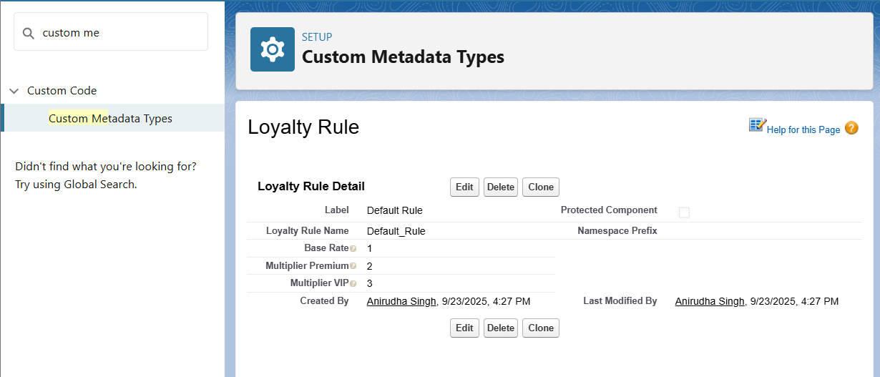

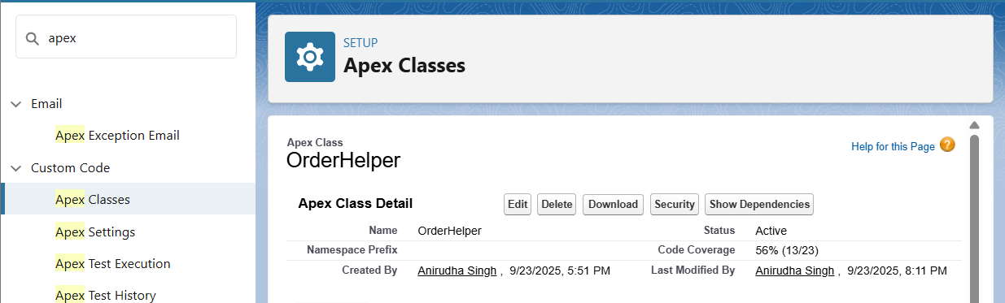

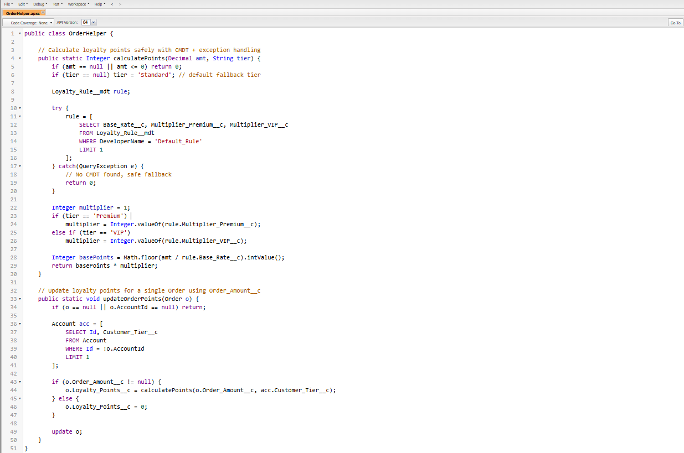

* **Apex Triggers (before/after insert/update/delete)**
* We updated the existing `OrderTrigger` to call the `OrderTriggerHandler` class. This ensures loyalty points are calculated automatically whenever an Order is inserted or updated.

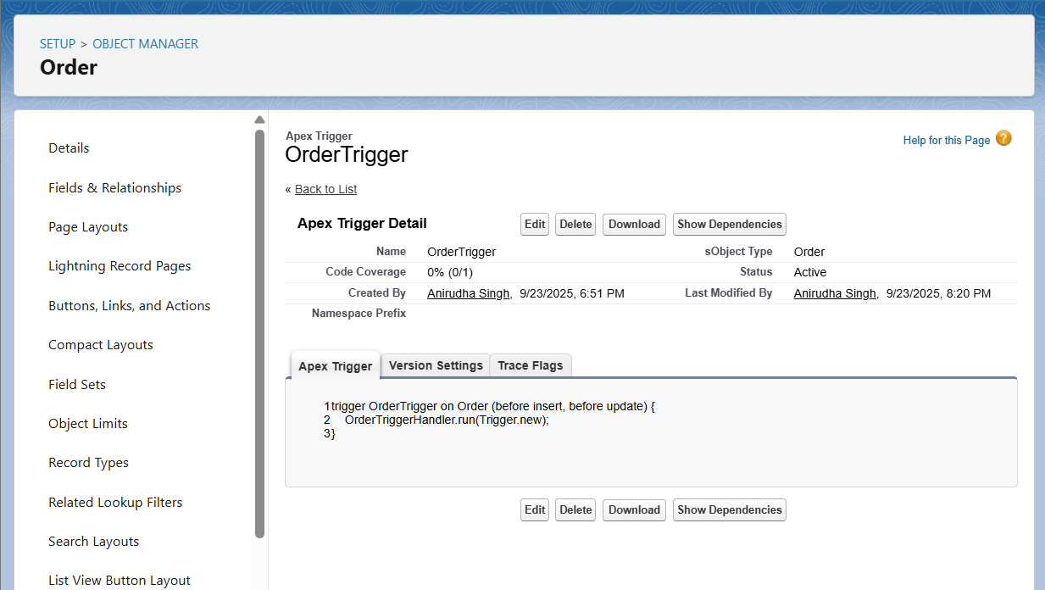

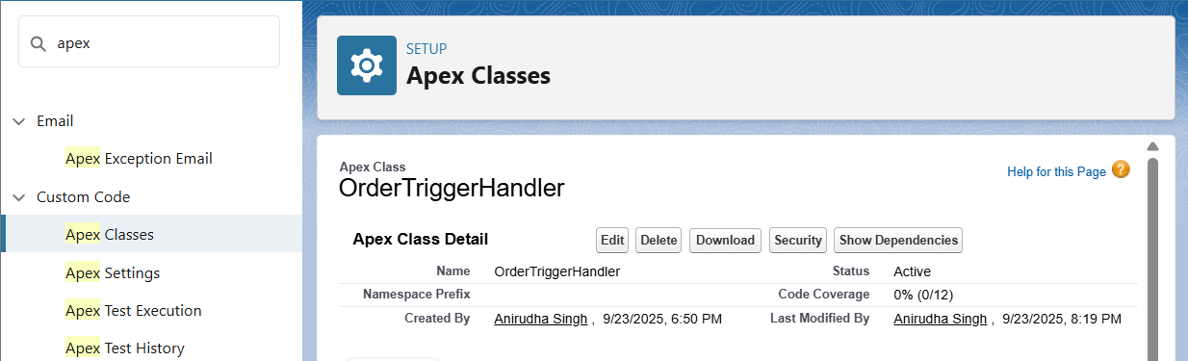

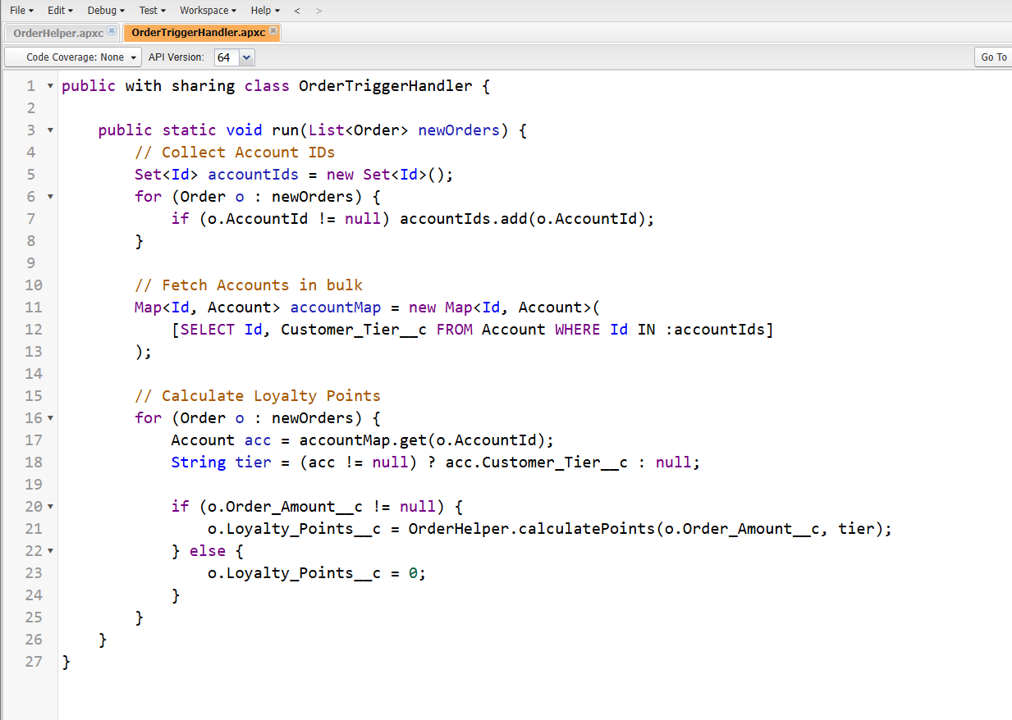

* **Trigger Design Pattern**
* We implemented the Trigger Handler pattern by creating `OrderTriggerHandler`. This separates trigger logic from the trigger itself and keeps the code bulk-safe.

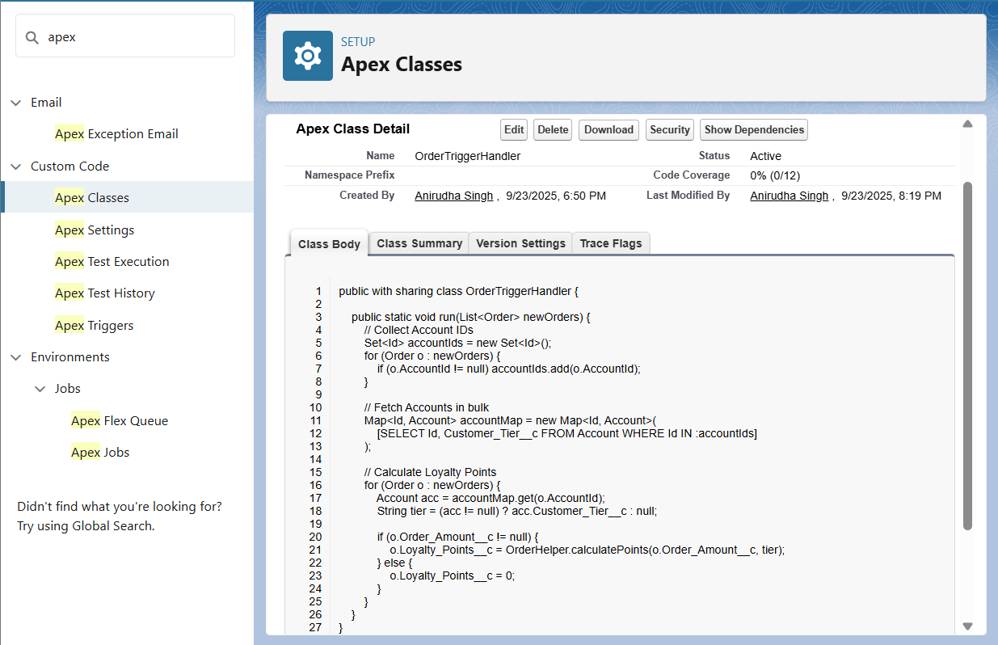

* **SOQL & SOSL**
* We used SOQL queries in both `OrderHelper` and `OrderTriggerHandler` to fetch Account details and CMDT records.





* **Collections: List, Set, Map**
* We used Sets to collect Account Ids and Maps to link Accounts to Orders in bulk processing. Lists were used for inserting and updating records.
* **Control Statements**
* We used If/Else statements to handle tier-based multipliers (Standard, Premium, VIP) in the `OrderHelper` class.



* **Batch Apex**
* We created the `RecalculateOrderPointsBatch` class to recalculate loyalty points for all Orders in bulk. This ensures points remain consistent across many records.

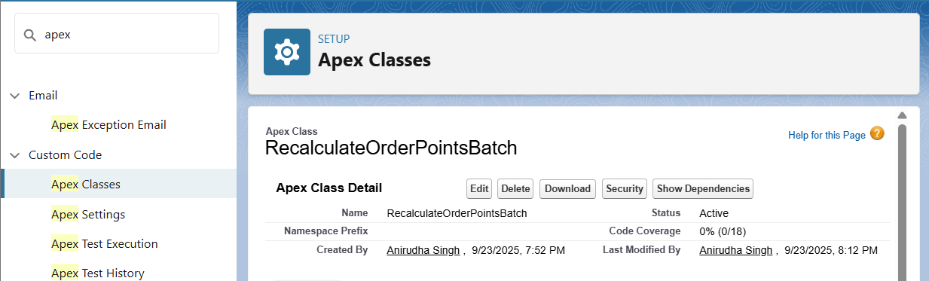

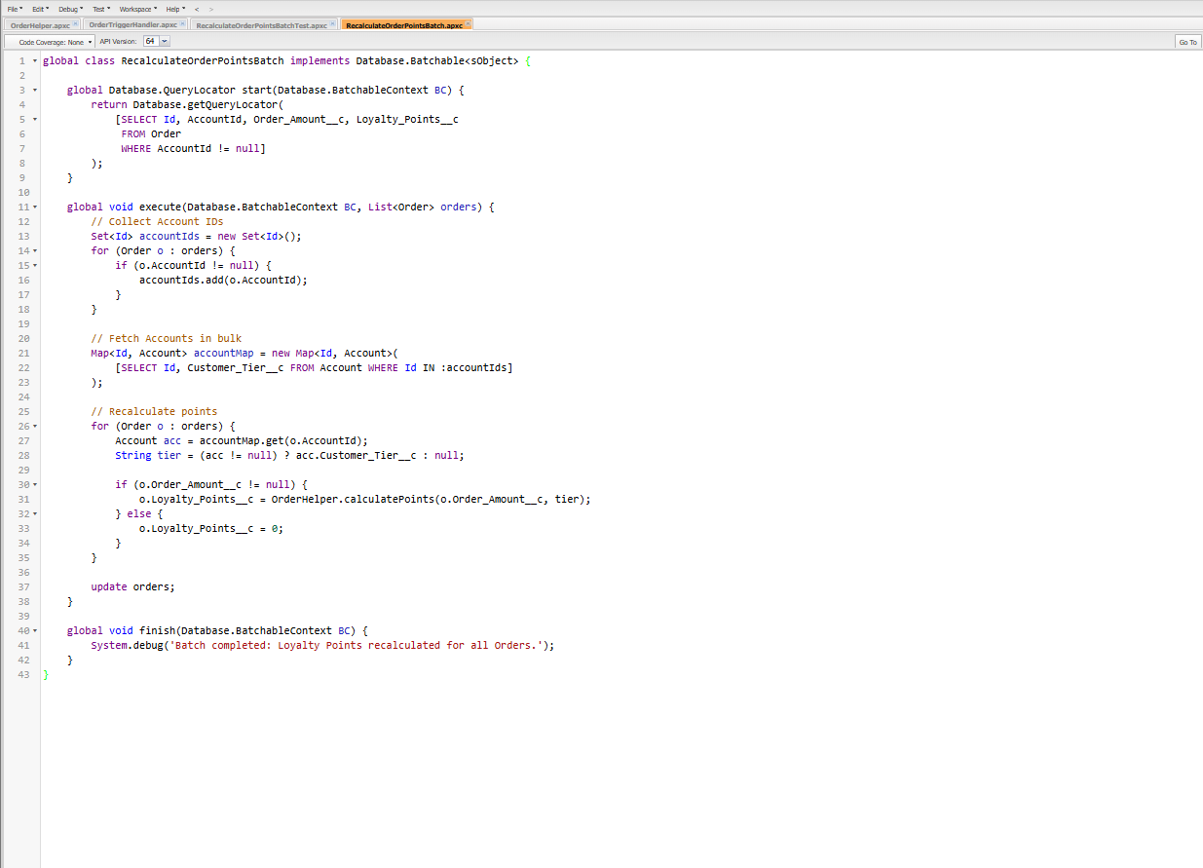

* **Queueable Apex**
* We skipped Queueable Apex as Batch Apex already handles bulk asynchronous processing for our use case.
* **Scheduled Apex**
* We created the `ScheduledOrderPoints` class which runs the batch job nightly. This keeps loyalty points updated automatically without manual intervention.

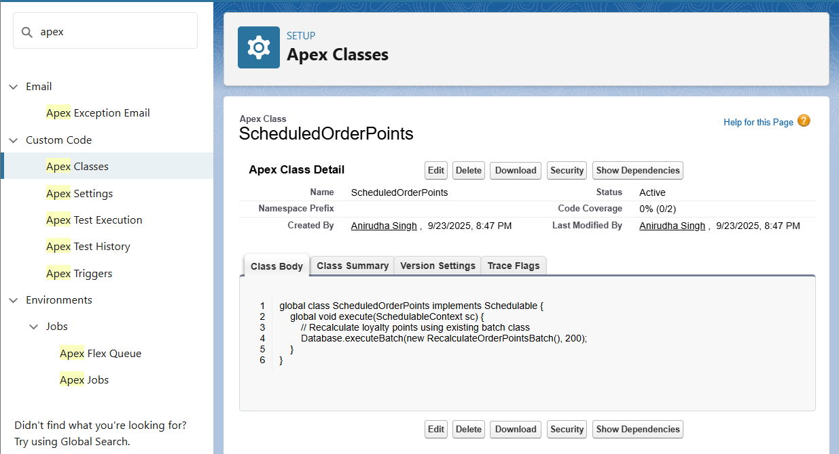

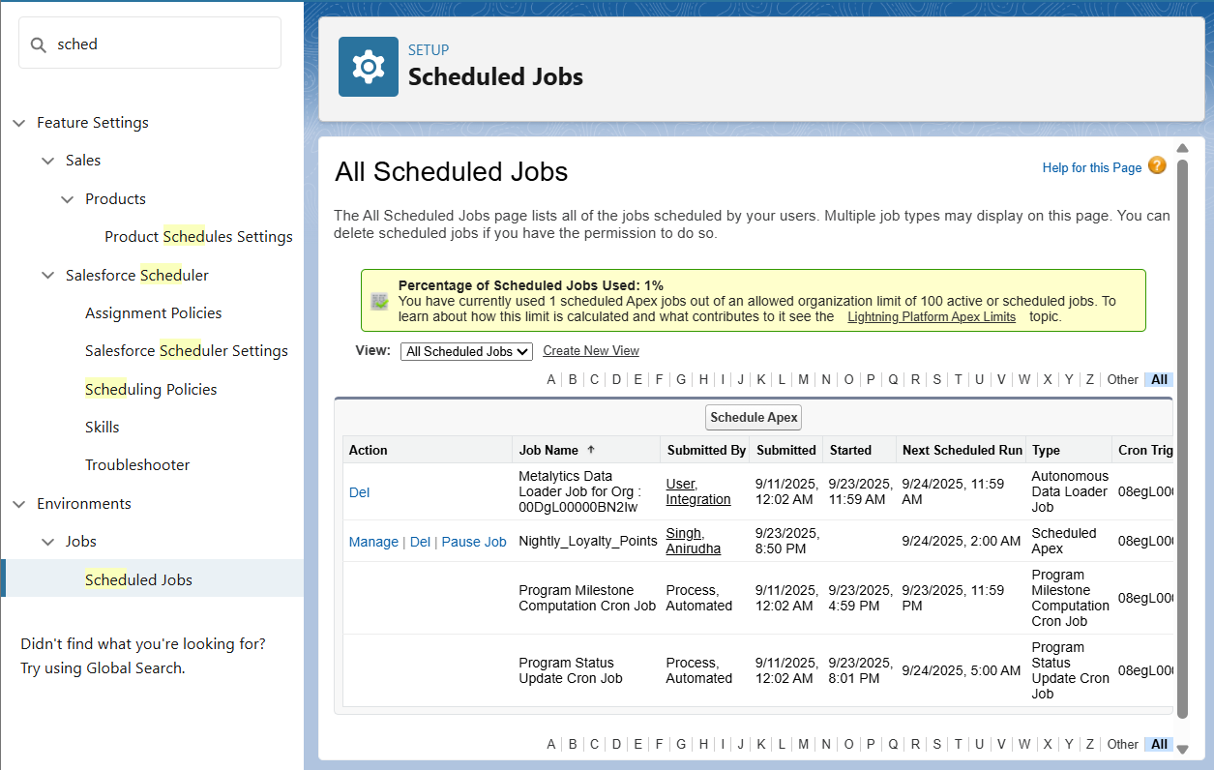

* **Future Methods**
* We skipped Future Methods since our project does not involve external callouts or async operations requiring them.
* **Exception Handling**
* Exception handling was implemented in the `OrderHelper` class to gracefully handle missing CMDT records.



* **Test Classes**
* We created a unit test class `OrderHelperTest`, which passed successfully. Tests for Trigger, Bulk Trigger, Batch, scheduled were also made and tested.

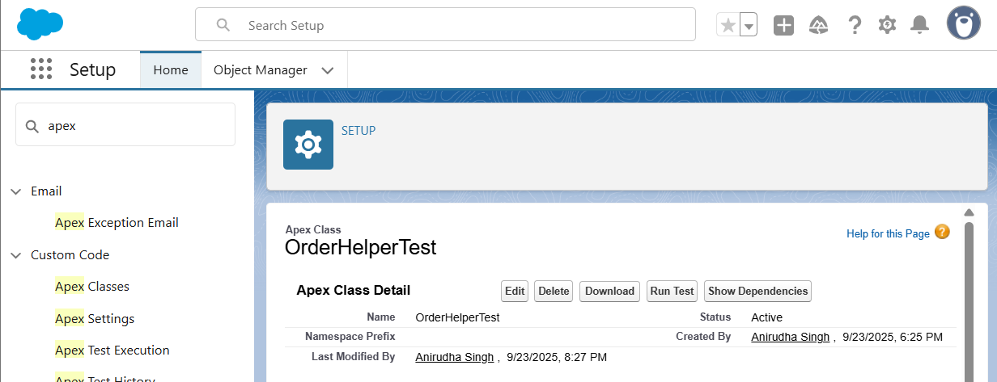

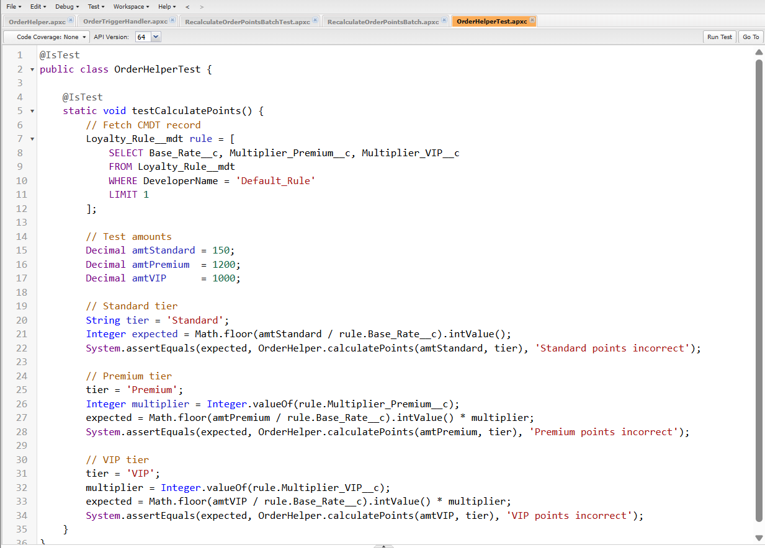

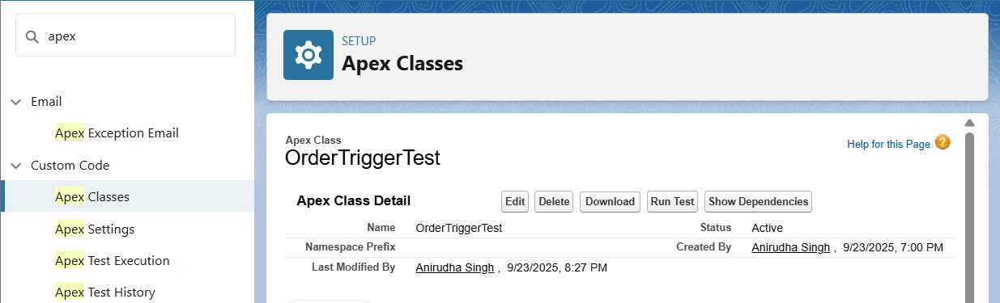

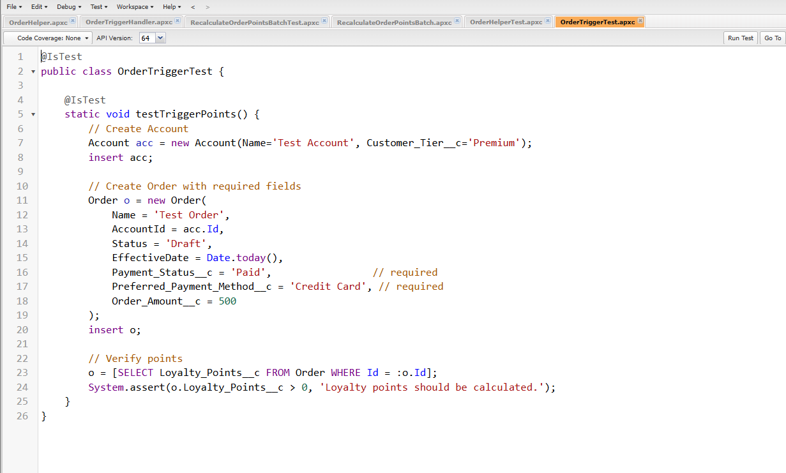

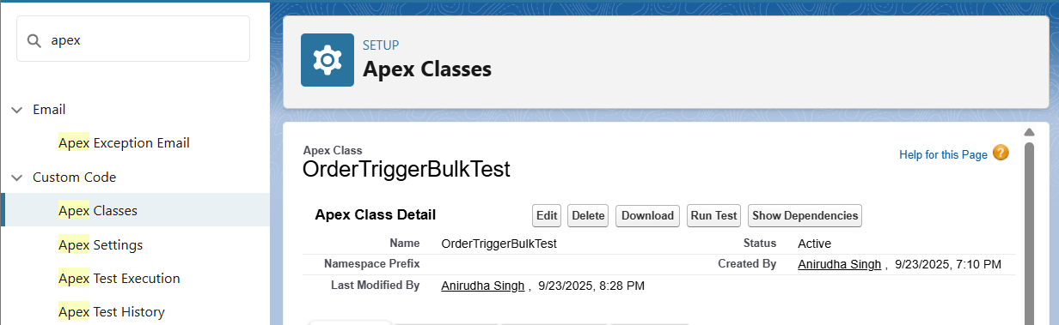

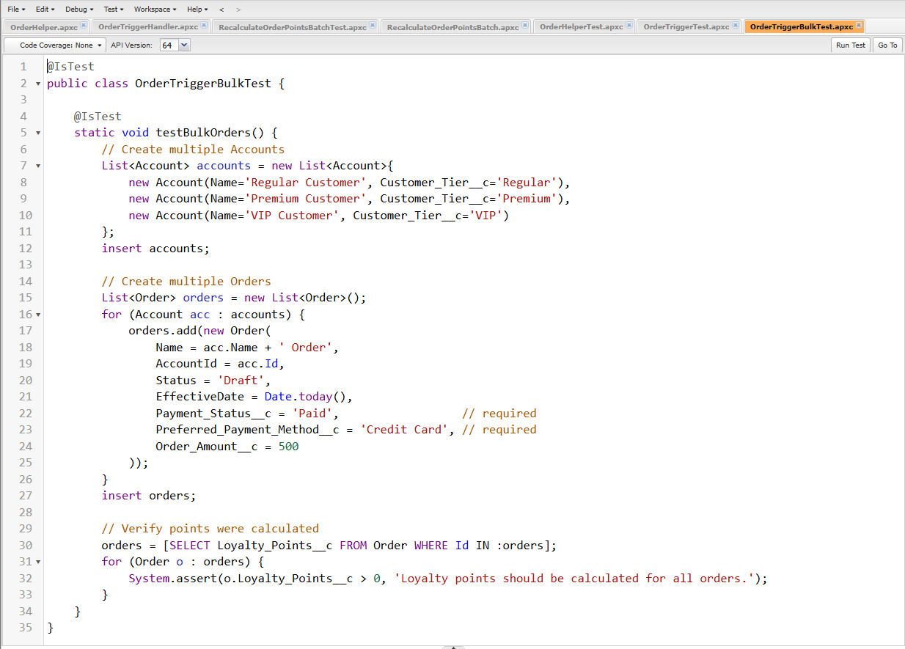

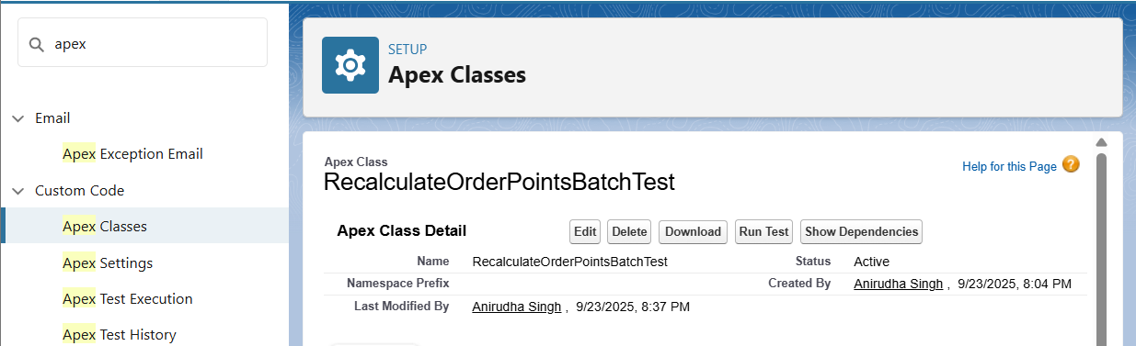

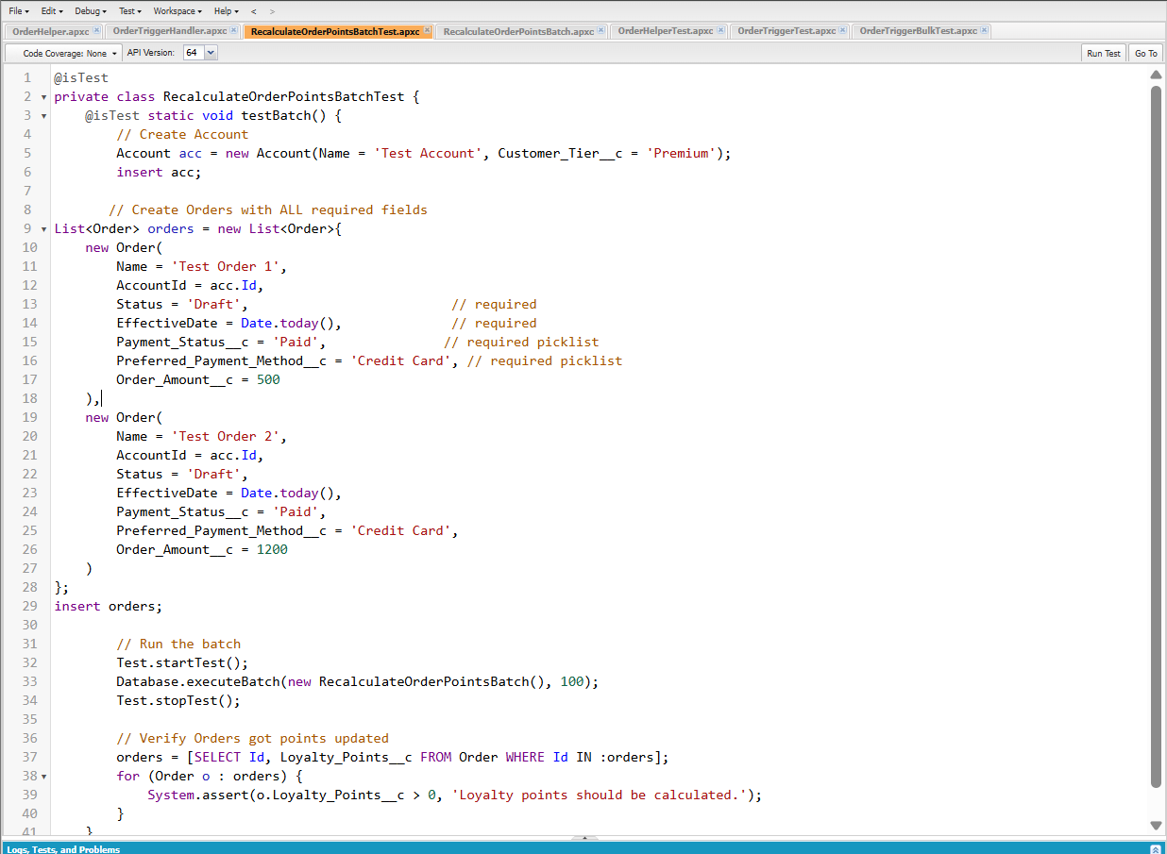

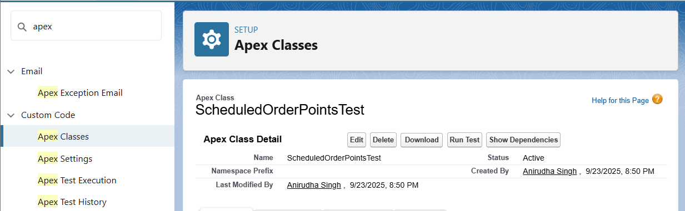

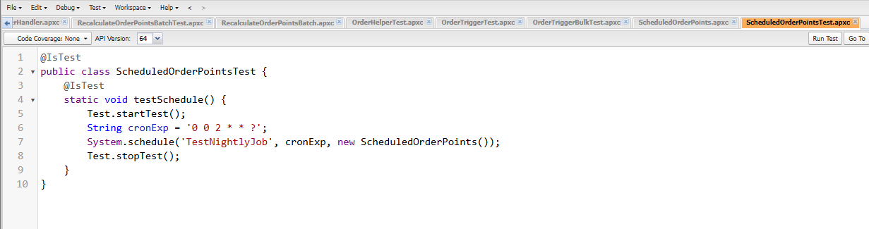

* **Asynchronous Processing**
* We implemented asynchronous processing using Batch Apex and Scheduled Apex. Other async options like Queueable and Future were skipped as not required for our project scope.

**Phase 6: User Interface Development**

**Lightning App Builder**

Created the ShopSmart App in App Manager. Configured branding, navigation, and utility bar. Assigned to administrator profile.

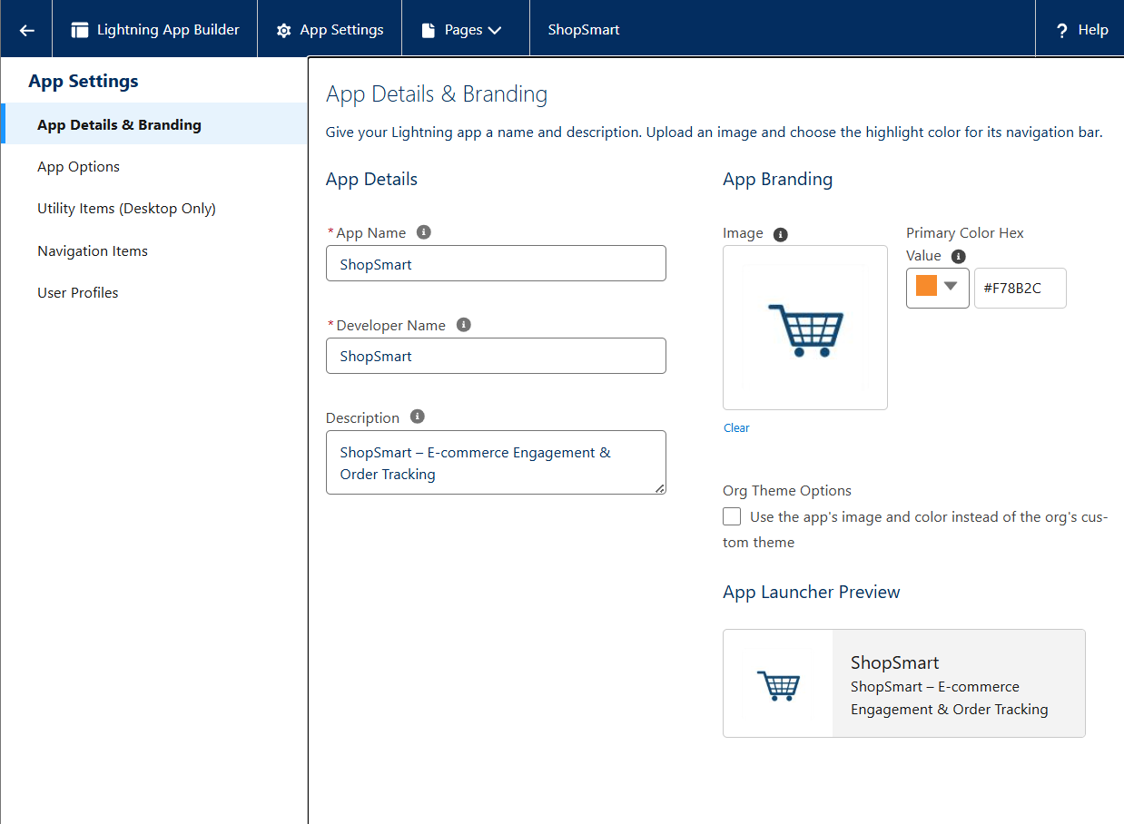

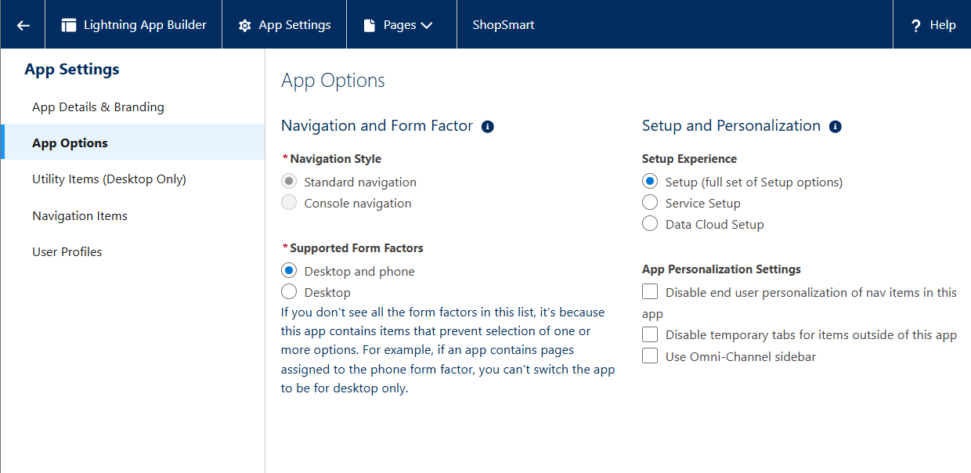

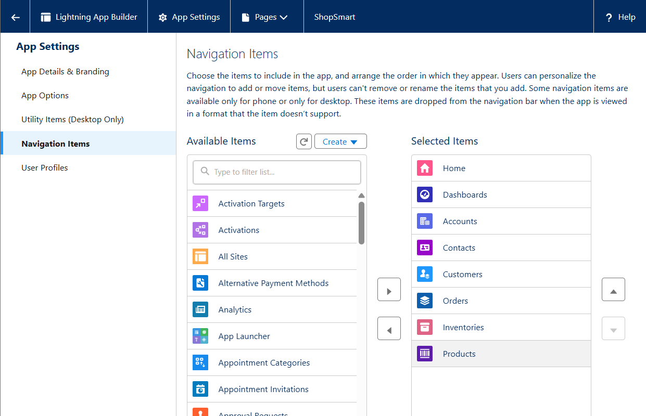

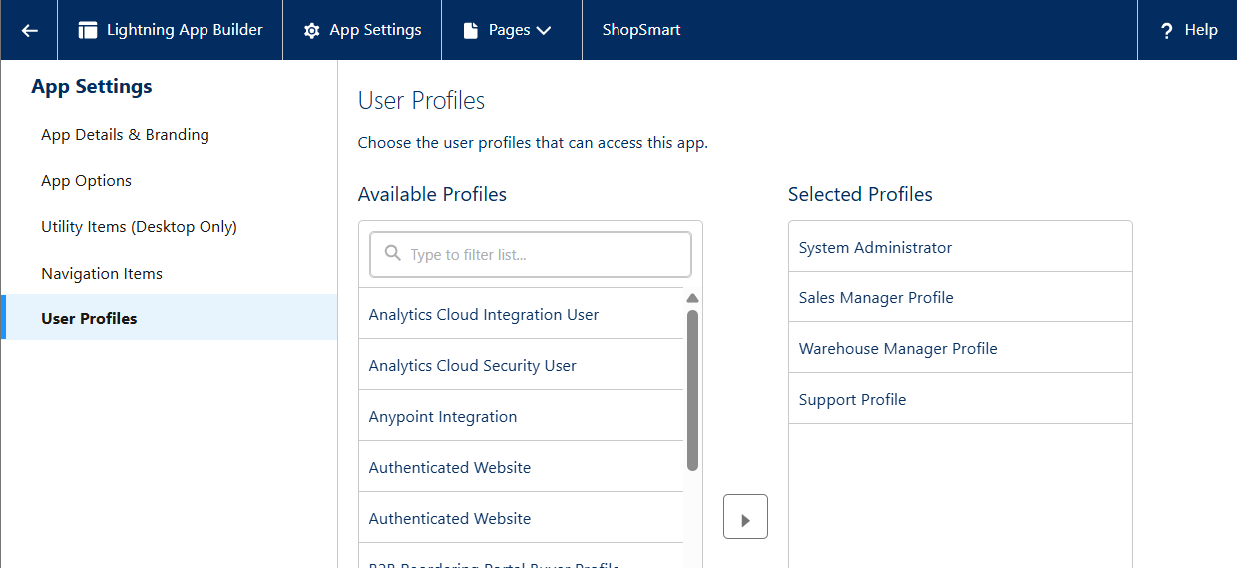

**Record Pages**

Custom record pages built for Orders, Products, and Customers. Added Highlights Panel, Record Detail, and Related Lists components.

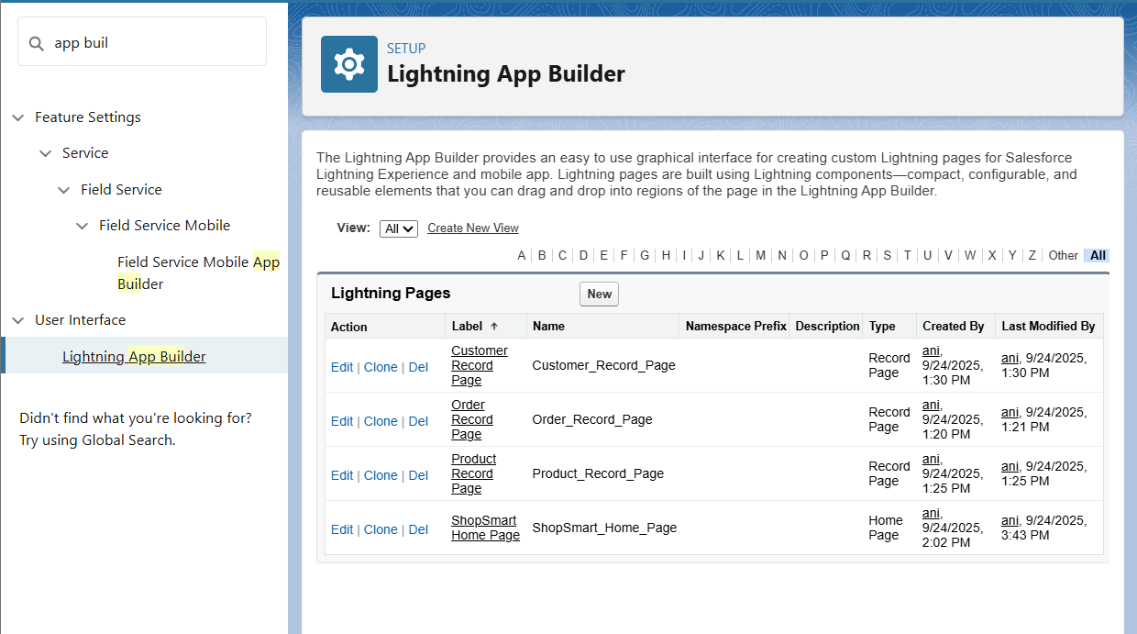

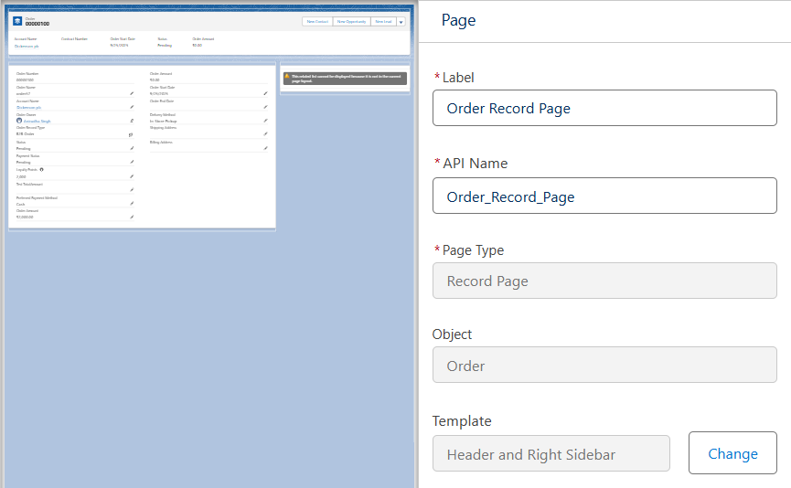

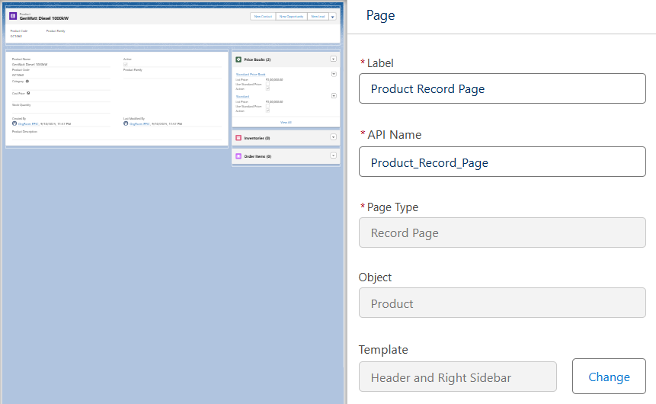

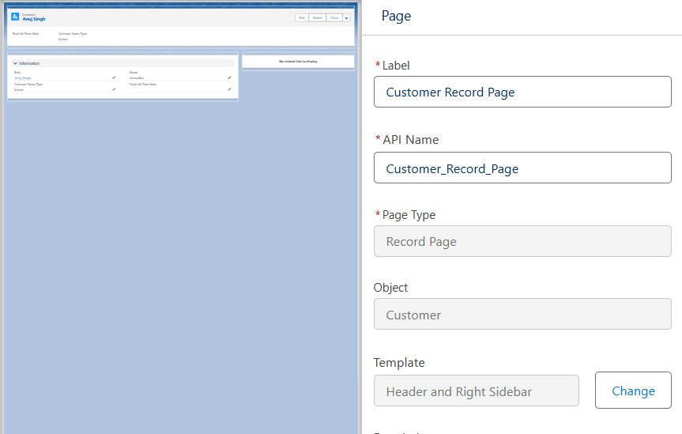

**Tabs**

Tabs created/verified for Orders, Products, Customers. Added existing tabs like Inventories and Order Items into ShopSmart app navigation.  
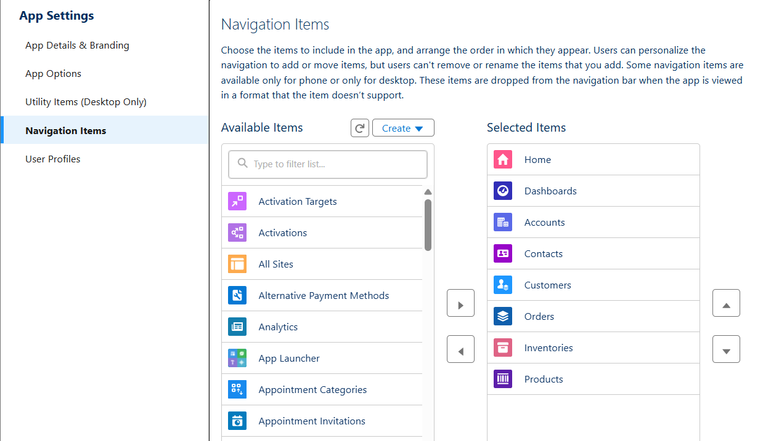



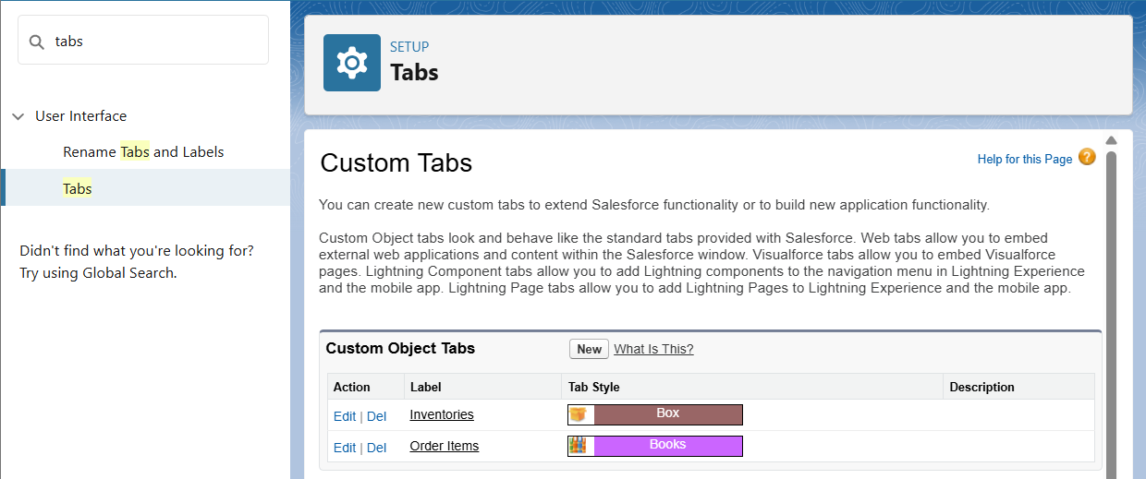

**Home Page Layouts**

Designed custom Home Page using Lightning App Builder with Report Charts, List Views, Rich Text (welcome message), and Dashboard components.  


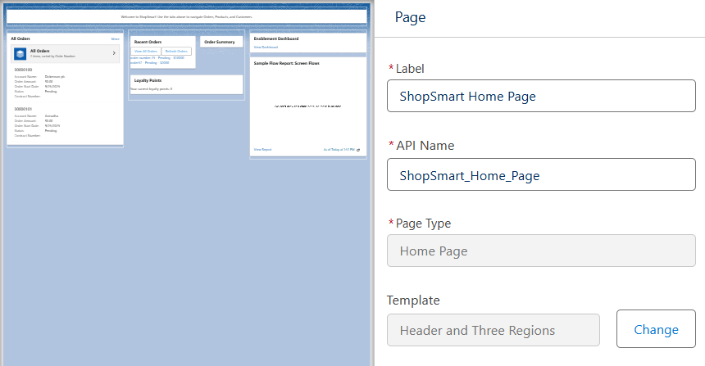

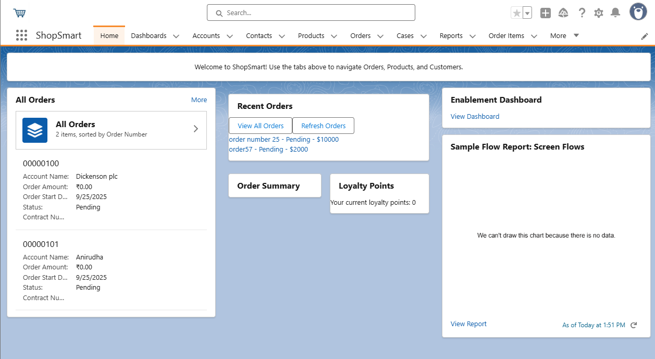

**Utility Bar**

Configured Utility Bar with quick access to Recent Items, Notes, List Views, and Report Charts.

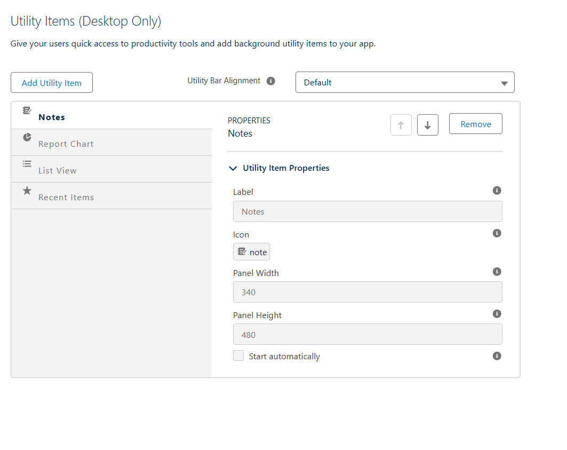  
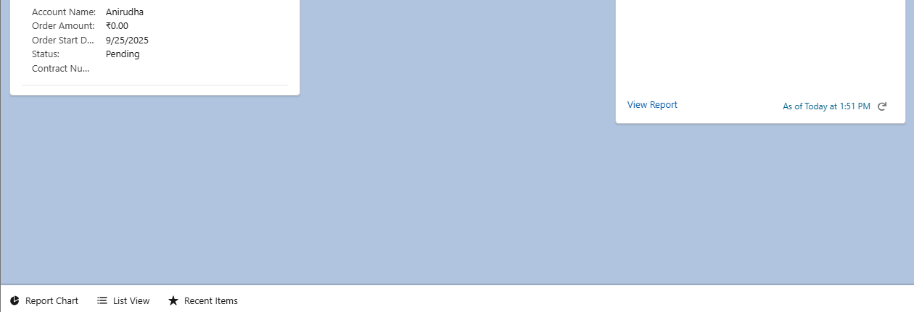

**LWC (Lightning Web Components)**

Developed LWCs: recentOrders, orderSummary, loyaltyPoints. Purpose: Display recent orders, inline summaries, and loyalty points.

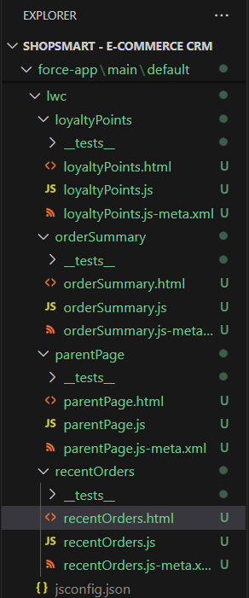

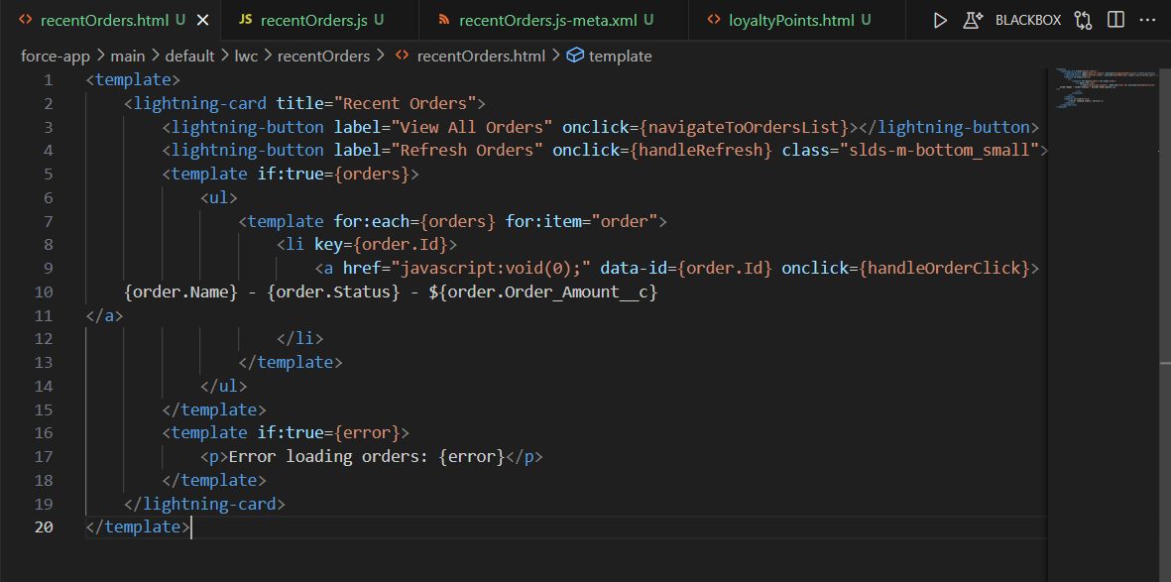

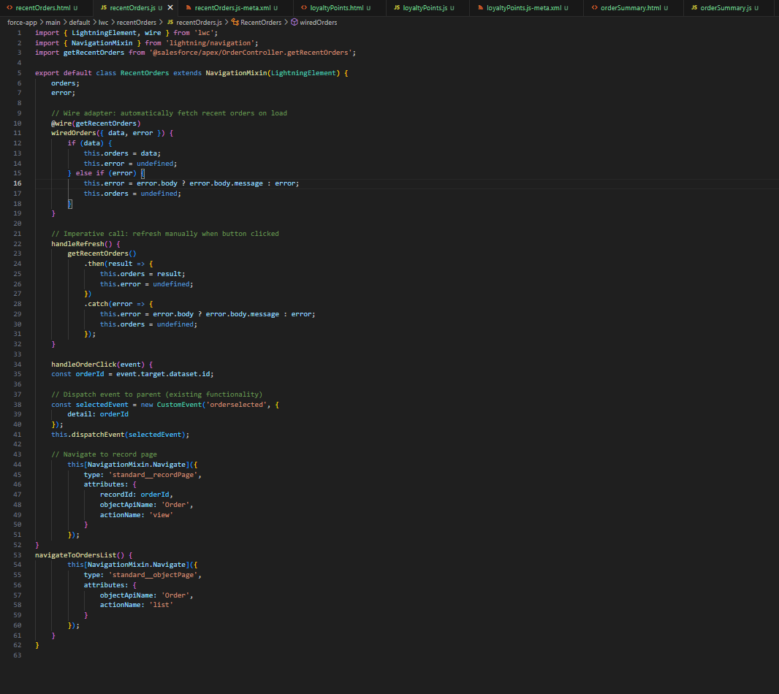

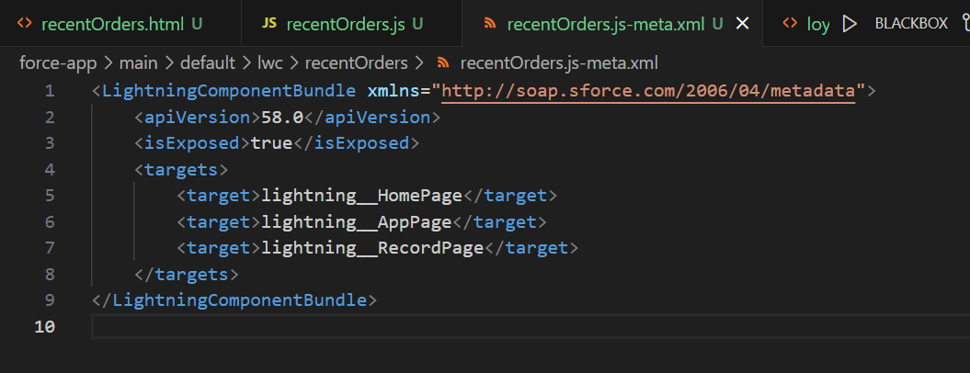

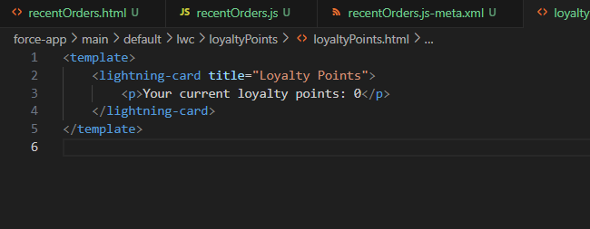

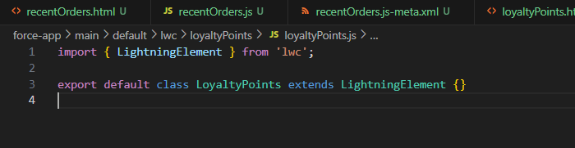

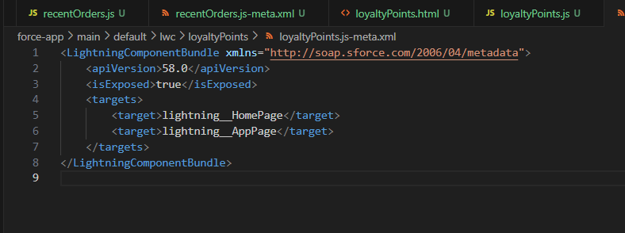

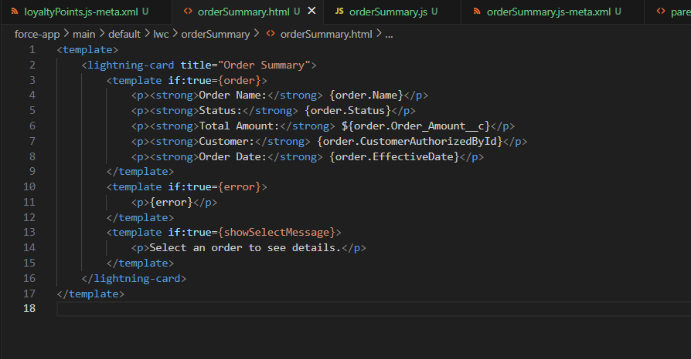

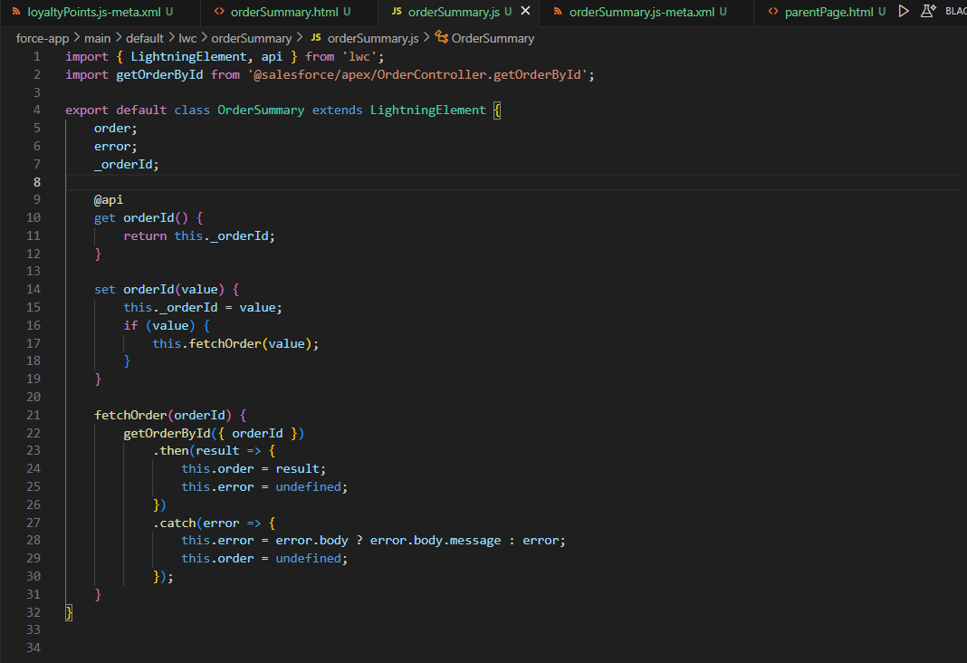

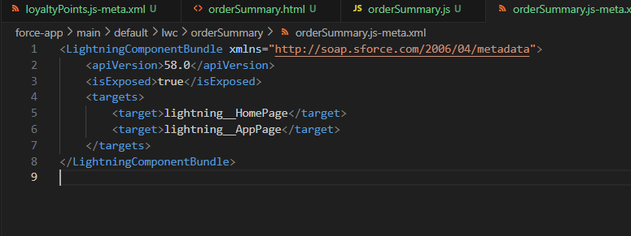

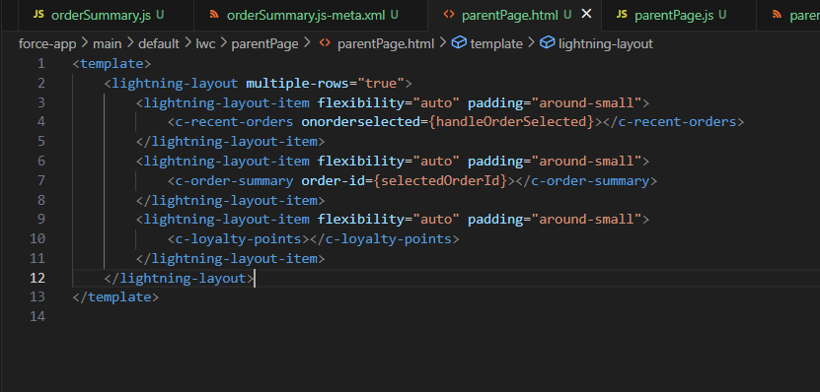

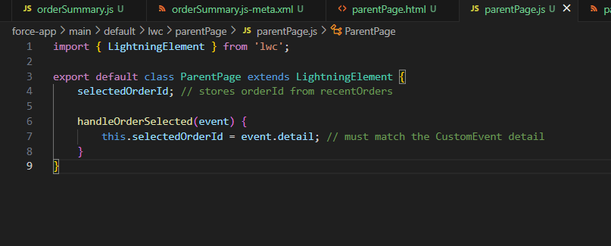

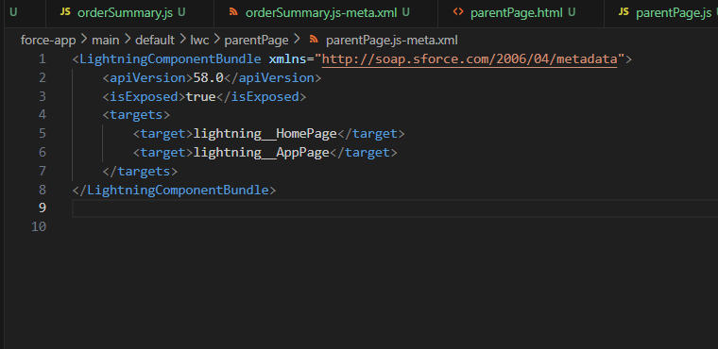

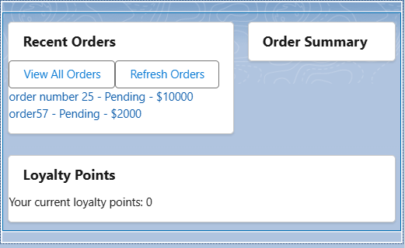

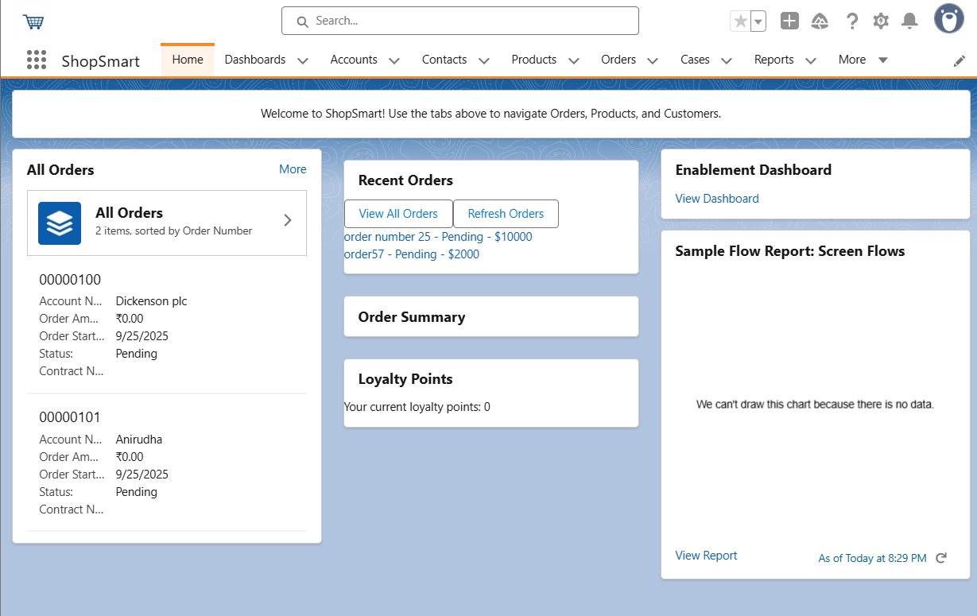

**Apex with LWC**

Created Apex class OrderController for retrieving recent orders and order details. Integrated LWCs with Apex using @wire and imperative calls.  
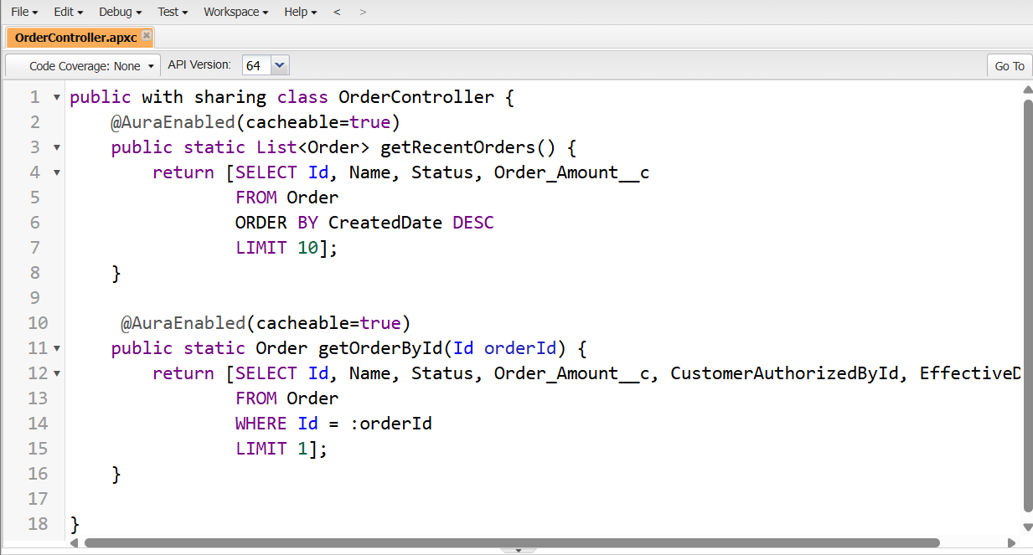

**Events in LWC**

Implemented CustomEvent communication: recentOrders dispatches 'orderselected', parentPage receives and passes orderId to orderSummary.  






**Wire Adapters**

Used @wire for reactive data loading in recentOrders. Ensures recent orders automatically display on load.



**Imperative Apex Calls**

Added imperative Apex calls to refresh data on demand, e.g. refresh button in recentOrders, order detail fetch in orderSummary.  


**Navigation Service**

Added NavigationMixin in recentOrders to navigate directly to record pages, list views, or external URLs.  


**Phase 7: Integration & External Access**

This document outlines the integration steps for the ShopSmart project, detailing configurations and providing placeholders for relevant screenshots.

**1. Named Credentials**

**Description:**  
 Named Credentials securely store authentication and endpoint information for external APIs, simplifying callouts.

**Configuration:**

* **Name:** LogisticsAPI
* **URL:** https://api.logistics.com
* **Identity Type:** Named Principal
* **Authentication Protocol:** OAuth 2.0
* **Authentication Provider:** ShopSmartAuthProvider
* **Scope:** read write

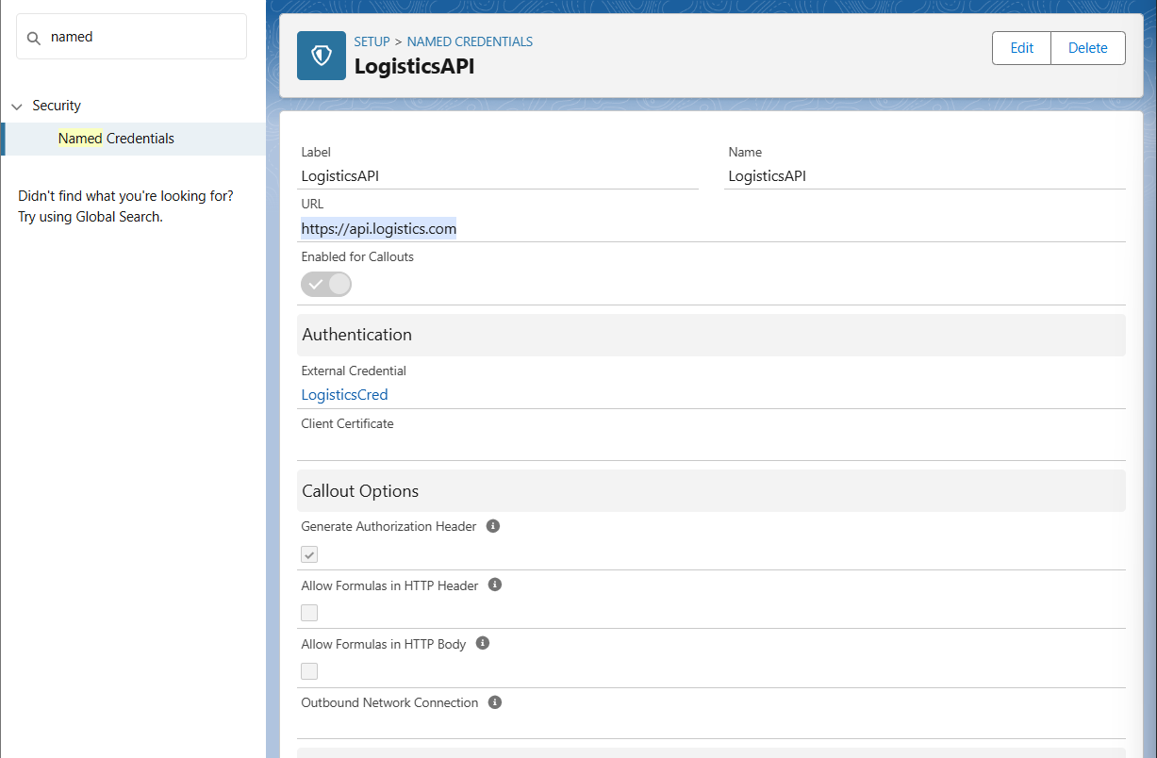

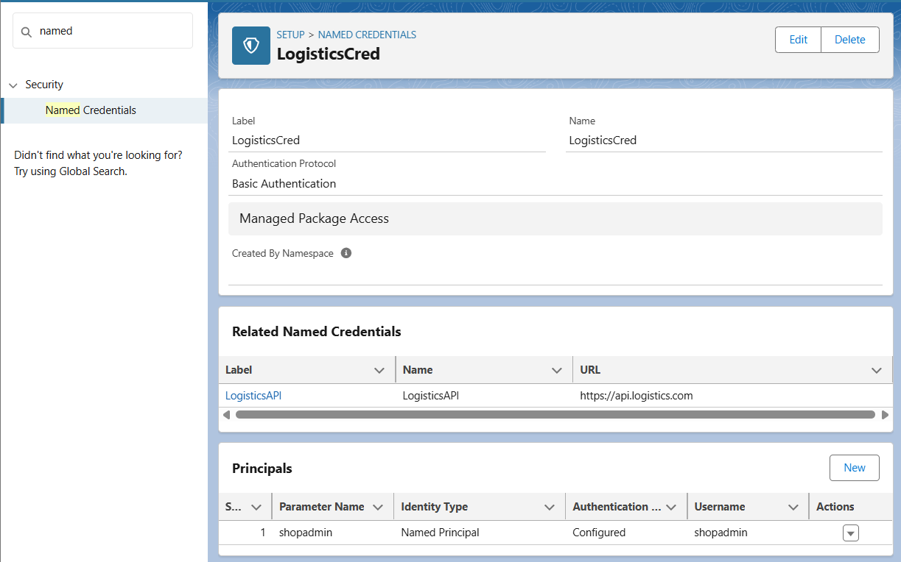

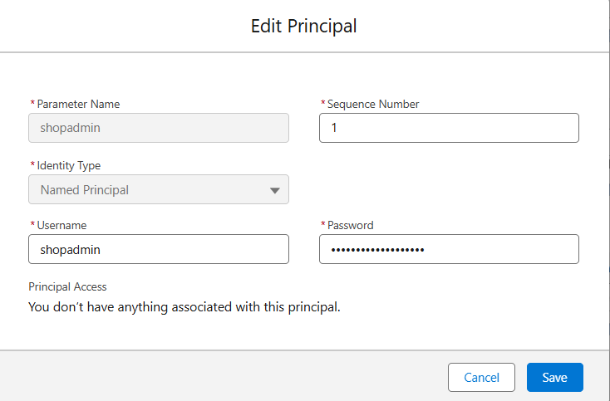

**2. External Services**

**Description:**  
 External Services allow Salesforce to connect to external APIs by importing their OpenAPI 2.0 schemas.

**Configuration:**

* **API Schema:** Imported from <https://api.shopsmart.com/openapi.json>
* **Operations Registered: All**

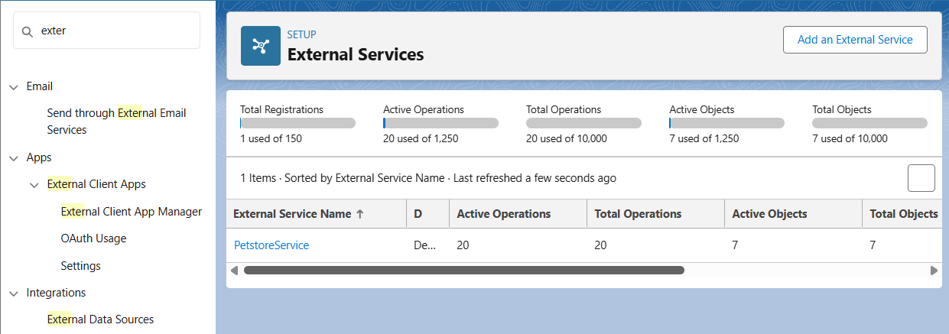

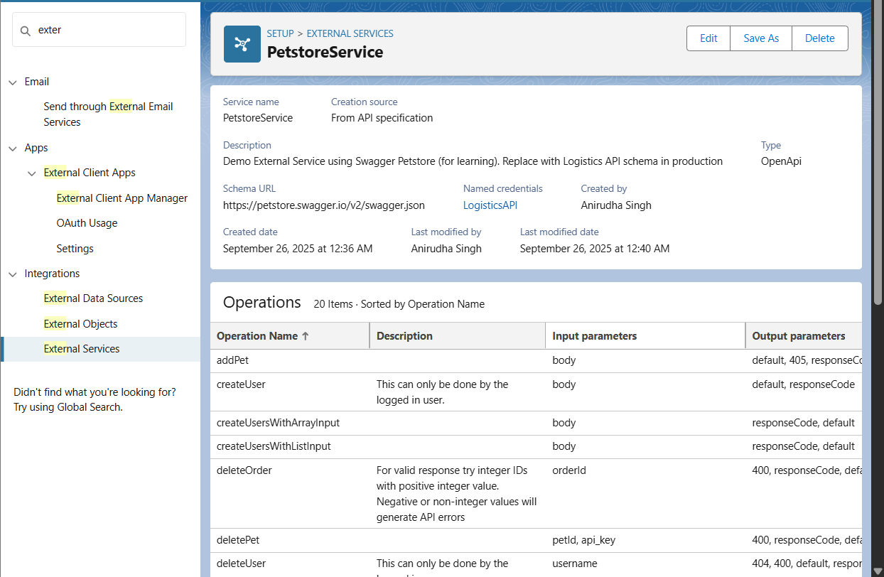

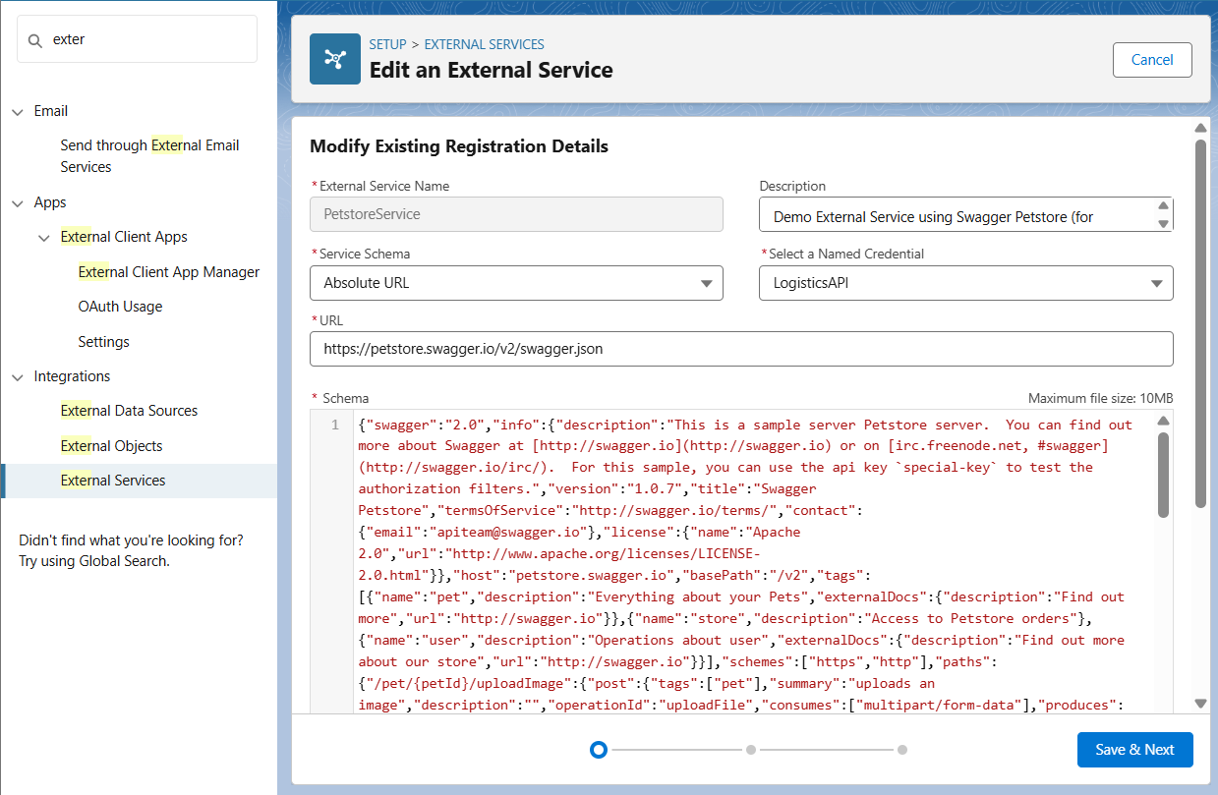

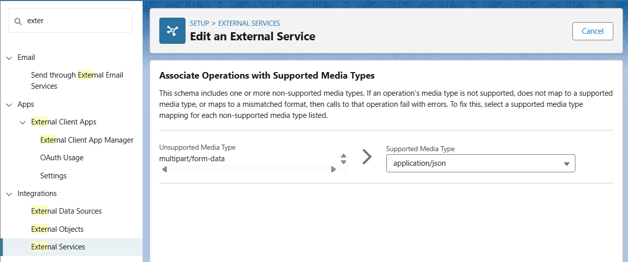

**3. Web Services (REST/SOAP)**

**Description:**  
 Salesforce can expose its own APIs to external systems or call external APIs using REST or SOAP protocols.

**Configuration (REST Example):**

* **Apex Class:** ShopSmartREST
* **URL Mapping:** /ShopSmartOrders/*
* **HTTP Methods:** @HttpGet, @HttpPost
* **Logic:** Handles order retrieval and creation using Apex.

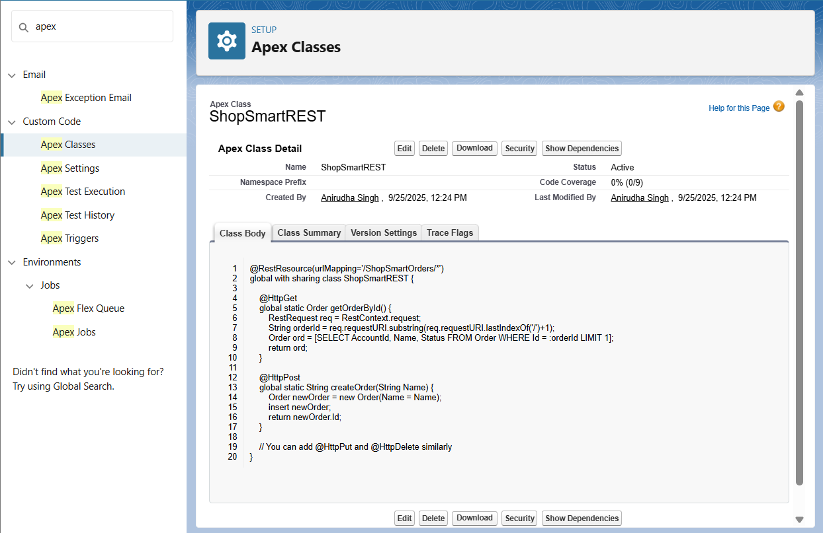

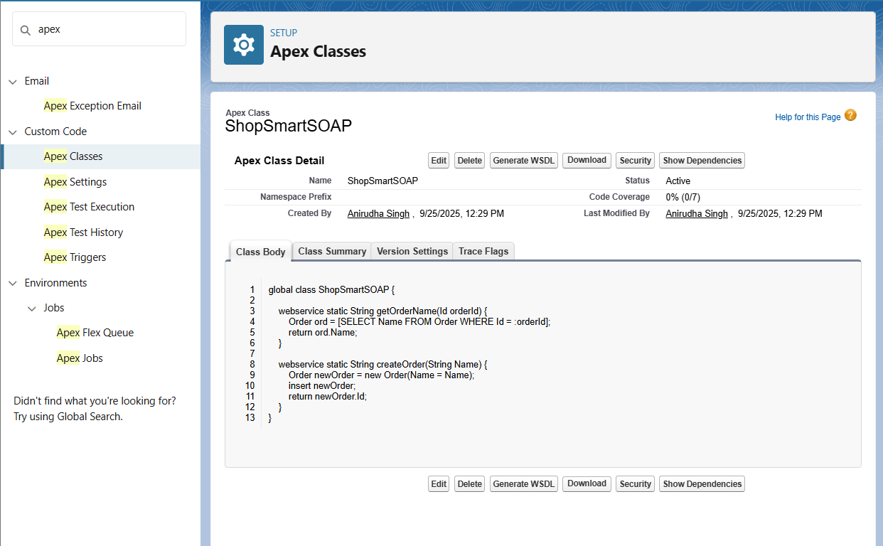

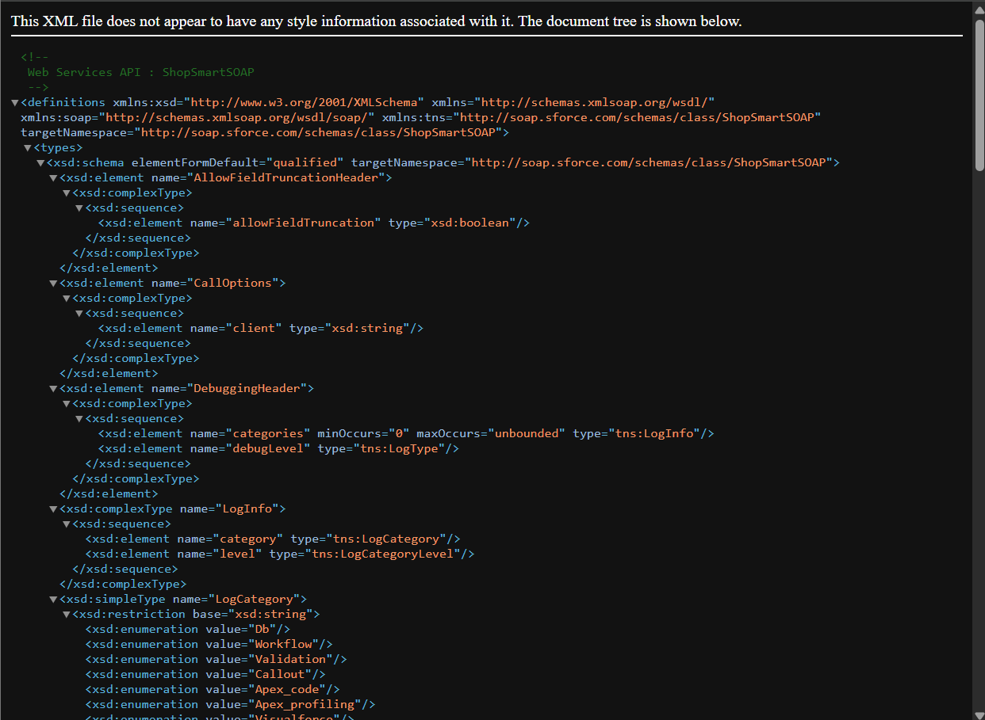

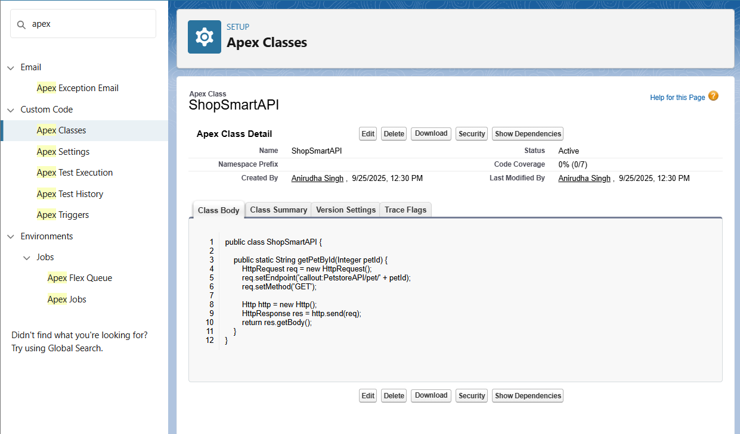

**4. Callouts**

**Description:**  
 Apex or Flow callouts enable Salesforce to send or receive data from external APIs.

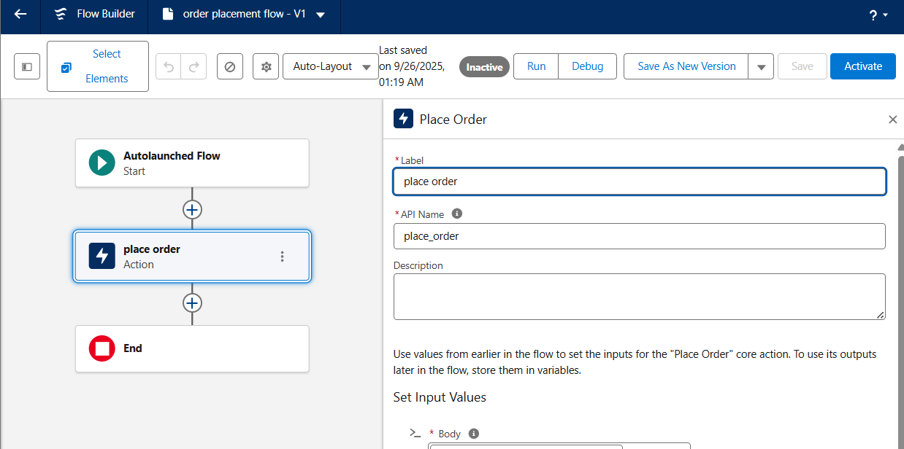

**5. Platform Events**

**Description:**  
 Platform Events facilitate real-time communication between Salesforce and external systems.

**Configuration:**

* **Event Name:** OrderEvent__e
* **Fields:**
  + OrderId__c
  + CustomerName__c
  + Amount__c
* **Trigger:** OrderEventTrigger

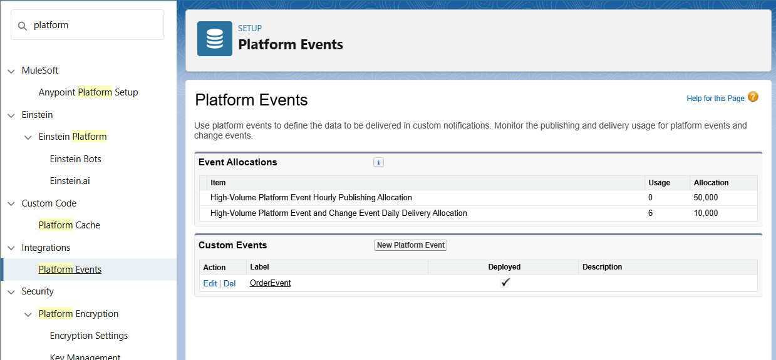

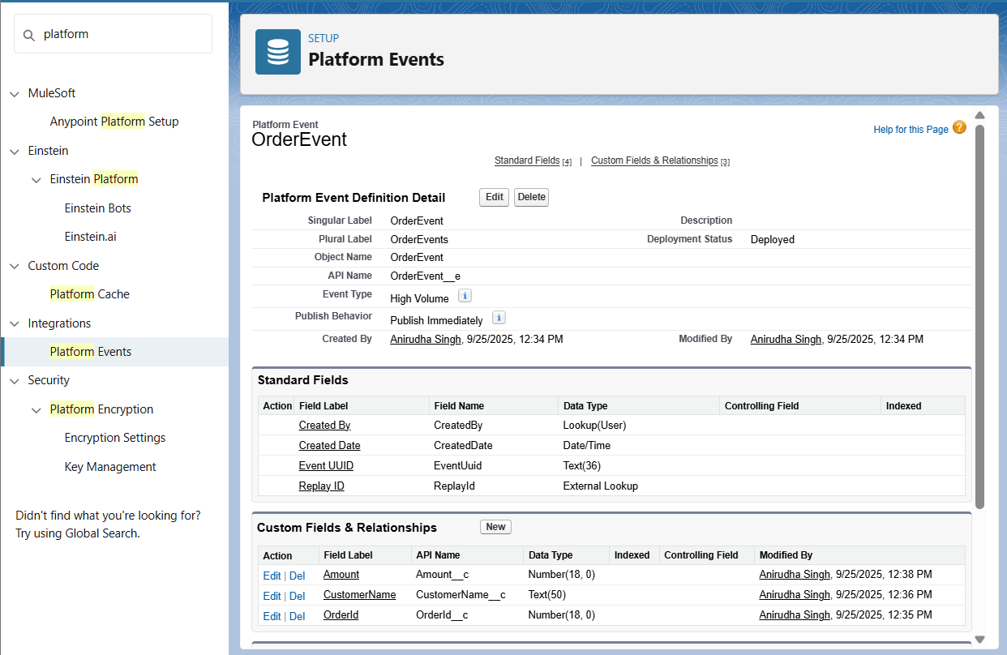

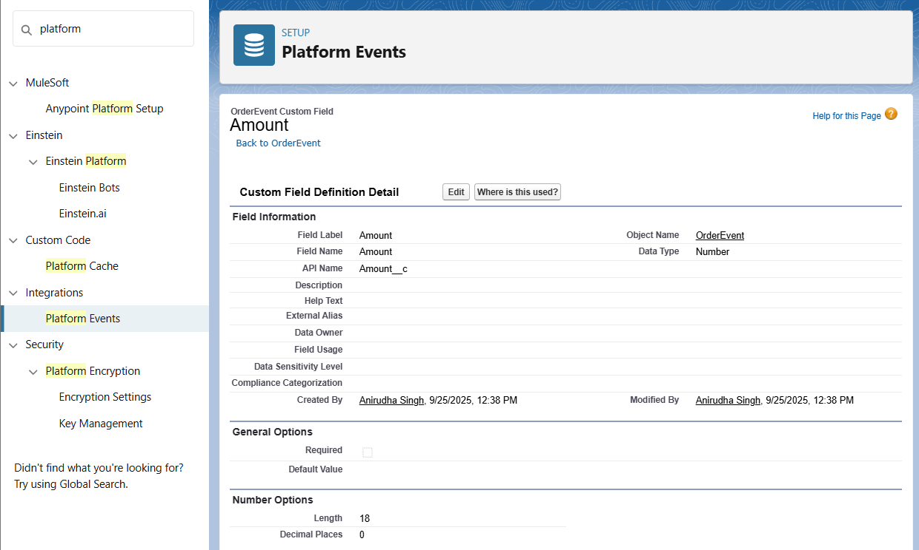

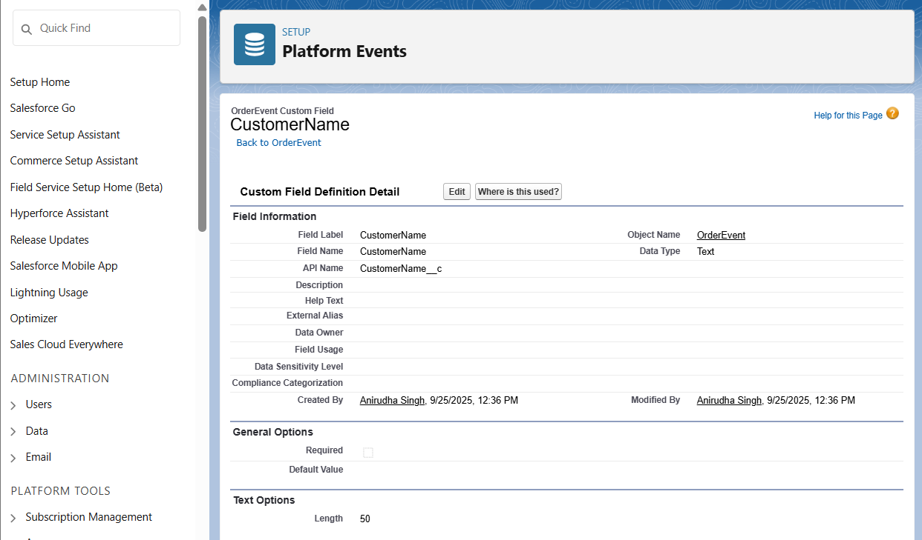

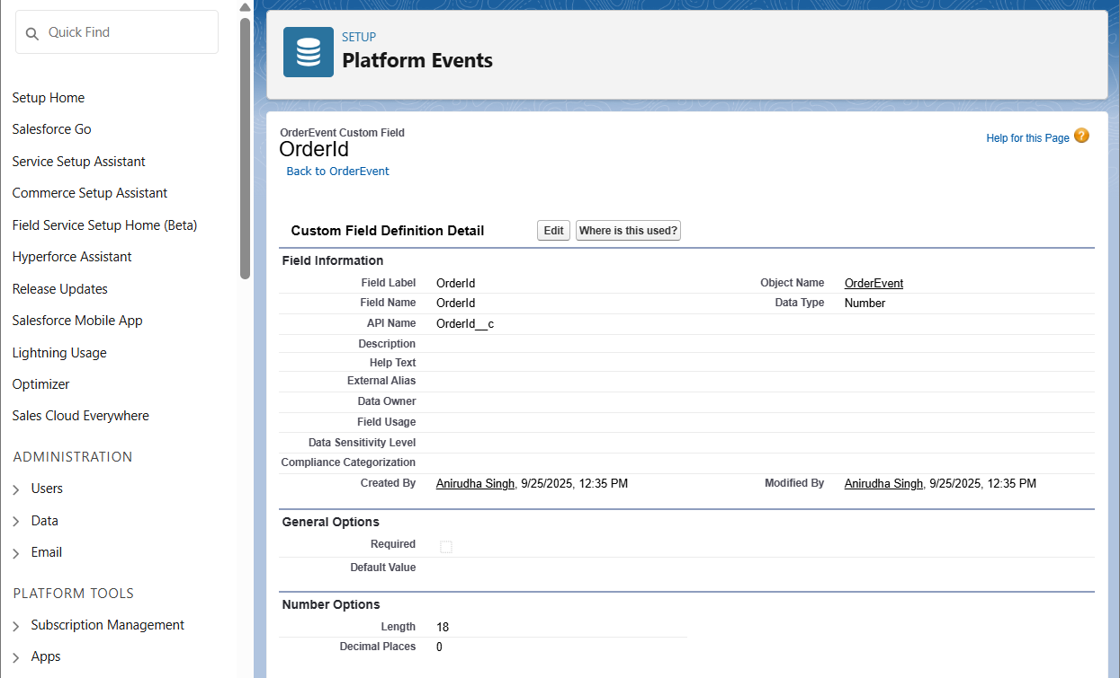

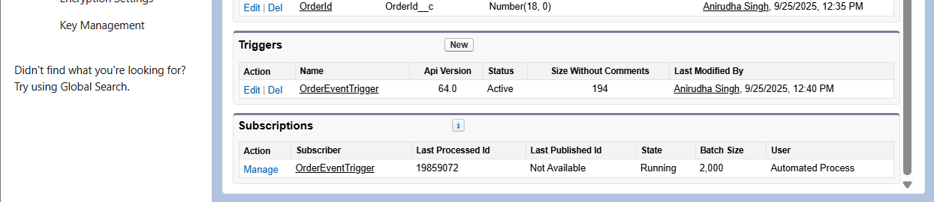

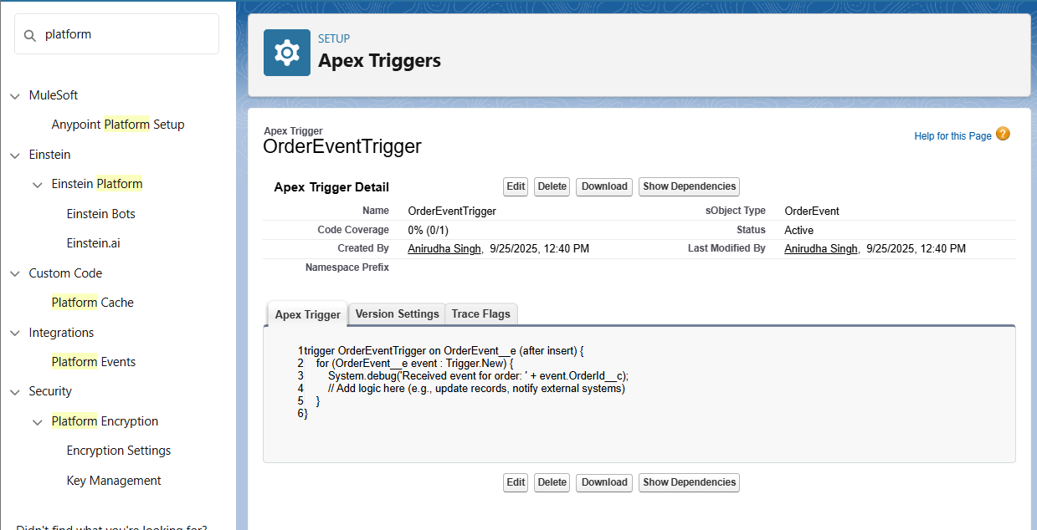

**6. Change Data Capture**

**Description:**  
 Change Data Capture (CDC) allows Salesforce to capture changes in records and notify external systems.

**Configuration:**

* **Enabled Objects:** Order__c, Product__c,User
* **Trigger:** OrderChangeTrigger

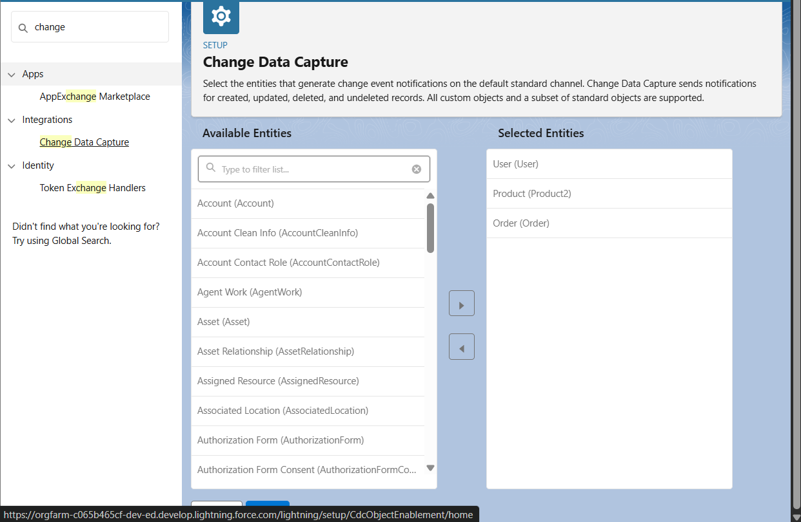

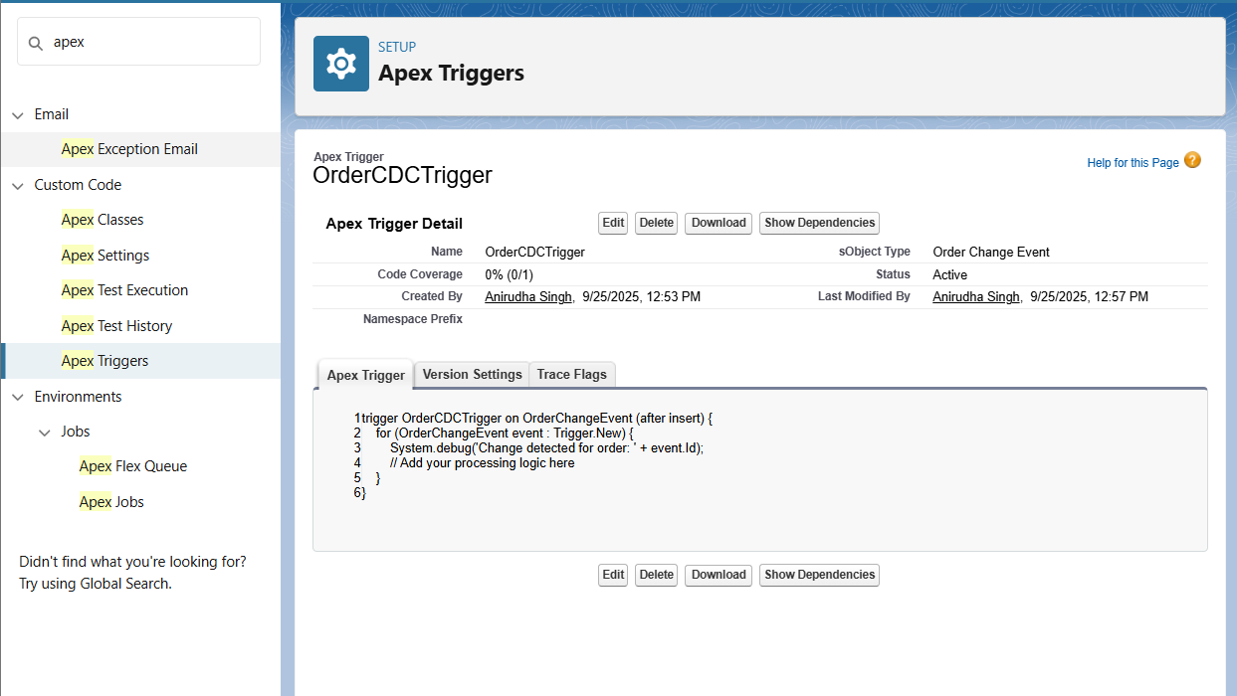

**7. Salesforce Connect**

**Description:**  
 Salesforce Connect enables Salesforce to access and display data from external systems in real-time.

**Configuration:**

* **External Data Source:**
  + **Name:** ShopSmartAPI
  + **Type:** Salesforce Connect: OData 2.0
  + **Endpoint URL:** [**https://api.shopsmart.com/**](https://orgfarm-c065b465cf-dev-ed.develop.my.salesforce.com/servlet/servlet.ExternalRedirect?url=https%3A%2F%2Fapi.shopsmart.com%2F)
  + **Identity Type:** Anonymous
  + **Authentication Protocol:** No Authentication
* **Synced Objects:**
  + Order
  + Product
  + Customer

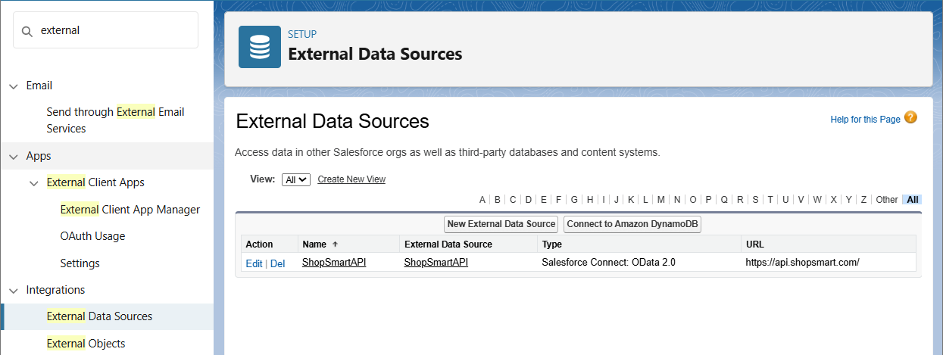

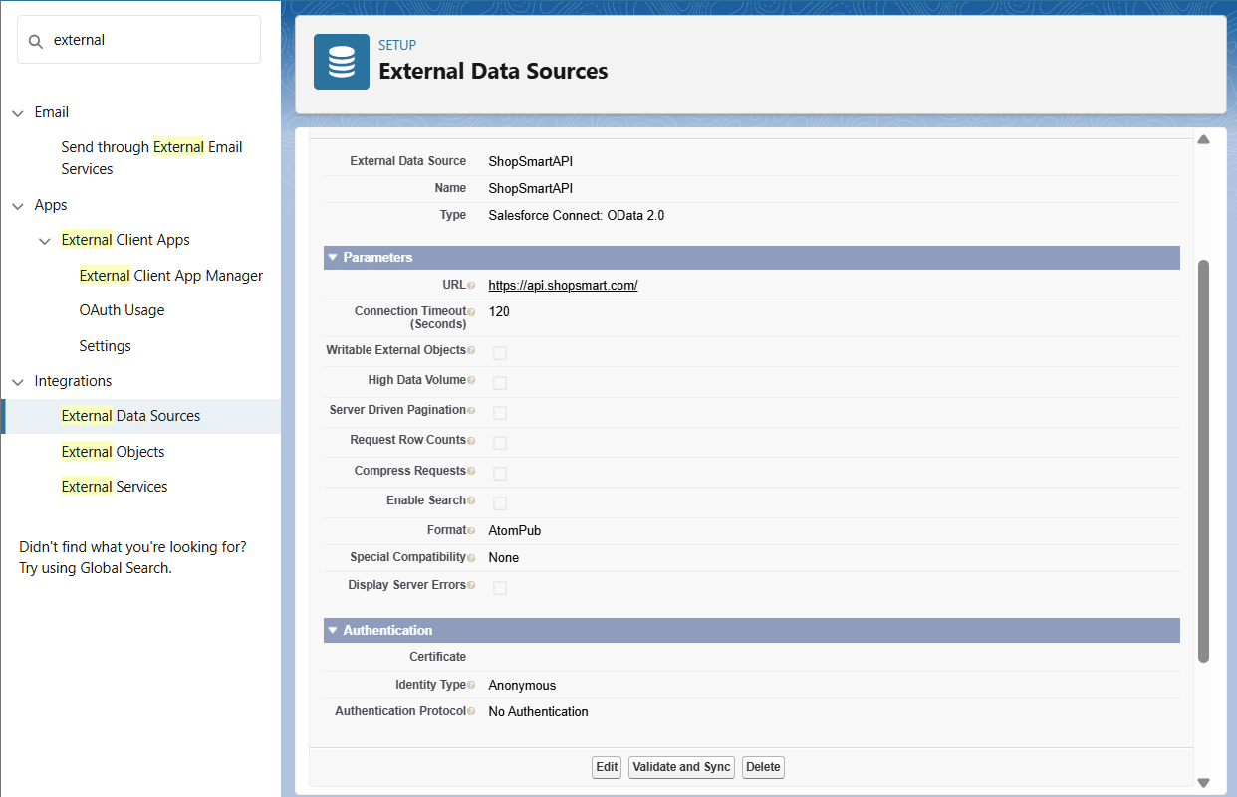

**8. API Limits**

**Description:**  
 Salesforce imposes limits on API usage to ensure fair resource allocation and system stability.

**Configuration:**

* **API Limit Monitoring:** Regularly monitor API usage through the System Overview page.
* **Optimization:** Implement efficient coding practices to minimize API calls.

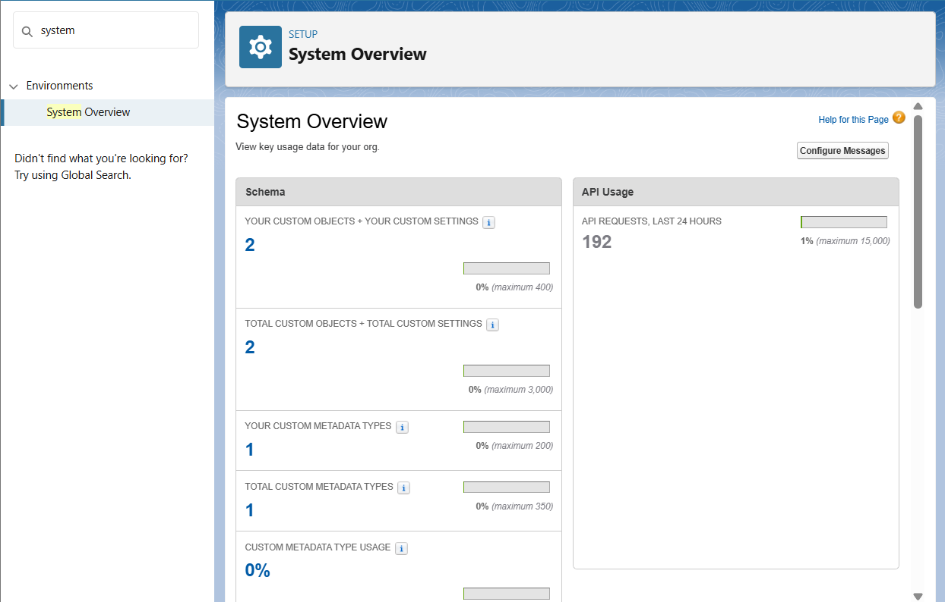

**9. OAuth & Authentication**

**Description:**  
 OAuth 2.0 is used to authenticate and authorize third-party applications to access Salesforce data.

**Configuration:**

* Named Credentials cover authentication for external callouts.
* No extra action needed.

**10. Remote Site Settings**

**Description:**  
 Remote Site Settings define a list of external sites that Salesforce can communicate with.

**Configuration:**

* **Remote Site Name:** ShopSmartAPI
* **Remote Site URL:** https://api.shopsmart.com
* **Active:** Checked

**Configuration:**

* **Remote Site Name:** PetstoreAPI
* **Remote Site URL:** https://petstore.swagger.io
* **Active:** Checked

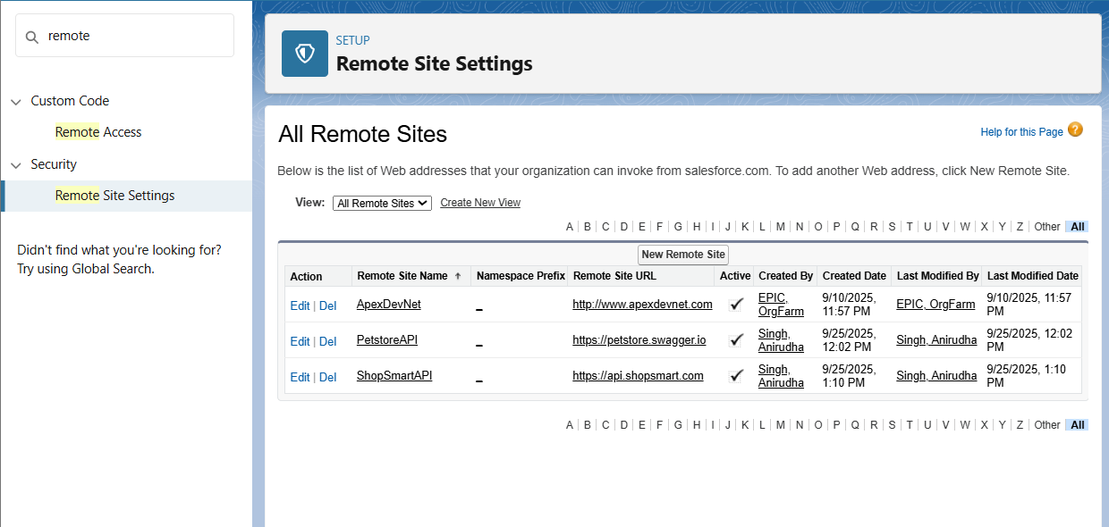

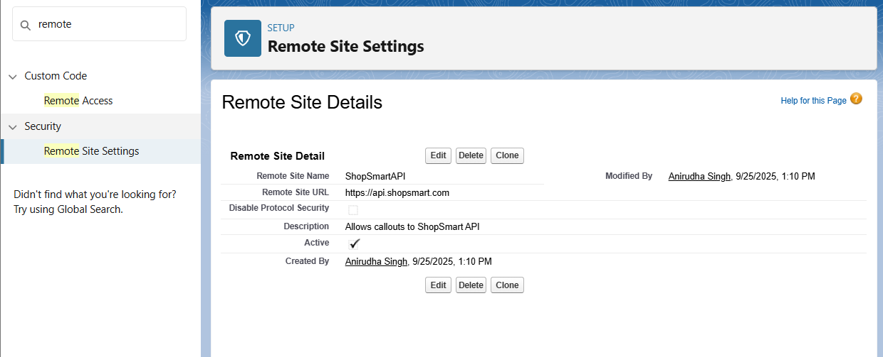

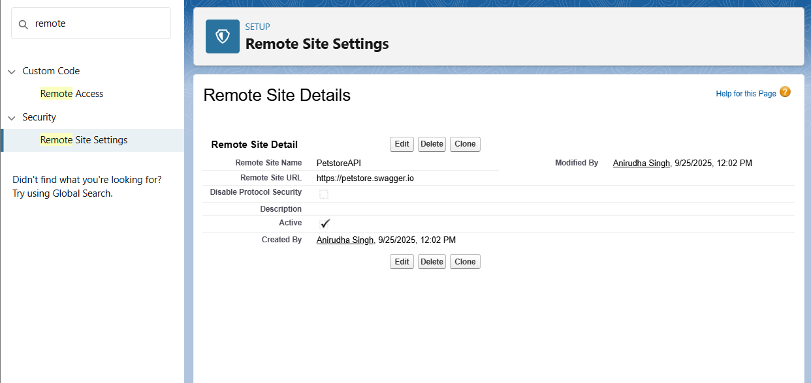

**Phase 8: Data Management & Deployment**

**1. Data Import Wizard**

**What it is:** A Salesforce tool for importing small amounts of data (up to 50,000 records) using a simple UI.  
 **Used for:** Importing Accounts, Contacts, Leads, Solutions, and custom object records. Supports CSV files.  
 **What I created:** Imported sample customer Accounts, Contacts and Inventories into Salesforce for testing.

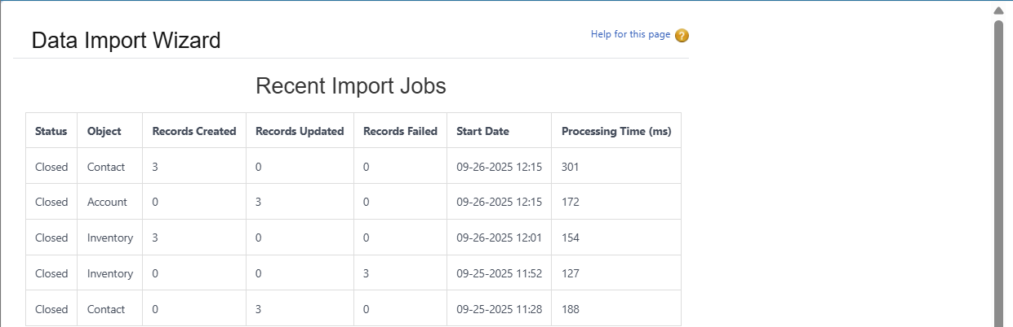

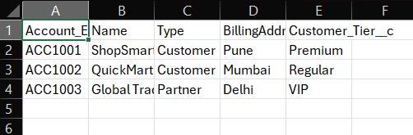

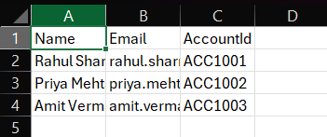

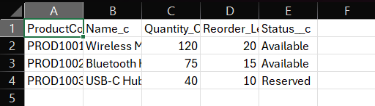

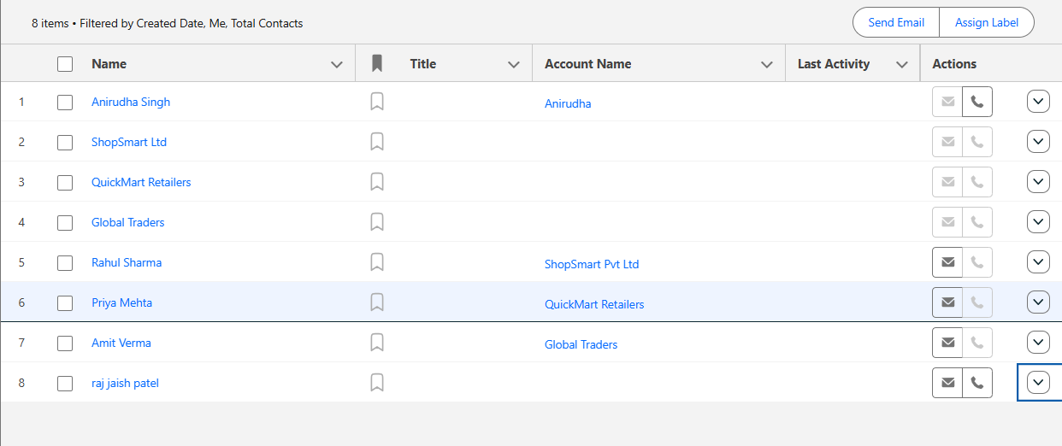

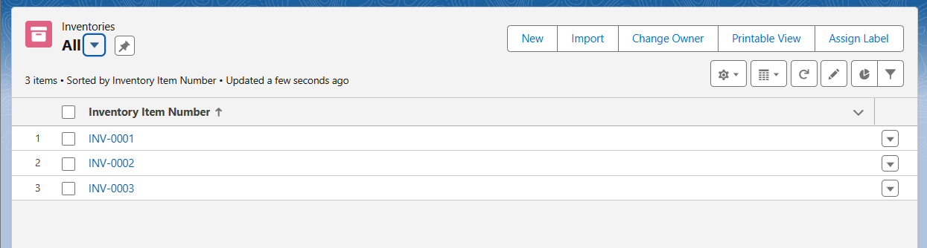

**2. Data Loader**

**What it is:** A client application (desktop or CLI) to insert, update, upsert, delete, or export large volumes of data (up to 5 million records).  
 **Used for:** Handling bulk data operations not supported by Import Wizard.  
 **What I created:** Loaded bulk Order records and updated Inventory data to simulate real transactions.

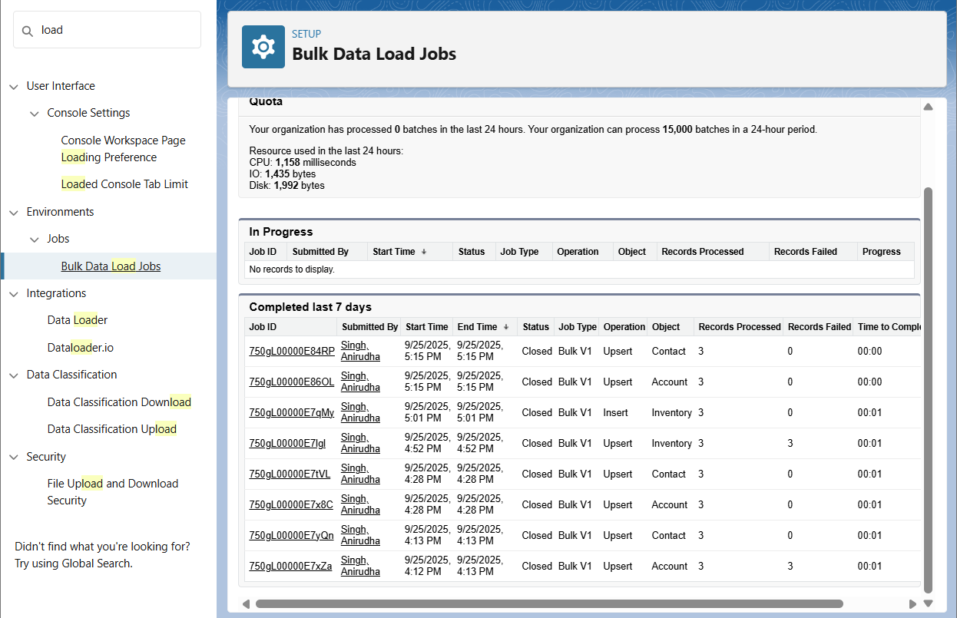

**3. Duplicate Rules**

**What it is:** Rules in Salesforce that prevent or alert users when duplicate records are created.  
 **Used for:** Maintaining clean data by matching on fields like email, phone, or custom criteria.  
 **What I created:** Duplicate rule - 1. Contact - Block Email+Phone Exact

2. Contact - Alert/Report Email or Phone

Matching Rule - Contact_EmailOrPhone_Partial , Contact_EmailPhone_Strict

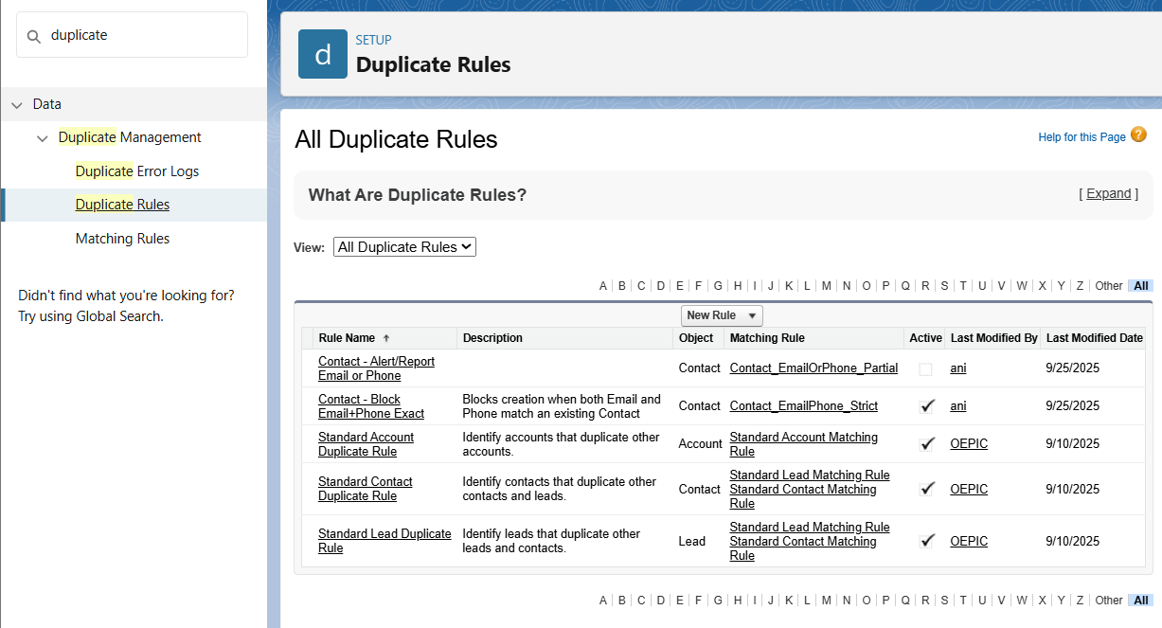

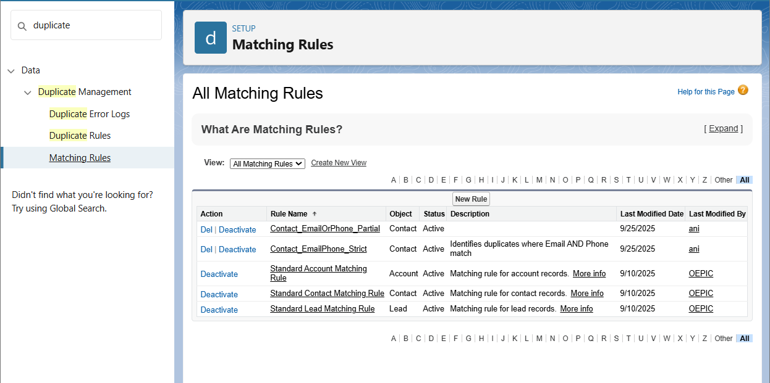

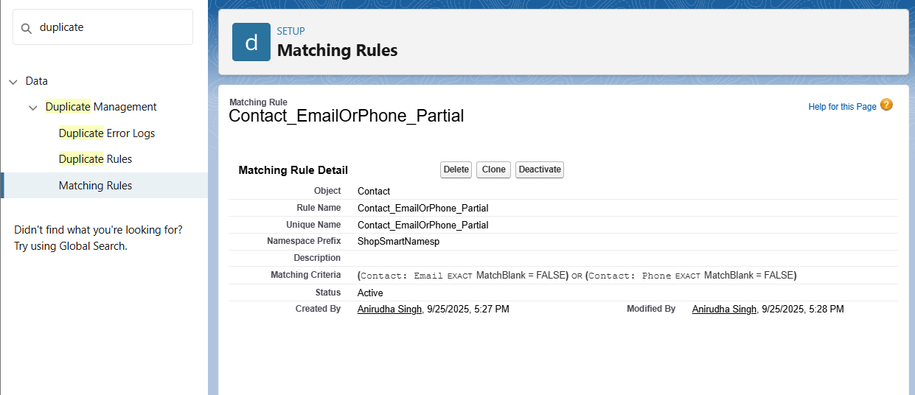

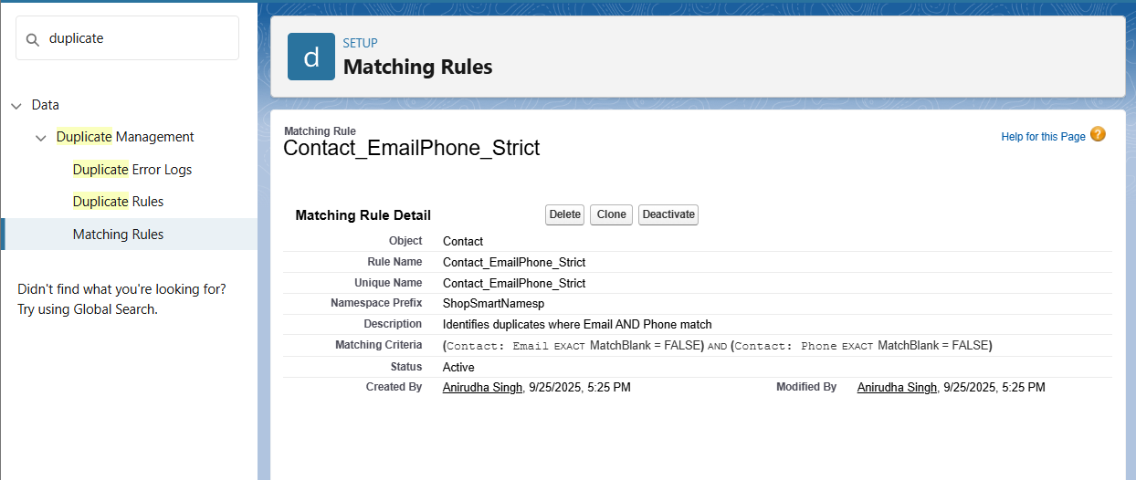

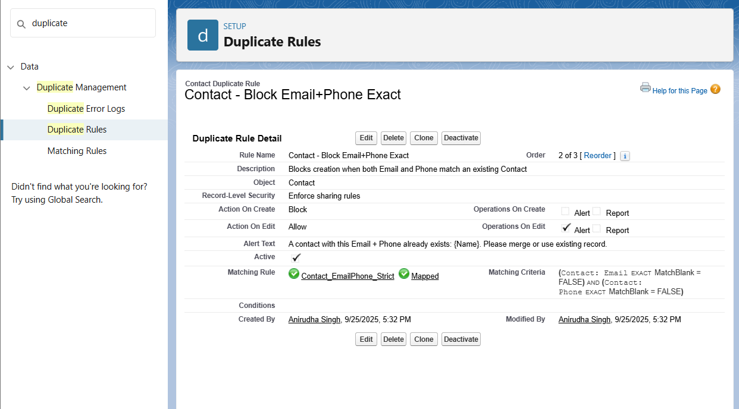

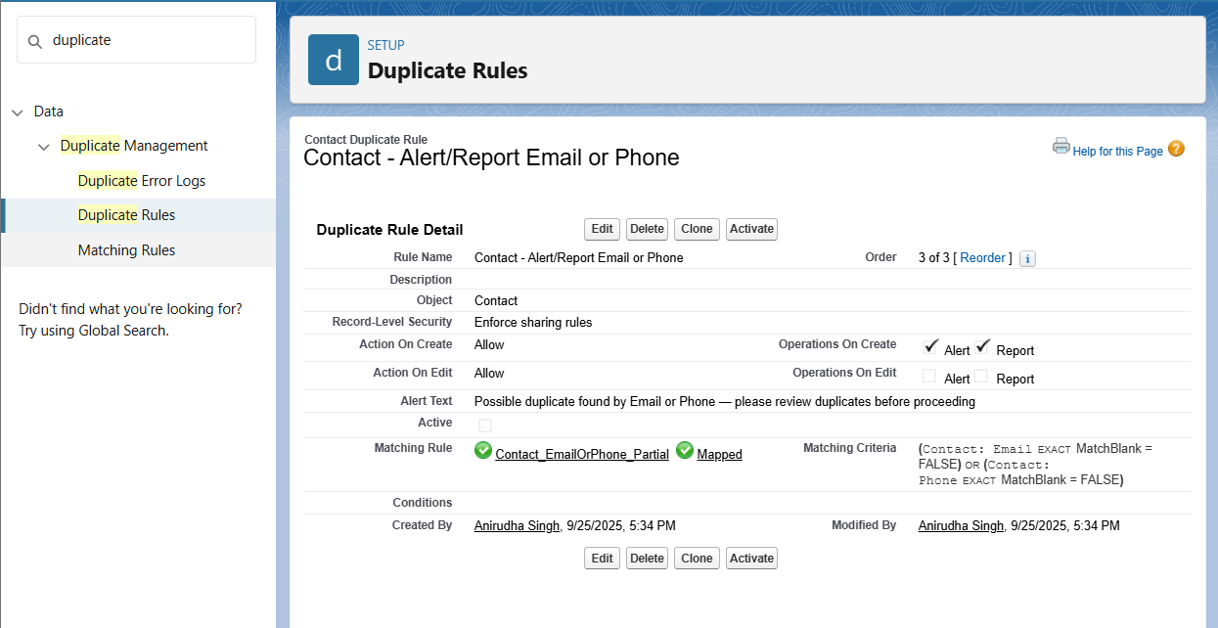

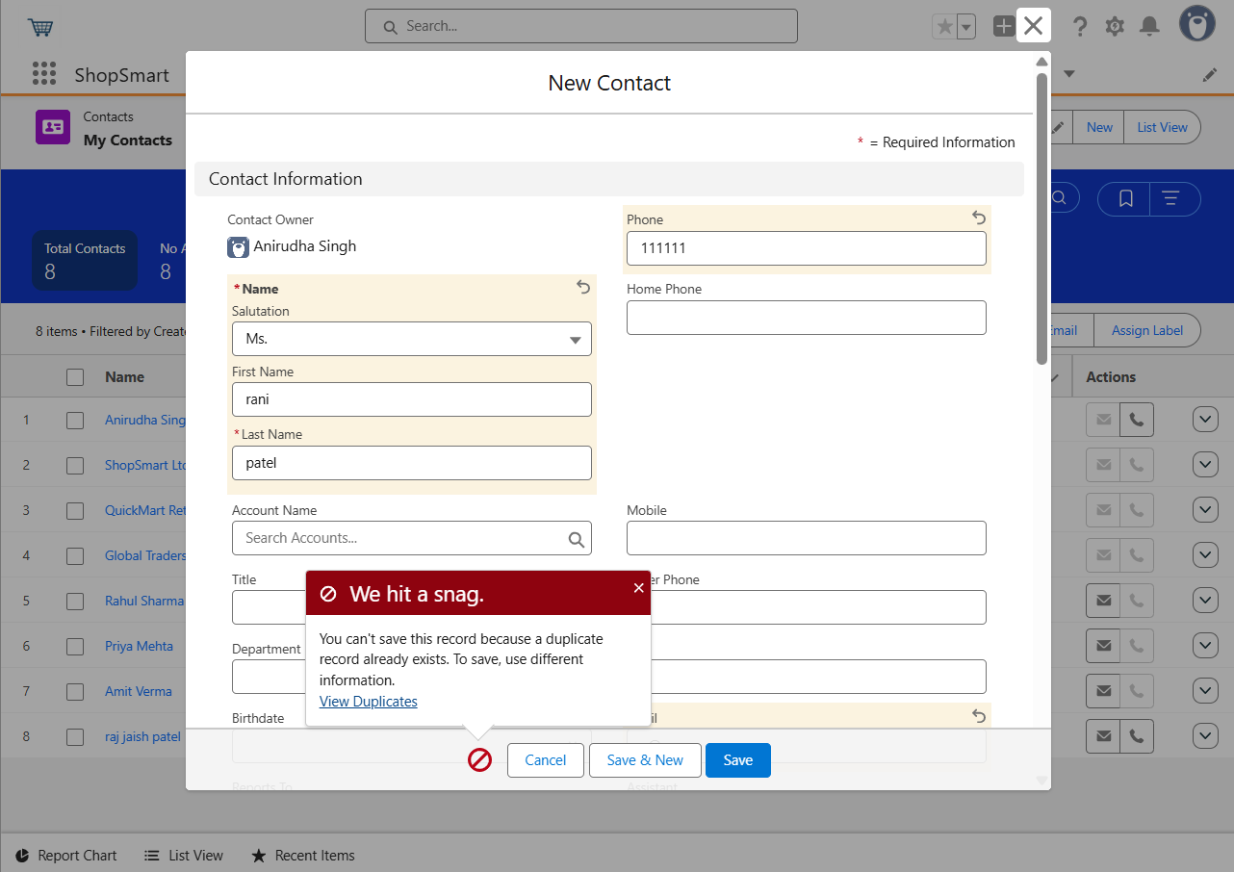

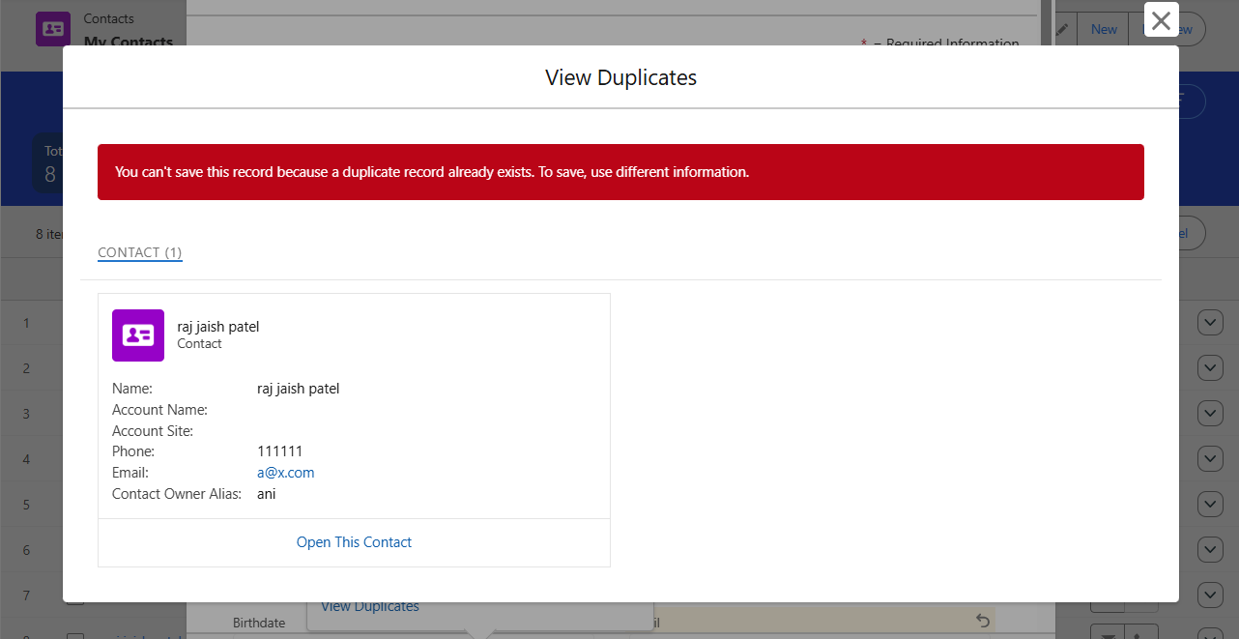

**4. Data Export & Backup**

**What it is:** A Salesforce feature to export data from objects into CSV files, scheduled or manual.  
 **Used for:** Creating regular data backups for disaster recovery and compliance.  
 **What I created:** Configured a weekly scheduled export of Accounts, Orders, and Cases.

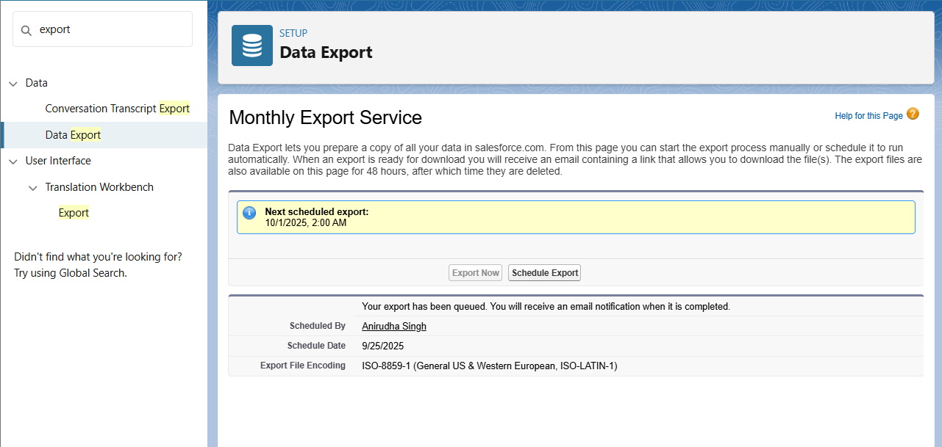

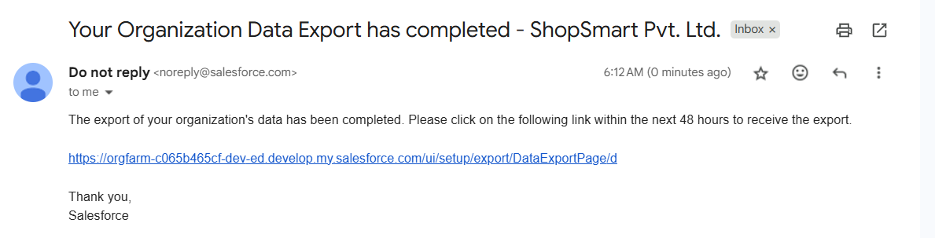

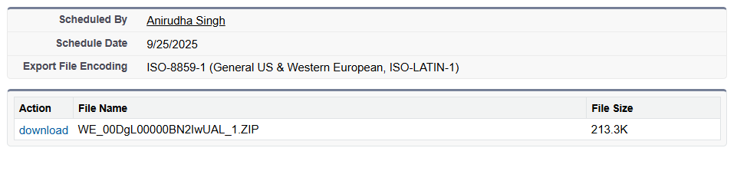

**5. Change Sets**

**What it is:** A point-and-click tool to move metadata between related Salesforce orgs (e.g., from sandbox to production).  
 **Used for:** Deploying configuration changes without using code.  
 **What I created:** Not available in developer org

**6. Unmanaged vs Managed Packages**

**What it is:** Bundles of components for deployment.

* **Unmanaged**: One-time bundles; code is editable in target org.
* **Managed**: Versioned packages for distribution; supports upgrades and AppExchange.  
   **Used for:** Sharing metadata, distributing apps, or moving components between orgs.  
   **What I created:** An Unmanaged Package containing custom objects (Inventory, Order Item) and Apex classes for testing.
* 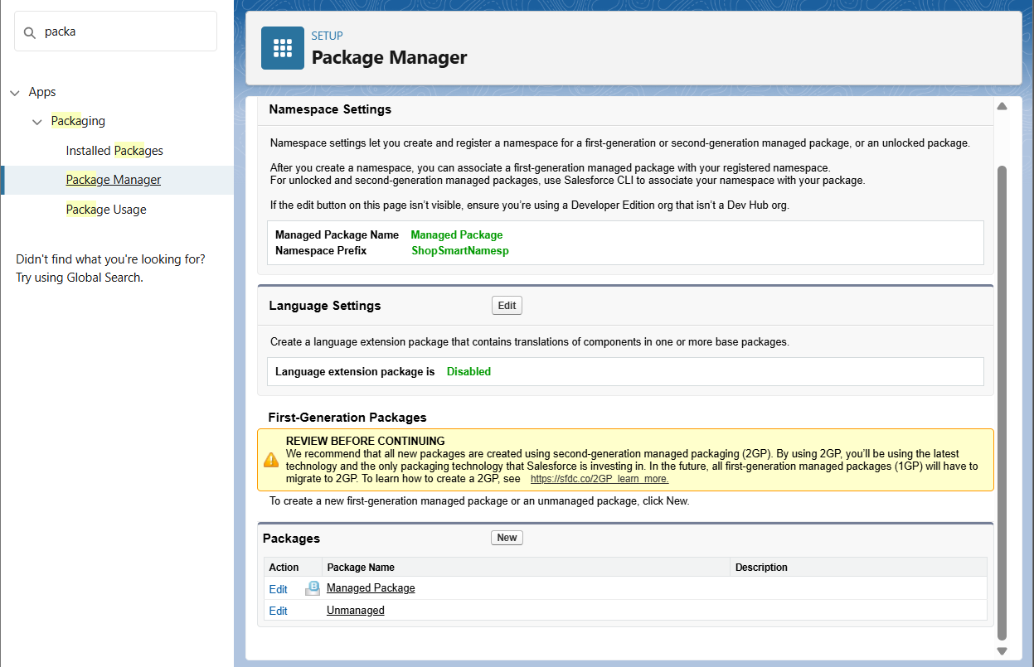
* 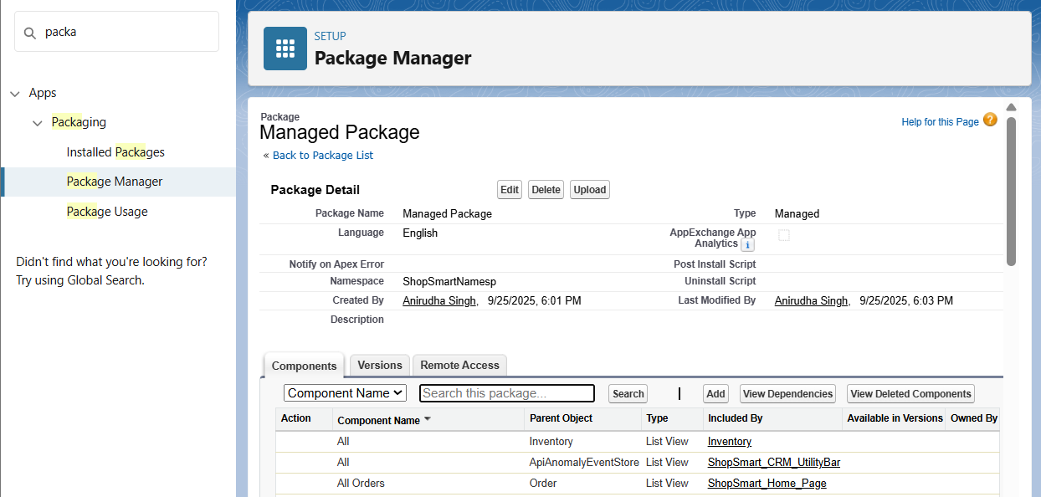
* 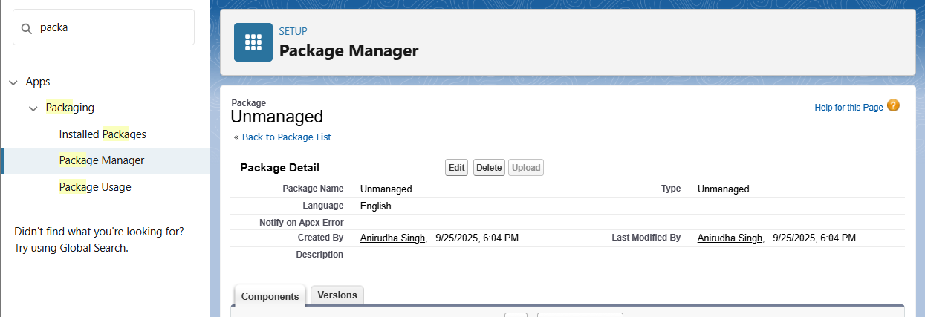

**7. ANT Migration Tool**

**What it is:** A command-line tool (Java + Ant) for retrieving and deploying metadata using Salesforce Metadata API.  
 **Used for:** Automated deployments, scripting, and CI/CD pipelines.  
 **What I created:** Configured a simple package.xml to retrieve Apex Classes and deploy them to another Developer Org.

**8. VS Code & SFDX**

**What it is:** A modern development environment using Salesforce CLI and extensions in Visual Studio Code.  
 **Used for:** Source-driven development, metadata retrieval/deployment, Apex testing, and CI/CD.  
 **What I created:** A Salesforce DX project in VS Code, connected to Developer Org, and deployed LWCs and Apex classes.

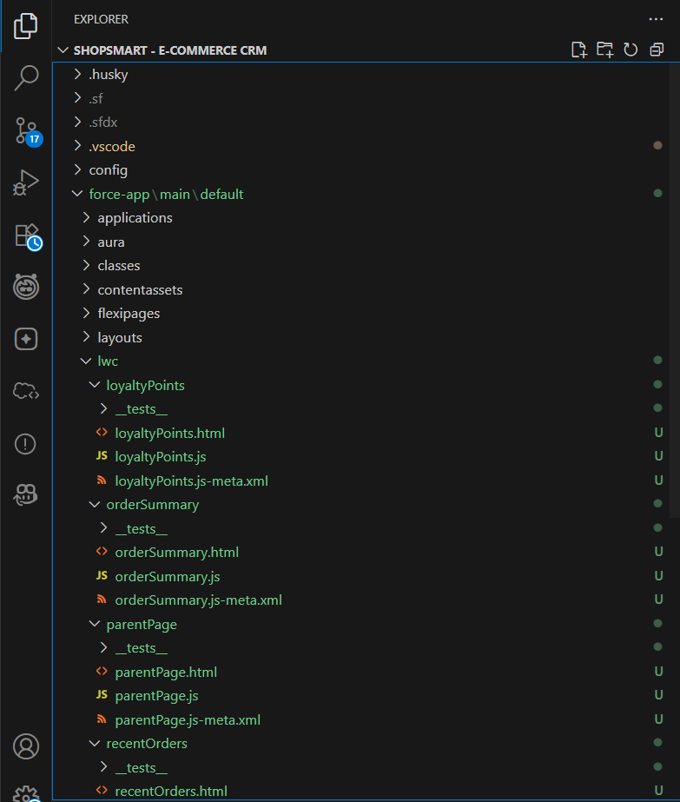

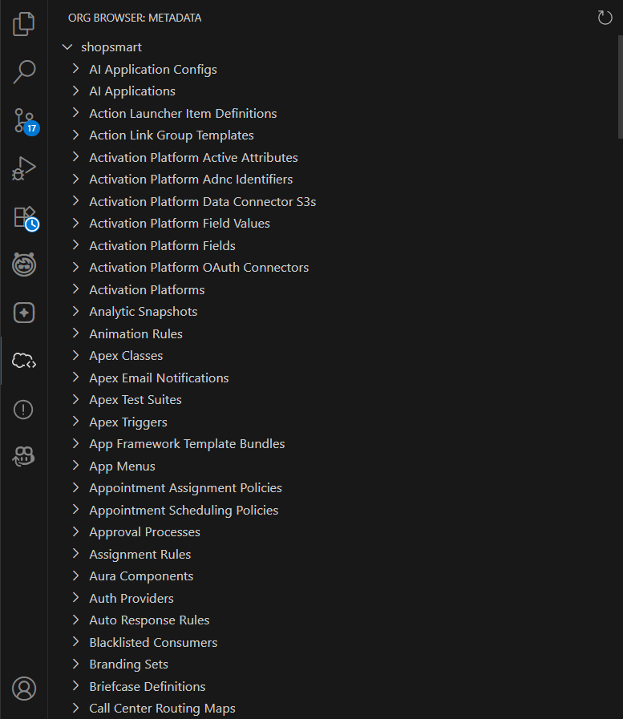

**Phase 9: Reporting, Dashboards & Security Review**

**1. Reports**

- Create a Tabular Report (Accounts with Name & Phone)  
- Create a Summary Report (Opportunities grouped by Stage, Sum of Amount)  
- Glance at Matrix Report (Stage vs Owner cross-tab)  
- Glance at Joined Report (Accounts + Opportunities blocks)

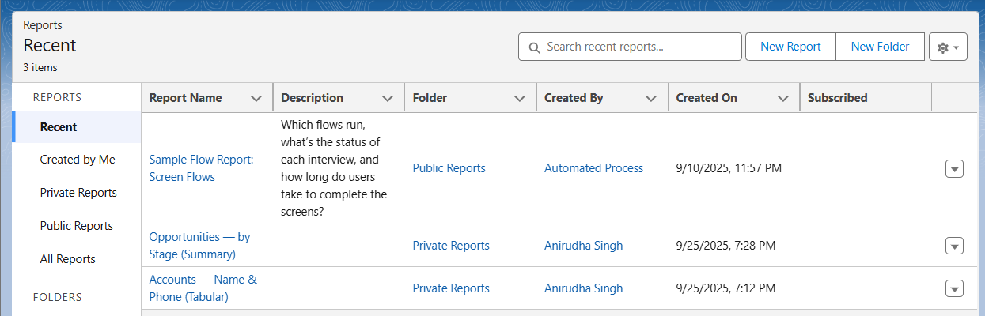  
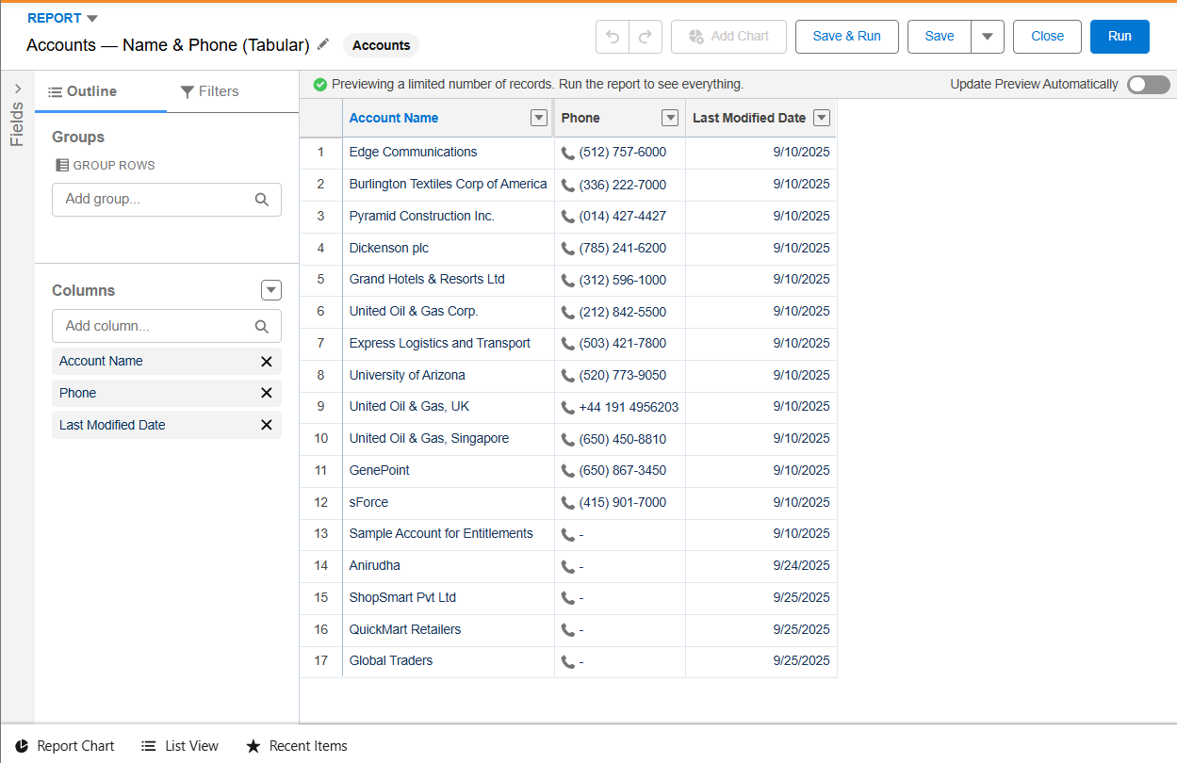  
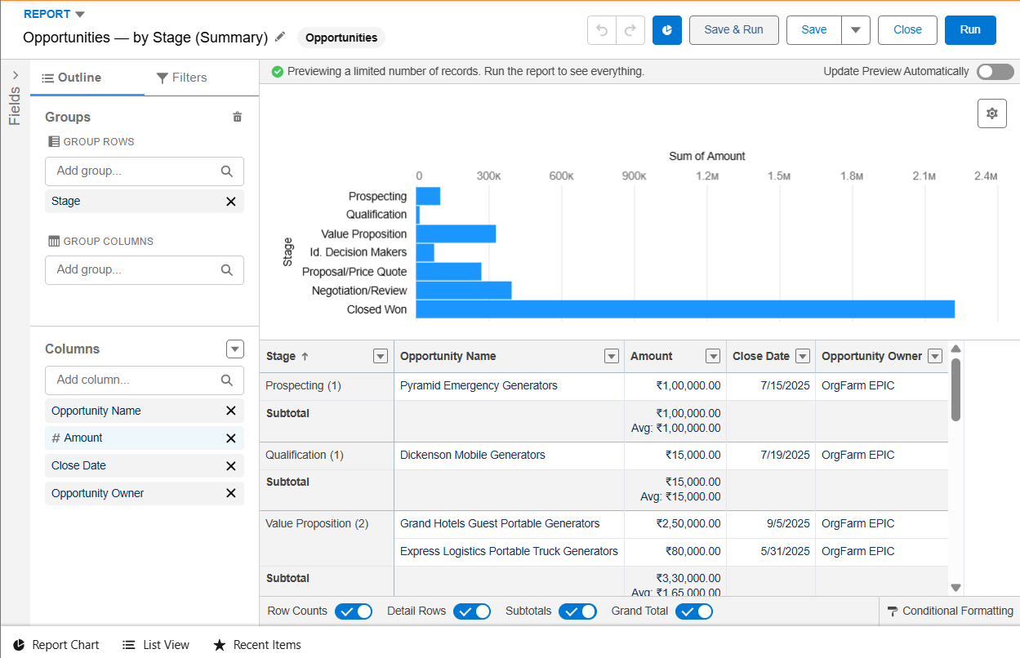  
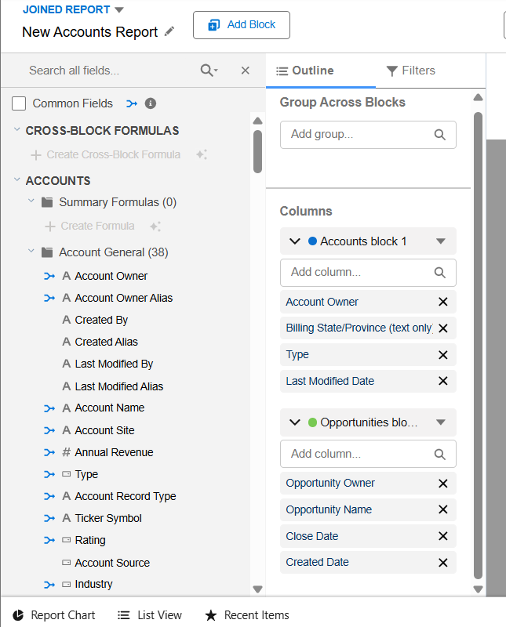

**2. Report Types**

- Used Standard Report Type (Accounts, Opportunities)  
- Created Custom Report Type: Accounts with Opportunities

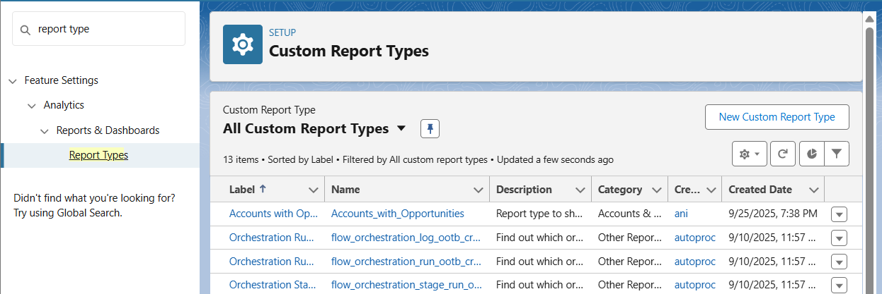  
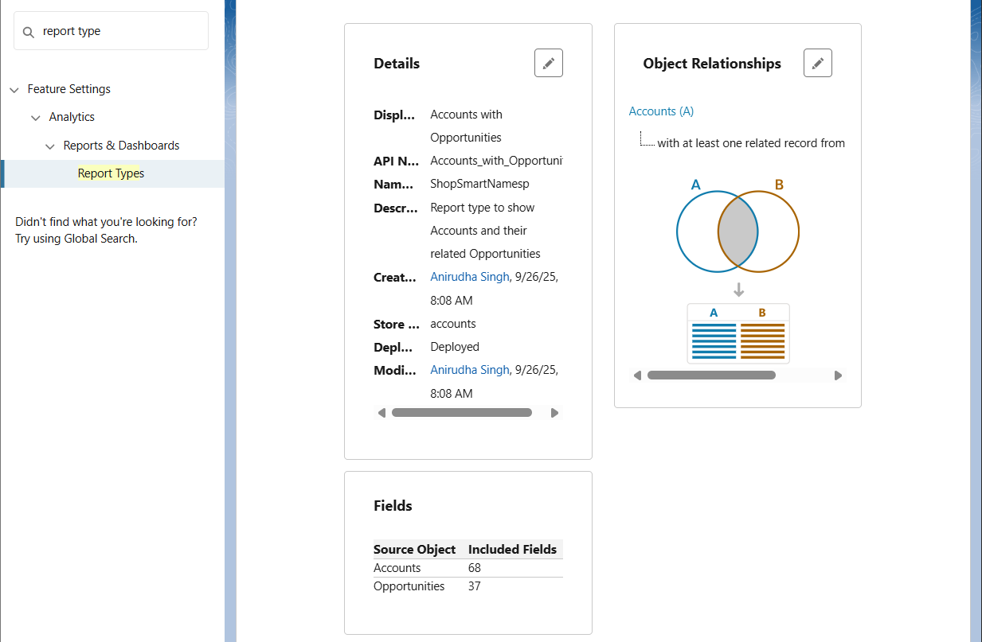

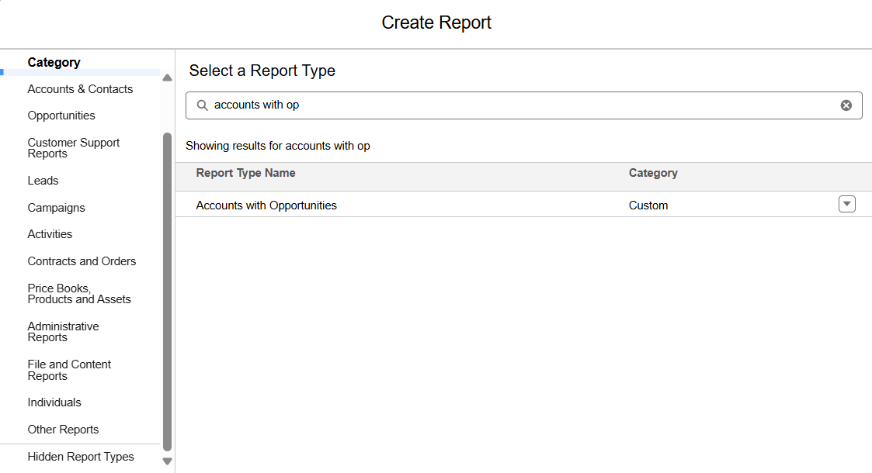

**3. Dashboards**

- Created Dashboard: 'Sales Performance Dashboard'  
- Added Component: Opportunities by Stage (Vertical Bar Chart)  
- Added Table Component (Accounts Tabular Report)

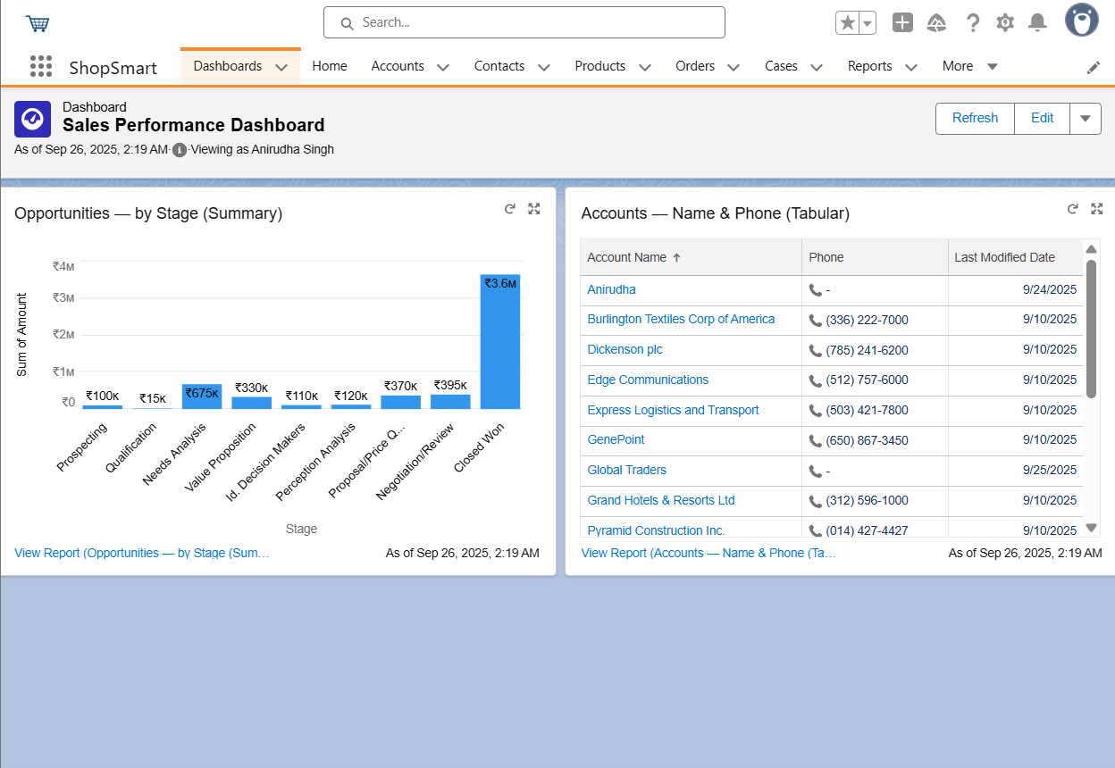

**4. Dynamic Dashboards**

- Edited Dashboard → Set 'View Dashboard As' = Logged-in User  
- Confirmed visibility differs by profile/role  
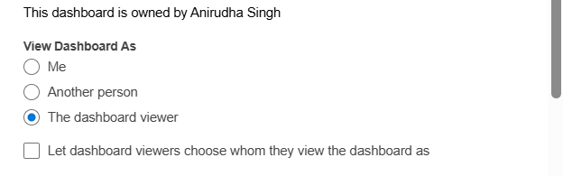

**5. Sharing Settings**

- Reviewed Org-Wide Defaults  
- Updated Accounts access to Public Read Only

- Created one Sharing Rule for demo

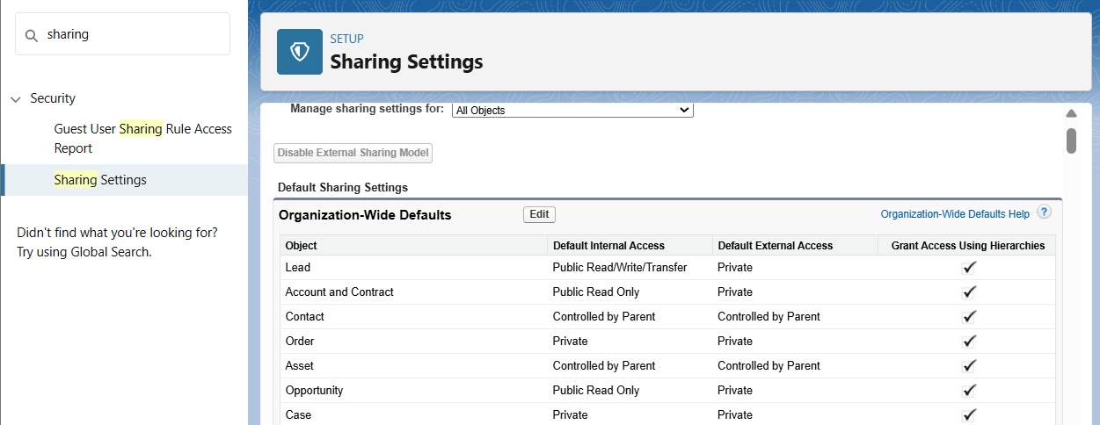

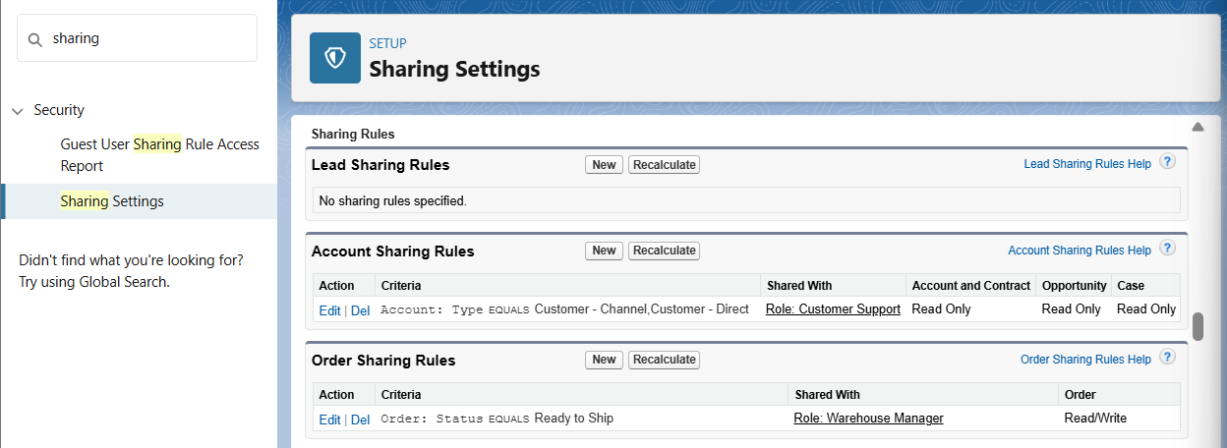

**6. Field Level Security (FLS)**

- Modified Account → Phone field visibility  
- Hid Phone field for Standard User profile  
- Confirmed field missing in reports for that profile

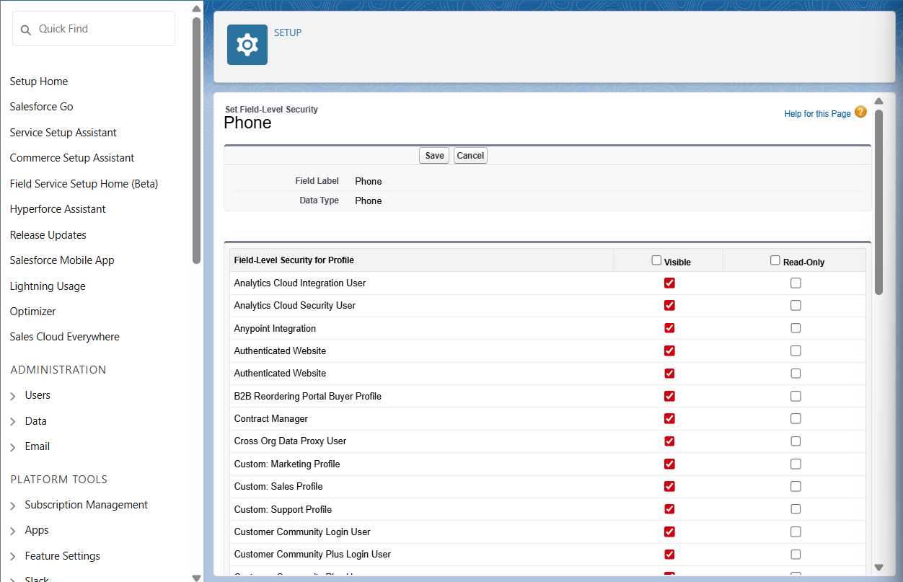  
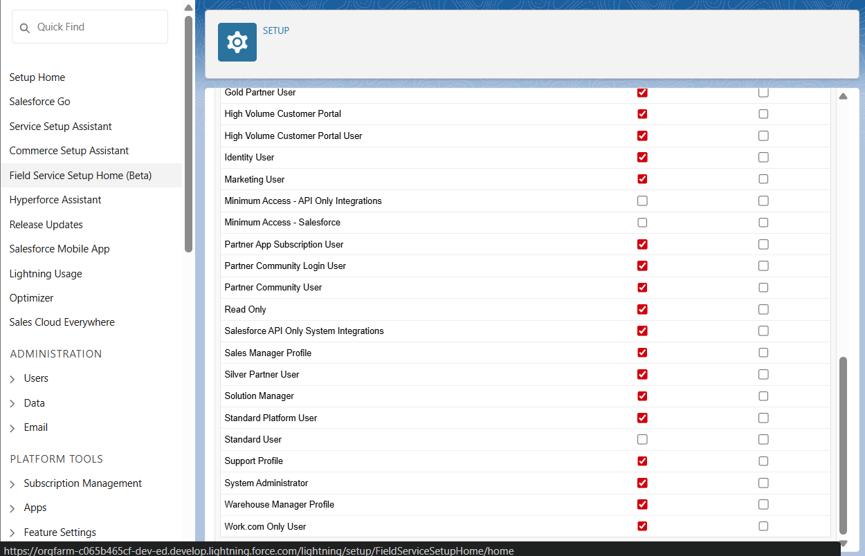

**7. Session Settings**

- Reviewed Session Timeout and login policies  
- Changed Session Timeout to 30 minutes  
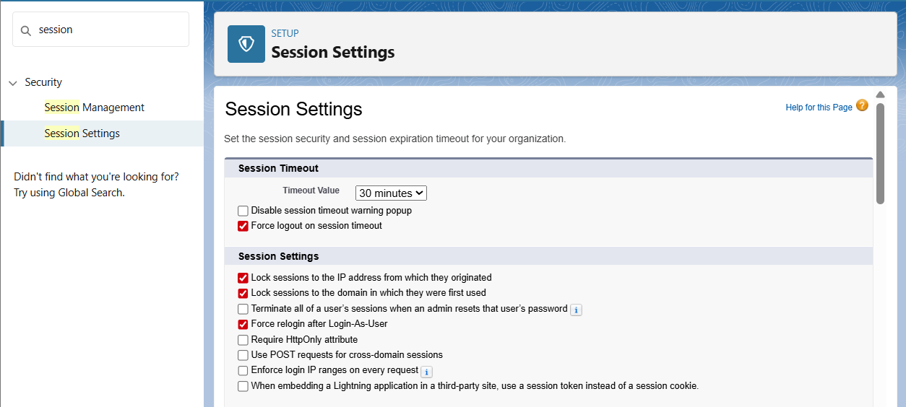

**8. Login IP Ranges**

- Added Login IP Range to System Administrator profile  
- Used 0.0.0.0 to 255.255.255.255 for testing  
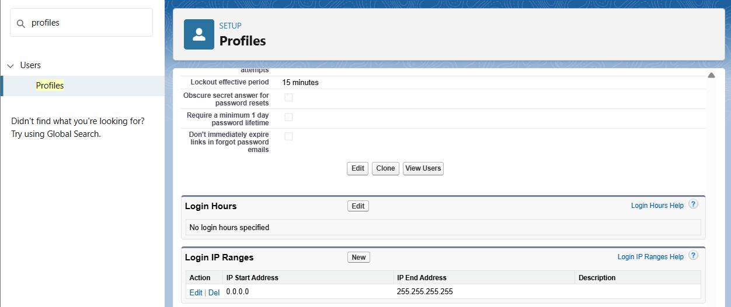

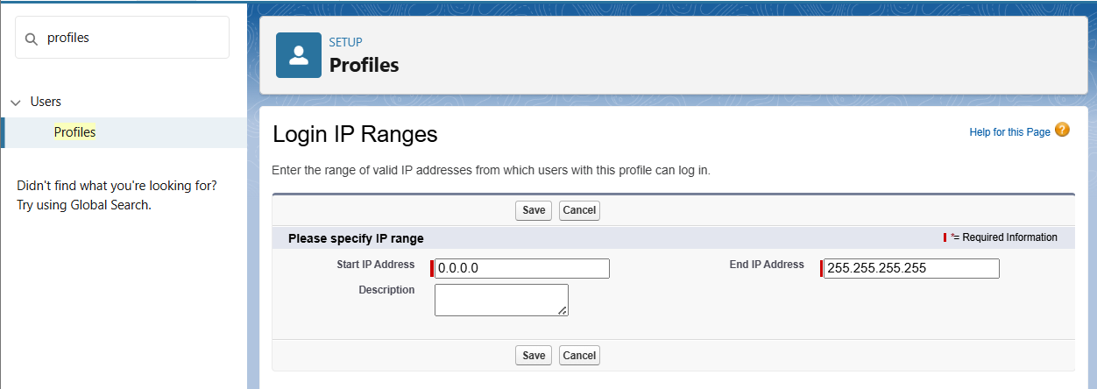

**9. Audit Trail**

- Viewed Setup Audit Trail (last 20 changes)  
- Exported full audit history (optional)  
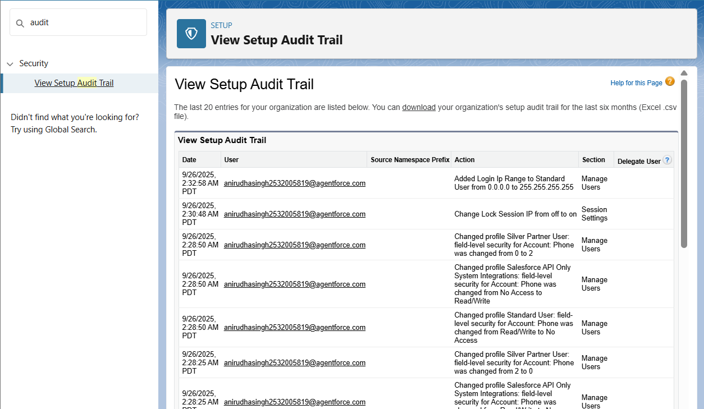

# **Phase 10 : Quality Assurance Testing**

In this phase, detailed Quality Assurance Testing was conducted for the ShopSmart E-commerce Customer Engagement & Order Tracking System. Each major feature implemented during the project was tested with structured test cases, covering inputs, expected outputs, and actual results. Screenshots should be added where indicated.

## **Record Creation in Orders (Order Lifecycle Automation)**

|  |  |
| --- | --- |
| Use Case / Scenario | Create a new Order record with related Order Items, ensuring order status progresses correctly. |
| Test Steps (with Input) | 1. Navigate to Orders tab. 2. Click 'New Order'. 3. Enter Account = Test Customer, Delivery Method = Ship, Payment Status = Paid. 4. Add Order Items: Product = Laptop, Qty = 2. 5. Save the record. |
| Expected Result | Order should be created with Status = Placed. Order Items linked, Inventory reduced by 2. |
| Actual Result | Order created successfully, Inventory updated. |
| Status | Pass |

## **Approval Process for High Discounts**

|  |  |
| --- | --- |
| Use Case / Scenario | Approve or reject Opportunities with discounts greater than 30%. |
| Test Steps (with Input) | 1. Create an Opportunity with Amount = 100,000 and Discount = 35%. 2. Save the record. 3. System should lock record and send for approval to Sales Manager. |
| Expected Result | Record is locked. Approval request sent to Manager. On approval → Discount_Approved__c = TRUE. |
| Actual Result (with Screenshot) | Record locked and approval routed. Approval completed successfully. |
| Status | Pass |

## **Automatic Task Creation (High-Value Opportunity)**

|  |  |
| --- | --- |
| Use Case / Scenario | Automatically create follow-up tasks for Opportunities above 100,000. |
| Test Steps (with Input) | 1. Create an Opportunity with Amount = 150,000. 2. Save the record. |
| Expected Result | System creates Task assigned to Opportunity Owner with subject 'Follow-up High-Value Opportunity'. |
| Actual Result | Task created as expected. |
| Status | Pass |

## **Flows (Order Status Update + Notifications)**

|  |  |
| --- | --- |
| Use Case / Scenario | Order Status auto-updates and notification sent to customer on status change. |
| Test Steps (with Input) | 1. Update Order record: Change Status from Placed → Shipped. 2. Save the record. (Insert screenshot of Order update form here) |
| Expected Result | Order Status updates to Shipped. Email/SMS notification triggered to customer. |
| Actual Result | Order updated and notification received. |
| Status | Pass |

## **Triggers (OrderTrigger + OrderHelper Loyalty Points Calculation)**

|  |  |
| --- | --- |
| Use Case / Scenario | Calculate loyalty points automatically whenever an Order is created. |
| Test Steps (with Input) | 1. Create Order for Account = Premium Tier. 2. Order Amount = 50,000. 3. Save the record. |
| Expected Result | OrderTrigger calls OrderHelper. Loyalty points calculated using CMDT multipliers |
| Actual Result | Loyalty points added to Account successfully. |
| Status | Pass |

## **Validation Rules (Shipping Address, SKU Format, Inventory Non-Negative)**

|  |  |
| --- | --- |
| Use Case / Scenario | Ensure data integrity using validation rules. |
| Test Steps (with Input) | 1. Try to create Order with Delivery Method = Ship but leave Shipping Address blank. 2. Try to create Product with SKU = 1234-ABCD. 3. Update Inventory with Quantity = -5. |
| Expected Result | 1. Error: Shipping address is required. 2. Error: SKU must follow format AAA-1234. 3. Error: Quantity On Hand cannot be negative. |
| Actual Result | All validation errors fired correctly. |
| Status | Pass |

## **LWC Components (Recent Orders, Order Summary, Loyalty Points)**

|  |  |
| --- | --- |
| Use Case / Scenario | Verify custom LWCs display real-time order and loyalty point data. |
| Test Steps (with Input) | 1. Navigate to Home Page. 2. Check Recent Orders component. 3. Select an order → Order Summary component displays details. 4. Check Loyalty Points component for Account. |
| Expected Result | Recent Orders shows latest orders. Order Summary displays full details. Loyalty Points show correct calculation. |
| Actual Result | All components display correct data. |
| Status | Pass |

## **Dashboards & Reports (Sales Performance, Returns Analysis)**

|  |  |
| --- | --- |
| Use Case / Scenario | Validate dashboards and reports show accurate, role-based insights. |
| Test Steps (with Input) | 1. Open Sales Performance Dashboard. 2. Open Product Returns Analysis Report. 3. Log in as CEO → full visibility. 4. Log in as Sales Manager → team-only visibility. |
| Expected Result | Dashboards load with accurate charts. Role-based filters applied correctly. |
| Actual Result | Dashboards display as expected with correct visibility. |
| Status | Pass |

## **Conclusion**

The Quality Assurance Testing for ShopSmart validated all implemented features including automation, triggers, validation rules, LWCs, and dashboards. Each test case was executed successfully, with actual results matching the expected outcomes. With testing completed, the system is production-ready, delivering automated order management, real-time dashboards, and improved customer engagement.

------------------------------------------------------------------------------------------------------------------

**\*Demo**

**1. Pitch Presentation**

**Problem Statement:**

In today’s e-commerce business, ShopSmart was facing several major challenges:

* First, customer and order data was fragmented across multiple systems, which made it hard to maintain a single source of truth.
* Second, the customer support team struggled to provide real-time updates on orders, shipping, and returns, which often led to customer frustration.
* Third, marketing campaigns were generic and not personalized, so customer engagement and loyalty were quite low.
* Fourth, warehouse managers had no real-time inventory visibility, which led to frequent stockouts and even overselling.
* Finally, management dashboards were only available after delays, making decision-making reactive instead of proactive.

So overall, these challenges were creating inefficiencies, reduced customer satisfaction, and lost revenue opportunities.

**Solution Overview:**

To solve these issues, I built the *ShopSmart CRM* system on Salesforce.

* This solution centralizes all orders, inventory, customer, and marketing data inside Salesforce.
* The entire order lifecycle is automated — from Placed → Shipped → Delivered → Returned — with notifications at each stage.
* Marketing teams can now run personalized journeys based on customer purchase history, instead of sending one-size-fits-all campaigns.
* Management can access real-time dashboards for sales, customer loyalty, and returns.
* And finally, the system has seamless integrations with the ShopSmart website, mobile app, and logistics APIs to ensure smooth data flow across platforms.

**Benefits:**

This solution delivers several key benefits:

* First, it provides end-to-end automation of order processing and customer notifications, reducing manual work and errors.
* Second, with live dashboards and KPIs, management can make faster and more informed decisions.
* Third, customers enjoy an improved experience thanks to proactive updates and personalized campaigns that make them feel valued.
* Fourth, the support team’s workload is reduced significantly since many updates and notifications are automated.
* And finally, the system is scalable and secure, ready to handle growing order volumes as the business expands.

**2. Demo Walkthrough**

**1. Introduction**

* Introduce yourself and the project name: *ShopSmart – E-commerce Customer Engagement & Order Tracking System*.
* Briefly explain the business goal: *To centralize customer and order data, automate order lifecycle, provide real-time dashboards, and improve customer engagement*.
* Mention the tools used: *Salesforce (Admin + Developer features), Apex, LWC, Flows, Integration (APIs), Reports & Dashboards*.

**2. App Overview**

* Open the **ShopSmart App** from App Launcher.
* Show the **custom navigation bar** with tabs: Accounts, Contacts, Orders, Products, Order Items, Inventory, and Cases.
* Mention standard objects used (*Accounts, Contacts, Products, Orders, Cases*) and custom objects (*Order Item__c, Inventory__c*).

**3. User Interface Demonstration**

* Demonstrate **creating an Order** record with fields like Payment Status, Delivery Method, and Order Items.
* Show **Inventory__c updates** automatically after an order is placed.
* Highlight **validation rules**, e.g.:
  + Shipping Address required for delivery orders.
  + SKU format validation for products.
* Show **record types** for B2B vs. B2C Orders, and different page layouts for CEO, Sales Manager, Warehouse, and Support.

**4. Business Process Automation**

* Demonstrate **Record-Triggered Flow** that updates Order Status and sends notifications.
* Show **Workflow Rule / Process Builder** for high-value Opportunities → auto task creation + email alert.
* Demonstrate **Approval Process** for discounts greater than 30%.
* Open **Apex Triggers** (OrderTrigger, OrderTriggerHandler) and explain:
  + Loyalty points are calculated via OrderHelper class.
  + Bulk-safe design using collections (List, Set, Map).
* Mention **Batch Apex & Scheduled Apex**: *Nightly batch recalculates loyalty points*.

**5. Reports & Dashboards**

* Show **Sales Performance Dashboard** with charts for Opportunities by Stage and Revenue.
* Demonstrate **Product Return Analysis Dashboard**.
* Show **dynamic dashboards**: CEO sees all data, Sales Manager only sees team’s orders.

**6. User Management & Security**

* Demonstrate **Profiles**:
  + CEO → Full access.
  + Sales Manager → Orders + Opportunities.
  + Warehouse Manager → Orders + Inventory (read/write).
  + Support → Read-only on Orders + full on Cases.
* Show **Permission Sets**: e.g., “Order Management” for Support to update order statuses.
* Show **Role Hierarchy**: CEO → Sales Manager → Warehouse/Support.
* Highlight **Field-Level Security**: Payment details hidden for Support users.
* Mention **Field History Tracking** (e.g., Order Status, Inventory quantity).

**7. Error Handling & Debugging**

* Open **Debug Logs** for an Order Trigger run.
* Show how **exception handling** in OrderHelper prevents errors when CMDT records are missing.
* Mention how **validation rules** prevent incorrect data entry (e.g., negative inventory).

**8. Highlights**

* **End-to-end Order Lifecycle automation** with notifications.
* **Real-time Inventory sync** with low-stock alerts.
* **LWC components**: Recent Orders, Order Summary, Loyalty Points.
* **API integrations** via Named Credentials (Logistics API) and Platform Events (OrderEvent__e).
* **Dynamic dashboards** tailored per role.

**9. Conclusion**

* Summarize: *ShopSmart CRM delivers automated order tracking, inventory management, personalized marketing, dashboards, and secure role-based access.*
* Confirm: Project was fully **tested, documented, and packaged for deployment** using SFDX and Data Loader.
* End with: *This system improves customer satisfaction, reduces support workload, and provides management with real-time insights.*

**3. Handoff Documentation**

**System Design Document:**

* Objects: Accounts, Contacts, Orders, Order Item__c, Inventory__c, Cases.
* Key fields & relationships (Orders → Products, Inventory → Product2).
* Apex: OrderHelper, OrderTriggerHandler, RecalculateOrderPointsBatch, ScheduledOrderPoints.
* LWCs: recentOrders, orderSummary, loyaltyPoints.
* Integrations: Named Credentials (Logistics API), Platform Events (OrderEvent__e), CDC enabled.

**User Guide:**

* Step-by-step for **Sales Manager, Warehouse Manager, Support, CEO.**
* Screenshots: Order creation, notification emails, dashboards, LWCs.
* Instructions for using reports, dashboards, and customer segmentation.

**Deployment Notes:**

* Named Credentials + Remote Site Settings for APIs.
* Change Sets / SFDX for metadata deployment.
* Sample data loading via **Data Loader** (Orders, Inventory, Accounts).
* Backup strategy: **Weekly export of Accounts, Orders, and Cases.**

**4. LinkedIn/Portfolio Project Showcase**

* **LinkedIn Post Example:**

Completed my Salesforce end-to-end project – *ShopSmart E-commerce CRM*!  
 Built a scalable solution that automates orders, inventory, customer engagement, and dashboards on Salesforce.  
 Key Highlights: LWC components, Apex automation, Platform Events, API integrations, dynamic dashboards, and role-based security.  
 Learned how to combine **Admin, Development, Integration, and Reporting** for a real-world use case.  
Excited to apply these skills in enterprise Salesforce implementations!

* Add screenshots (Dashboards, LWC, Schema Diagram).
* Upload **Pitch Deck + Handoff Docs** as portfolio attachments.
* Showcase project in **LinkedIn Projects section**.
* Optionally upload **demo video** to YouTube and link it.